Critical Review of Practice

Shaun Parkes
MA Photography - PHO750 Final Project
Supervisor: Dr Wendy McMurdo

(2323 words excluding captions, list of figures, references, bibliography, internet research, appendices and glossary).
Table of Contents
Introduction. 54
Chapter 1: Development, Research and Planning. 55
Chapter 2: Influences, inclusions and omissions. 58
Raymond Depardon. 59
Chloe Dewe Matthews 60
Jeremy Deller 62
Paul Seawright 63
Steve McQueen 64
Methodological Approach and Selection Criteria 65
Chapter 3. – Public Outcomes and Dissemination 68
Publications. 68
Website. https://tellthemofus.uk 74
Website Articles. 76
Chapter 4. Conclusion and Future Outcomes. 77
Conclusions. 77
Future public outcomes 78
Future Articles in Publications. 79
List of Figures (CROP) 80
References 82
Bibliography 83
Internet Research 87
List of Appendices 91
Appendix 1: 742131 Sergeant Francis John BROOKER RAFVR 92
Appendix 2: Flight Sergeant Leslie Raymond CARTER RAFVR 94
Appendix 3: 85673 Pilot Officer Thomas FAIRHURST RAFVR 96
Appendix 4: 617338 Aircraftman 2nd Class John Frederick HOPKINSON RAFVR 102
Appendix 5: 926591 Sergeant William Albert MCGINLEY RAFVR 105
Appendix 6: 1164953 Sergeant Lloyd James ATKINS RAFVR 106
Appendix 7: 29263 Private Ralph REATHER, The Lincolnshire Regiment. 107
Appendix 8: Lieutenant Colonel Arthur COCKS Royal Engineers. 109
Appendix 9: 305830 Lance Corporal John Henry AYTO 2nd Battalion Sherwood Foresters (Notts & Derby Regiment) 113
Appendix 10: Major Kenneth MUIR VC, Argyll and Sutherland Highlanders 115
Appendix 11: D/MX64183 Leading Air Mechanic Donald STEWART Royal Navy 119
Appendix 12: 1592376 Private James STOKES VC, Kings Shropshire Light Infantry 120
Appendix 13: 5235FN40 Corporal Pierre François TANNIOU No 10 (Inter-Allied) and No 4 Commandos 123
Appendix 14: Sergeant Guy Joseph Marie de VILLARDI, comte de Montlaur, No 10 (Inter-Allied) Commando and No 4 Commando 127
Appendix 15: 111789 Captain Gordon Spencer SHEILL MC Royal Army Medical Corps (Airborne) 129
Appendix 16: Lieutenant HE “Jimmy” PEARSON MC, The Reconnaissance Corps 131
Appendix 17: 2632 Private AMB ROOZEBOOM No 10 (Inter-Allied) Commando. 143
Appendix 18: Lieutenant HD BROTHERIDGE. Ox & Bucks Light Infantry (Airborne) 147
Appendix 19 – Flight Sergeant Josef FRANTIŠEK DFM* RAFVR. 149
Appendix 20: N1056 Lieutenant Henning Adolf LEIFSETH, RAFVR 154
Appendix 21: General Field Marshal Ernst Bernard Wilhelm BUSCH, German Army. 156
Appendix 22 - 119289 Flying Officer John Edward NORTHEND, RAFVR. 158
Appendix 23: 13005511 Lance Serjeant CF BRISTOW GM Royal Engineers. 164
Appendix 24: 6192346 Corporal William JACOBS, Middlesex Regiment. 168
Appendix 25: Rifleman Oliver Frank PENNEFATHER - New Zealand Army 170
Appendix 26: Map of locations visited and photographed. 172
Appendix 27: Index to Map 173
Appendix 28: Glossary 175

Introduction.

The death in action in January 1943 of my second Cousin John Northend, whilst serving as a Lancaster navigator in RAF Bomber Command, motivated me to conduct this project. His story, as part of our family’s deep military heritage, led me to investigate how the Commonwealth War Graves Commission commemorate those who made the ultimate sacrifice.

Once again, we are in an era of potential worldwide conflict. Santayana observed, in his soliloquy #25 ‘Tipperary’, that “only the dead have seen the end of war”, (Santayana, 1924, p. 102).

and Susan Sontag further wrote that “to make peace is to forget.” (Sontag, 2004, p 103.)

Not forgetting, by keeping the massive loss of life through 20th century wars at the forefront of our collective, societal memory, through projects such as this, can only serve to help prevent us from perpetrating the same mistakes again.

Chapter 1: Development, Research and Planning.

The project's developmental phase began with preliminary photographic studies of local Commonwealth War Graves Commission (CWGC) cemeteries to analyse their architectural features and variations. The CWGC was originally known as the Imperial War Graves Commission (IWGC). This initial research revealed how each site reflected both local considerations and the distinct architectural approaches of the IWGC / CWGC's principal architects: Sir Edwin Lutyens, Sir Reginald Blomfield, and Sir Herbert Baker, working under Sir Frederick Kenyon's architectural direction:

“While no two Commission cemeteries are the same, a CWGC site will often follow a similar pattern”.
https://www.cwgc.org/our-work/blog/who-were-the-architects-of-the-commonwealth-war-graves-commission/ (accessed 12 December 2024.)

These cemeteries follow two primary establishment patterns: those constructed on or adjacent to original battlefield burial sites, and those created to consolidate dispersed graves for more efficient maintenance. Lutyens' architectural philosophy conceptualized these spaces as "cathedral[s] containing a field of tombs surrounded by trees in the places where the columns of a cathedral would be" (Geurst, 2010, p.5), establishing a framework that balanced commemorative dignity with practical maintenance requirements.
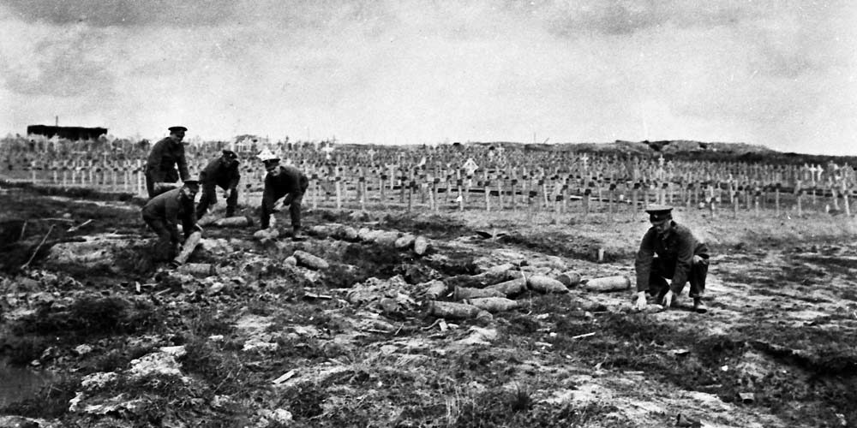
Figure 1: Soldiers clear unexploded mines away from the site of the Imperial War Graves Commission Hooge Crater Cemetery in the battlefields of the Ypres Salient on the Western Front. https://www.cwgc.org/our-work/blog/what-was-the-imperial-war-graves-commission-doing-in-1918/

The research methodology employed a systematic analysis of two primary databases: the CWGC database, documenting approximately 1.7 million casualties across 23,000 sites worldwide, and the International Bomber Command Centre (IBCC) database, which provides detailed information on roughly 55,000 Bomber Command casualties. This dual database approach enabled identification of significant sites based on casualty numbers, nationalities, and historical context, informing both my site selection and photographic strategy.

Sustainability was a very important consideration in both my methodology and execution of the project. I utilised a strategic approach methodology to site visits, integrating cemetery photography into other travel plans to minimize environmental impact. For instance, photography of Newark-on-Trent's significant Polish airmen's graves was coordinated with other local commitments, while visits to my parents’ grave at Northwood Cemetery enabled systematic documentation of its substantial CWGC plot, including graves of Polish airmen from RAF Northolt's fighter squadrons.

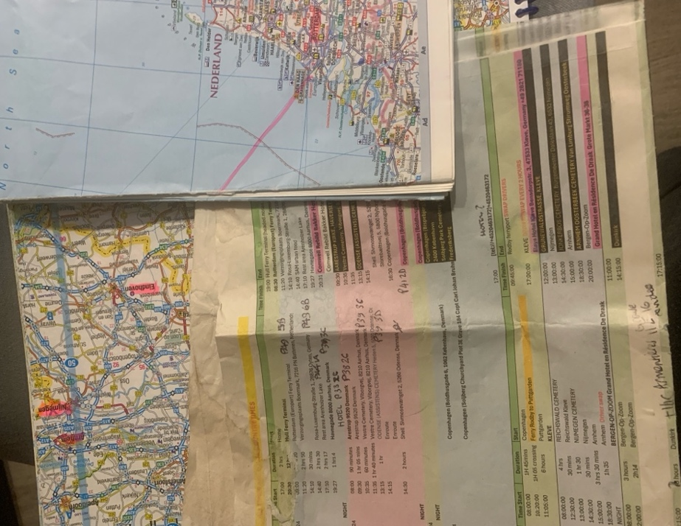
This approach culminated in an extensive European journey. Initiated to celebrate a Copenhagen-based niece’s birthday, the journey was planned using digital and traditional navigation tools, to ensure comprehensive coverage and resilience in case of technology failure or loss of data coverage.

The expedition encompassed nineteen sites across five countries, from Danish cemeteries including Arestrup Kirkegard and Aarhus Vestre, to the Reichswald British War Cemetery in Germany, demonstrating how careful planning could maximize photographic opportunities while
Figure 2: European road journey planning tools, map sheet, road atlas and Excel spreadsheet itinerary. S Parkes 2024

minimising environmental impact.

This structured methodology enabled a comprehensive execution of the project while maintaining sensitivity to both environmental considerations and the cultural solemnity of these commemorative spaces. Through careful integration of research, planning, and sustainable practices, the project developed a robust framework for systematically photographing these significant historical sites.

(See Appendix 26)

Chapter 2: Influences, inclusions and omissions.

The project's visual approach was informed by my research into several key practitioners who have addressed themes of memorial, absence, and commemoration in their work.

Such photographers included the following photographers;
Roger Fenton – Crimean War;
Ernest Brooks - First official British military war photographer, WW1;
Olive Edis – First official female Imperial War Museum Photographer;
Sir Don McCullin – British war photographer 1960s to date;
Paul Haley - Senior Photographer Soldier Magazine (Falklands War 1982).
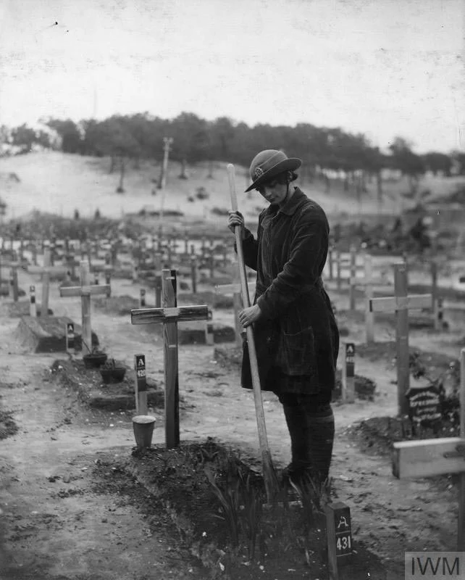

Figure 3: Olive Edis, 1919. The grave of Betty Stevenson is tended to by a member of the Women's Army Auxiliary Corps (WAAC) in a graveyard at Étaples, France. © Imperial War Museum Q8028
https://www.iwm.org.uk/collections/item/object/205214324

Due to the parameters of the project, whilst acknowledging their work, I have concentrated on the following photographers’ work:

Raymond Depardon.
Raymond Depardon's contribution to the 'War Memorials' exhibition at Église des Frères Prêcheurs (Recontres d'Arles) proved particularly influential in its treatment of memorials within urban contexts. Depardon's methodology of situating memorials within their community settings informed this project's approach to contextual documentation, where appropriate. His manipulation of light to produce slightly darker, more contemplative images reinforced the solemnity of these memorials, a technique that influenced this project's visual strategy, for example my photograph of the Czech Memorial at Brookwood Cemetery.

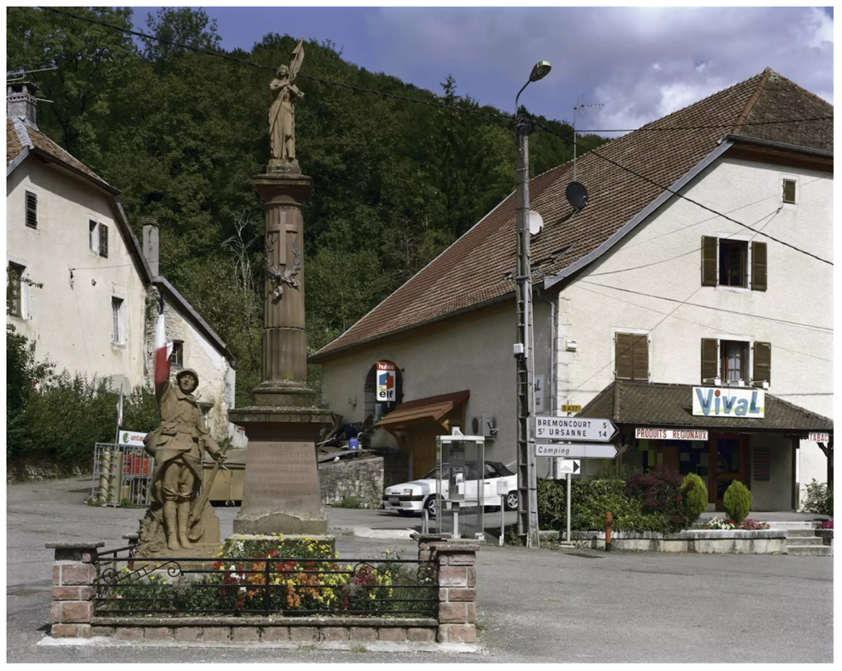

Figure 4: Raymond Depardon 2014. ‘Presence of a lost generation’. © Courtesy of Raymond Depardon / Magnum photos. Raymond Depardon, Franche-Comté, Doubs, Glère.
https://www.rencontres-arles.com/en/expositions/view/409/raymond-depardon

Chloe Dewe Matthews
Chloe Dewe Matthews ' 'Shot at Dawn' series provided crucial and intensely moving insights into photographing sites of loss and absence. Her work documenting World War I execution sites demonstrates how temporal specificity can enhance the significance of and the emotional response to the images of the sites. By photographing locations at the precise time and date of historical executions, Matthews creates powerful meditations on absence and loss.

Her documentation of 2nd Lieutenant Eric Skeffington Poole's cell at Poperinge Town Hall perfectly exemplifies how architectural space can convey personal narratives of conflict. This approach influenced this project's methodology, particularly the decision to maintain site authenticity by photographing in natural light and preserving the arrangement of commemorative objects at the graves in situ, resisting the urge to rearrange and straighten objects for aesthetic effect.

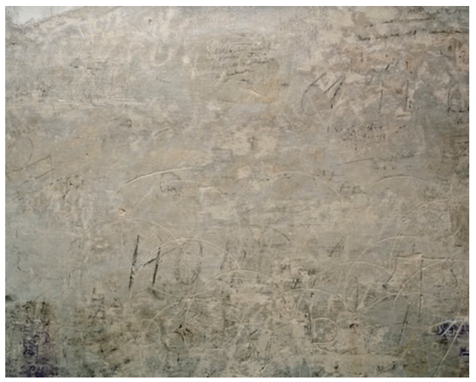
Figure 5: Photograph: Chloe Dewe Mathews. Prison cell, Town Hall, Poperinge, West-Vlaanderen.

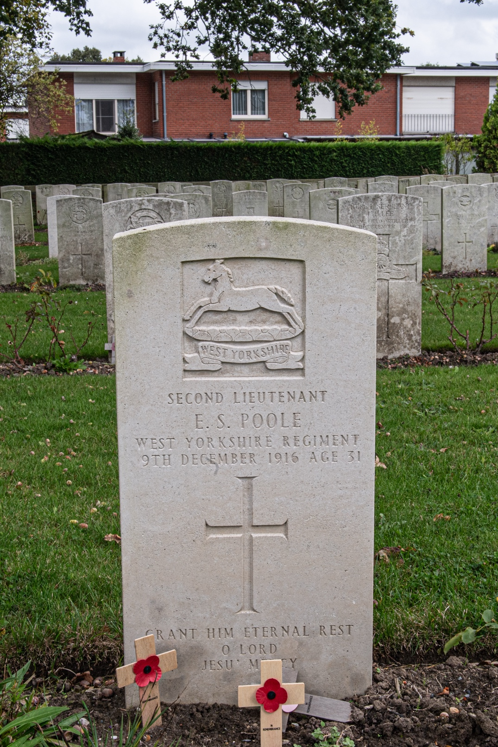

Figure 6: Shaun Parkes 2024. Grave of 2nd Lt Eric Skeffington Poole, 11th Bn. West Yorkshire Regiment (Prince of Wale’s Own). Poperinghe New Military Cemetery.

Jeremy Deller
Jeremy Deller’s brilliant performative art installation “We’re here because we’re here” utilised an intensely moving and inspirational contemporary framework for displaying a significant historical commemoration. Created for the centenary of the Battle of the Somme on 1st July 2016, Deller's work transformed abstract casualty statistics into immediate, physical human presence through silent performers who distributed biographical cards of fallen soldiers. This installation, and the resultant book and Tate Gallery exhibition, further informed the project's use of colour photography, supporting the aim of presenting these commemorative acts as living spaces of remembrance rather than mere historical artifacts.


Figure 7: Mark Carline 2016. East Gate Street Chester. (Deller, 2016, p.31.)

Paul Seawright
Contemporary Irish photographer Paul Seawright was commissioned by the Imperial War Museum to record the war in Afghanistan in 2002. Seawright replicated a famous photograph taken by Roger Fenton in 1855 during the Crimean War, showing a line of cannonballs littering a valley. In Seawright’s recreation he modernises the image by using contemporary artillery shells and land mines. The image is powerful in communicating and commemorating the loss of life caused by powerful modern artillery, not just in the conventional use of such munitions, but also as widely used in Afghanistan to create powerful Improvised Explosive Devices which killed many servicemen and women.

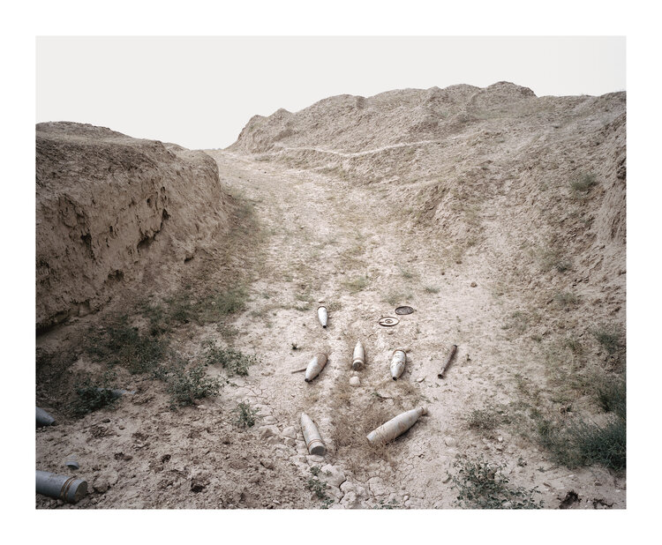
Figure 8: Paul Seawright 2002. Colour plate from ‘Hidden’, 2003. https://www.paulseawright.com/hidden

Steve McQueen
McQueen memorialised British military casualties who died on active service in Iraq in his project ‘Queen and Country’. Taking the form of 160 portrait images encapsulated in a large oak cabinet, like a tomb or sarcophagus, displayed like a stamp collection, McQueen wanted to pay tribute to the close, familial-like bonds between the service personnel.

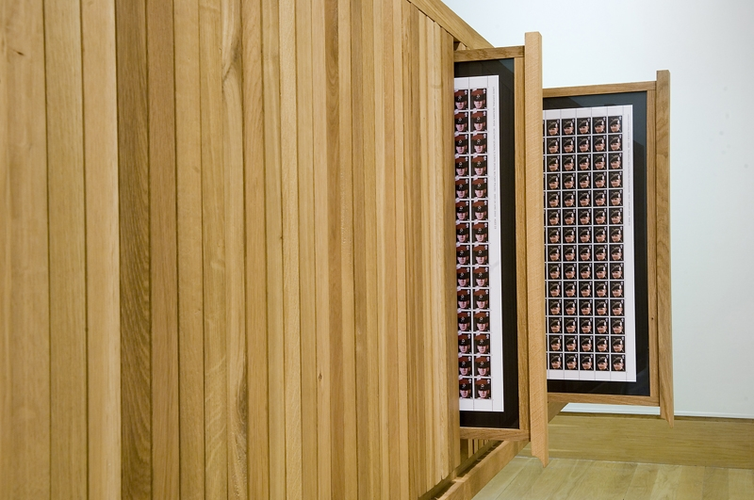
Figure 9: Steve McQueen.'Queen and Country', Cabinet with 160 portrait images of British military personnel who died on active service in Iraq. © IWM Art.IWM ART (17290) https://www.iwm.org.uk/history/8-powerful-works-from-our-contemporary-art-collection

Displaying the mixed media art installation like a stamp collection was deliberate as he intended the images to be issued by the Post Office as postage stamps, cementing their place in the public’s collective memory as modern and ongoing memorialisation, however the Post Office declined to use the images fearing that the casualties’ families may feel the work was disrespectful.

These influences directed and shaped the project's methodological approach: maintaining site authenticity, employing natural light, and preserving the spontaneous arrangement of commemorative objects. This framework enabled a project that respects both the historical significance and contemporary relevance of these memorial spaces, maintaining a more conventional and less performative art medium for commemoration.

These influences also helped shape the content of the final project, as I included images which complimented the styles of the artists that inspired me.

Methodological Approach and Selection Criteria
I adopted a multi-layered documentation strategy for the project, encompassing individual graves, group memorials, and wider-angle views of cemeteries to capture both personal and collective commemorations. This approach enabled examination of memorial spaces across varying aspects of remembrance.

Site selection followed specific criteria to maintain focus on Commonwealth War Graves Commission (CWGC) sites. While initially considering the American Military Cemetery at Cambridge, this was ultimately excluded to maintain thematic coherence. However, the study incorporated CWGC-managed sites representing other nations, for example including Free French and Muslim graves at Brookwood, ANZAC graves at Harefield, and the German 'Soldatenfriedhof' at Cannock Chase, providing a broader context for comparative analysis.

From approximately 3,500 images captured during the fieldwork phase, the final selection employed purposeful sampling to represent diverse memorial types. Selection criteria prioritised variety in headstone design, nationality, historical context, and geographical location. Particular attention was paid to documenting memorials to missing airmen and the graves of unidentified casualties; whose headstones are engraved "Known unto God"; acknowledging the scale of unresolved loss - over 570,000 still missing from World War I and over 20,000 airmen from Western Europe alone in World War II. As Campany notes, each photograph's significance is determined by "the place it is afforded in the always fraught project of remembrance." (Campany, 2007:186)

Technical considerations significantly influenced the methodology. Digital photography was chosen over analogue for environmental and practical reasons, reducing chemical waste while enabling greater image capture, consistent visual presentation, and speedier and cheaper processing. The decision to utilise colour rather than monochrome photography emerged from careful consideration of how best to represent the CWGC's integrated approach to architecture and horticulture, where "equal thought and design was given to horticultural elements as to the 'built' elements" (CWGC, 2024).

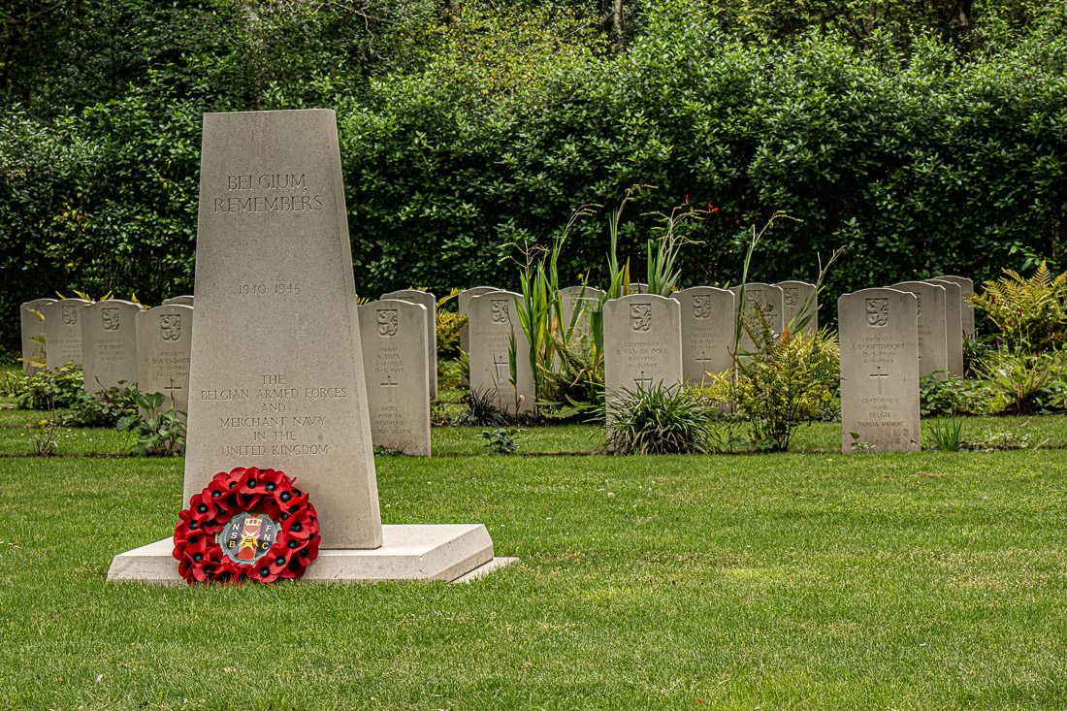
Figure 10: S Parkes 2024: Belgian national plot within the Brookwood Military Cemeteries complex.

As shown above, many of the plots and sections within Brookwood Military Cemeteries have strong natural backgrounds, emphasising the concept of life springing forth from the death and destruction of warfare. The CWGC has always considered horticulture to be a vitally important aspect of its cemeteries and memorials, as confirmed on its current website:

from the outset, the IWGC concept was more of garden cemeteries where equal thought and design was given to horticultural elements as to the ‘built’ elements.

https://www.cwgc.org/our-work/caring-for-our-sites/horticulture/

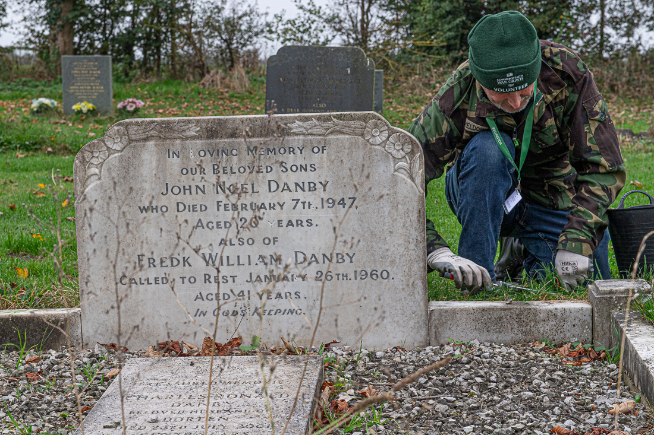
Figure 11: CWGC ‘Eyes On, Hands On’ Volunteer and Tornado F3 fighter pilot Squadron Leader Mark “Spike” Sheldon RAF (retired) tending the CWGC-maintained grave of Aircraftsman 2nd Class John Noel Danby at St Peter’s Church, Wildmore, Lincolnshire.
.

The documentary approach emphasized authenticity, usually photographing memorials at eye level without aesthetic manipulation or cleaning. This methodological choice aimed to capture these spaces' living history rather than present idealized representations. While logistical constraints necessitated photographing multiple sites daily, timing was optimized within these parameters based on weather conditions and light quality.

This systematic approach enabled comprehensive documentation while maintaining methodological consistency across diverse sites. The resulting archive provides a representative survey of CWGC memorial spaces, balancing historical significance with contemporary condition.

Chapter 3. – Public Outcomes and Dissemination

Publications.

Commonwealth War Graves Foundation Journal - Winter 2024
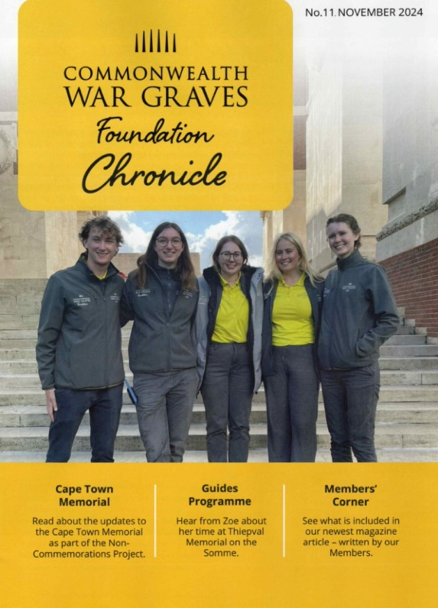
Figure 12: Cover page of Commonwealth War Graves Foundation Chronicle Winter 2024

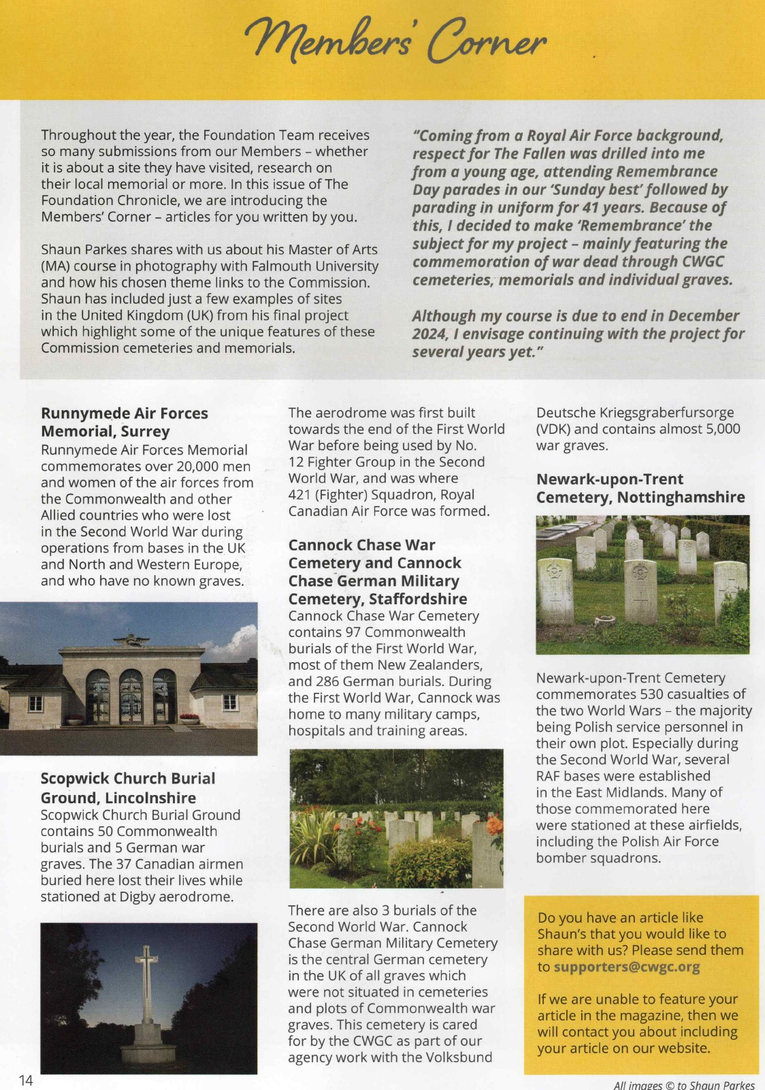
Figure 13: Inaugural Members’ Corner page, Commonwealth War Graves Foundation Chronicle Winter 2024

Focus on the NorthEast Magazine

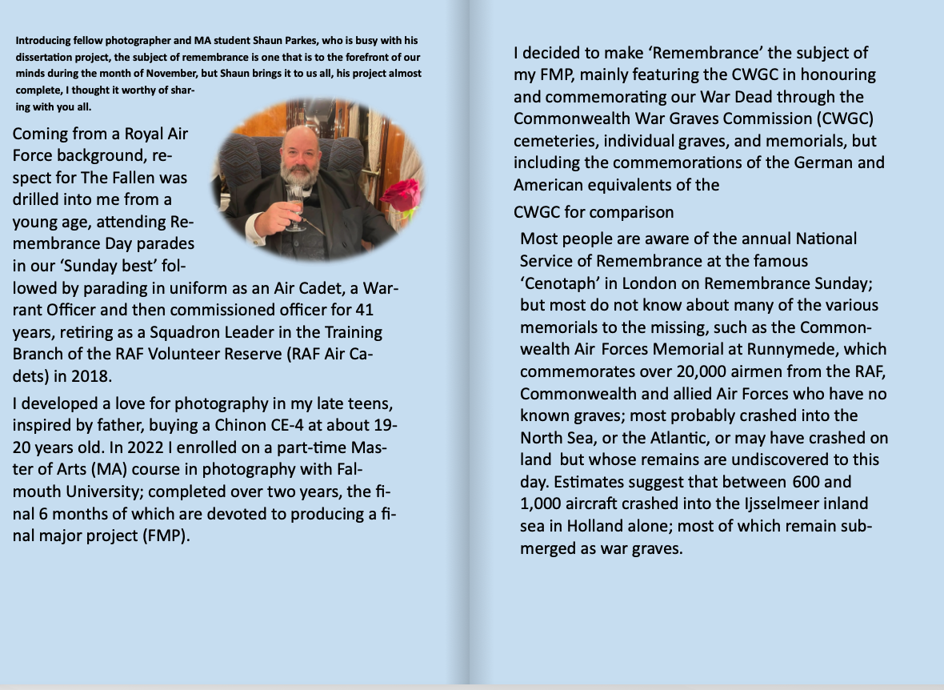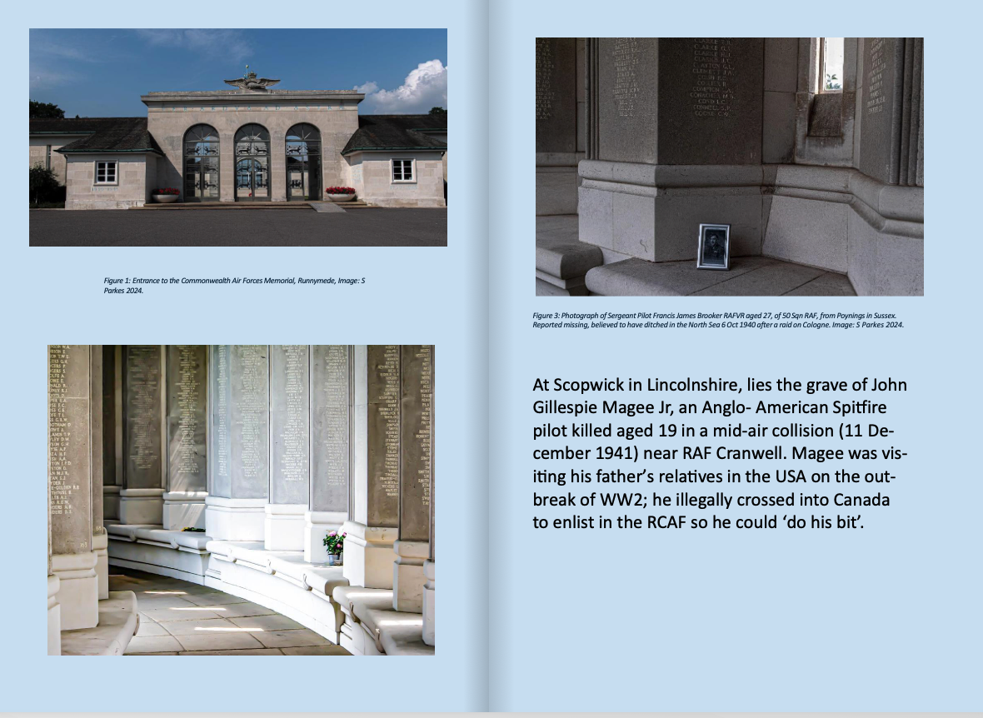
Figures 14 and 15. My article in the magazine ‘Focus on the NorthEast’.
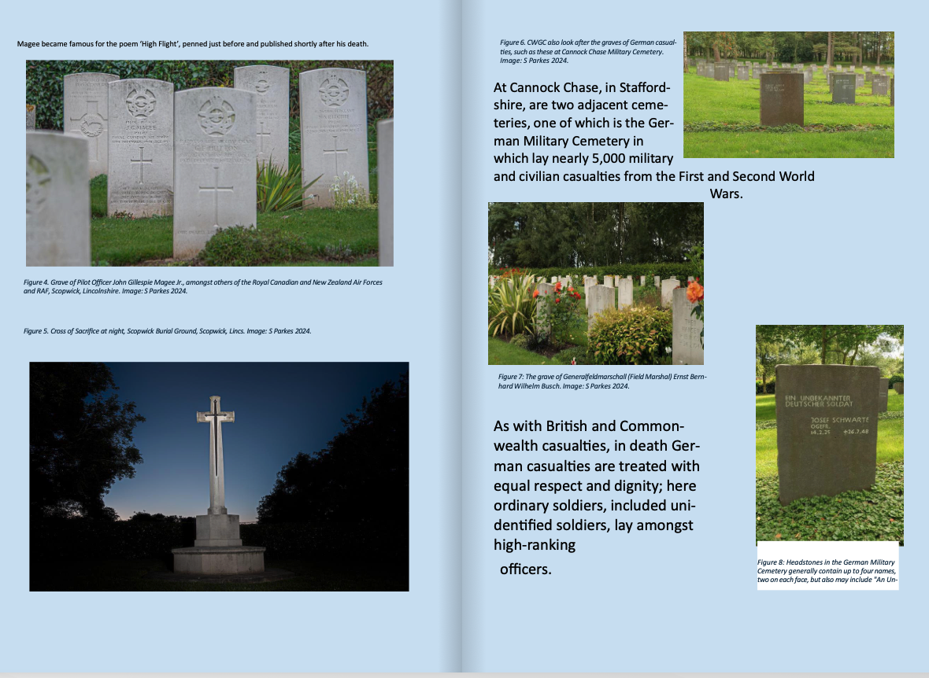
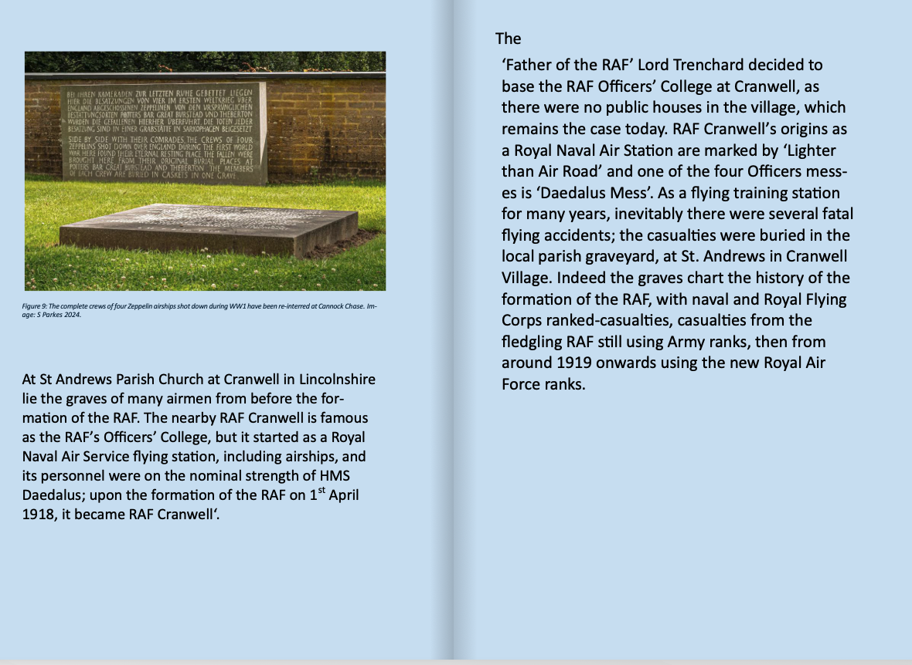
Figures 16 and 17. My article in the magazine ‘Focus on the NorthEast’ continued.

Figures 18 and 19. My article in the magazine ‘Focus on the NorthEast’ continued.

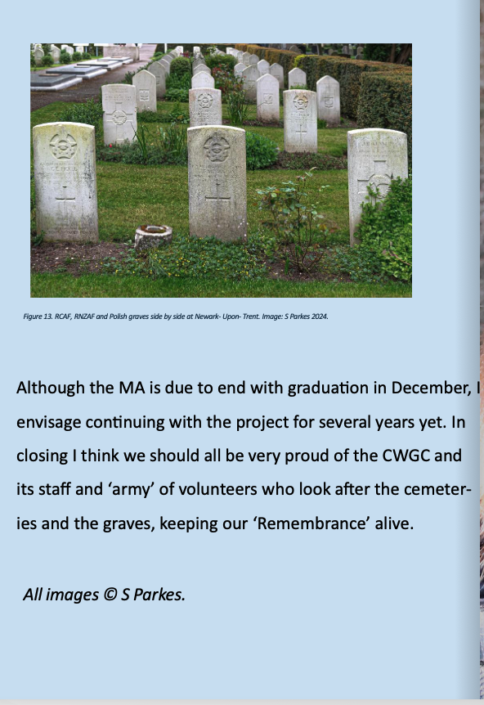
Figure 20. My article in the magazine ‘Focus on the NorthEast’ continued.

This can be accessed at: https://heyzine.com/flip-book/0362f7d74d.html#page/22

Website. https://tellthemofus.uk
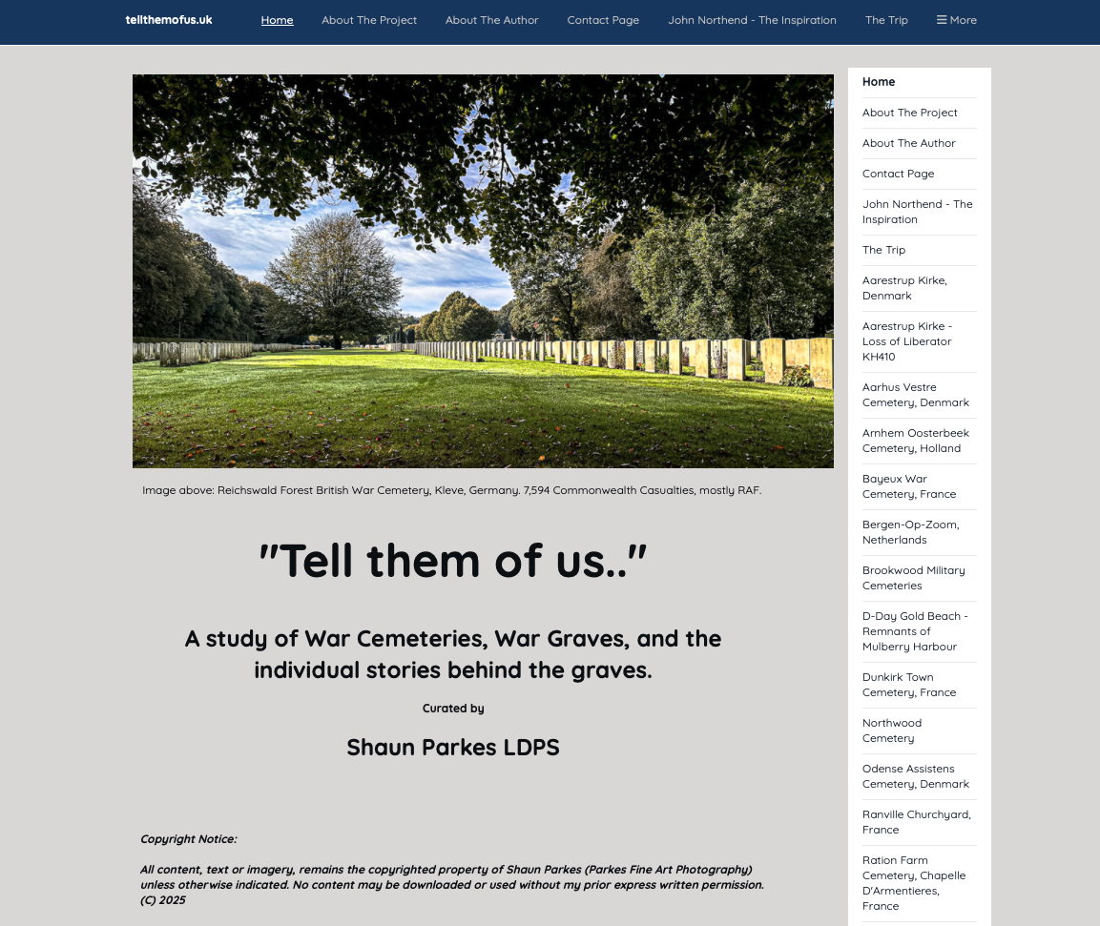
Figure 21: Website www.tellthemofus.uk home page.
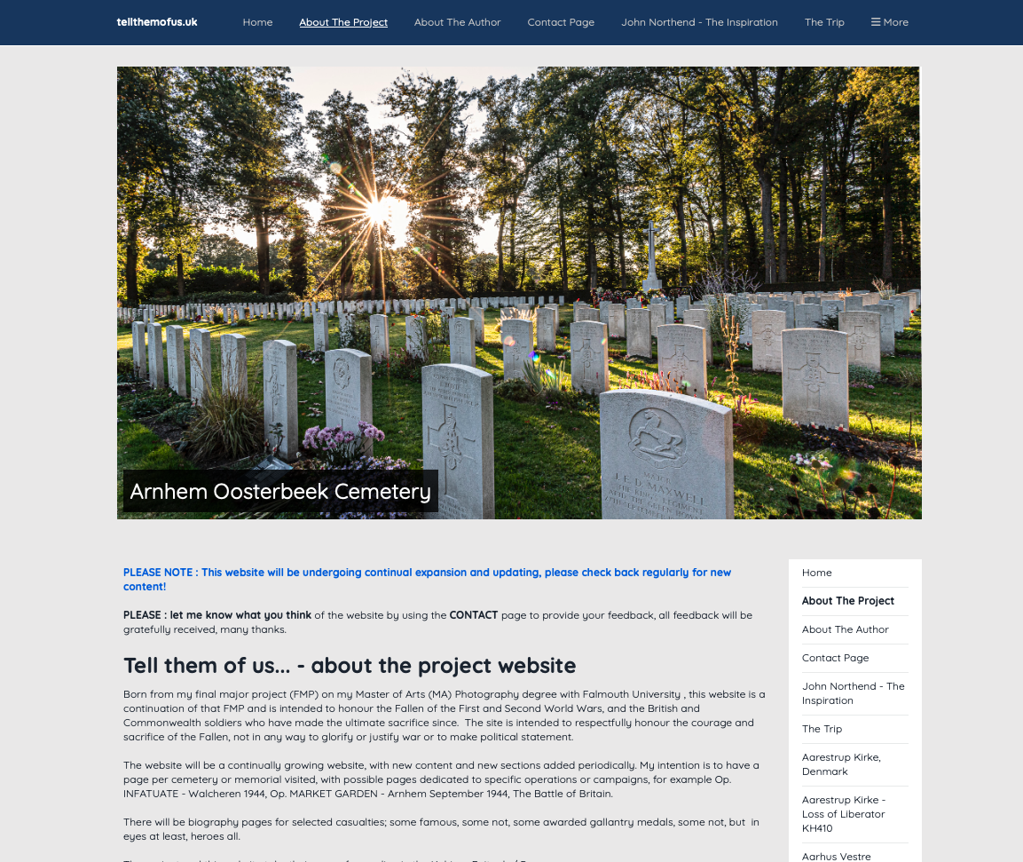
Figure 22: Introductory Page.
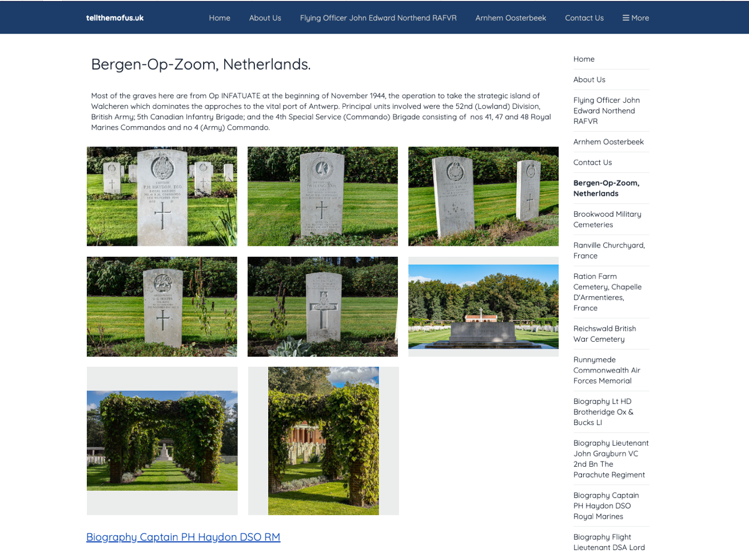
Figure 23: Example of a cemetery / memorial page including link to a casualty biography page

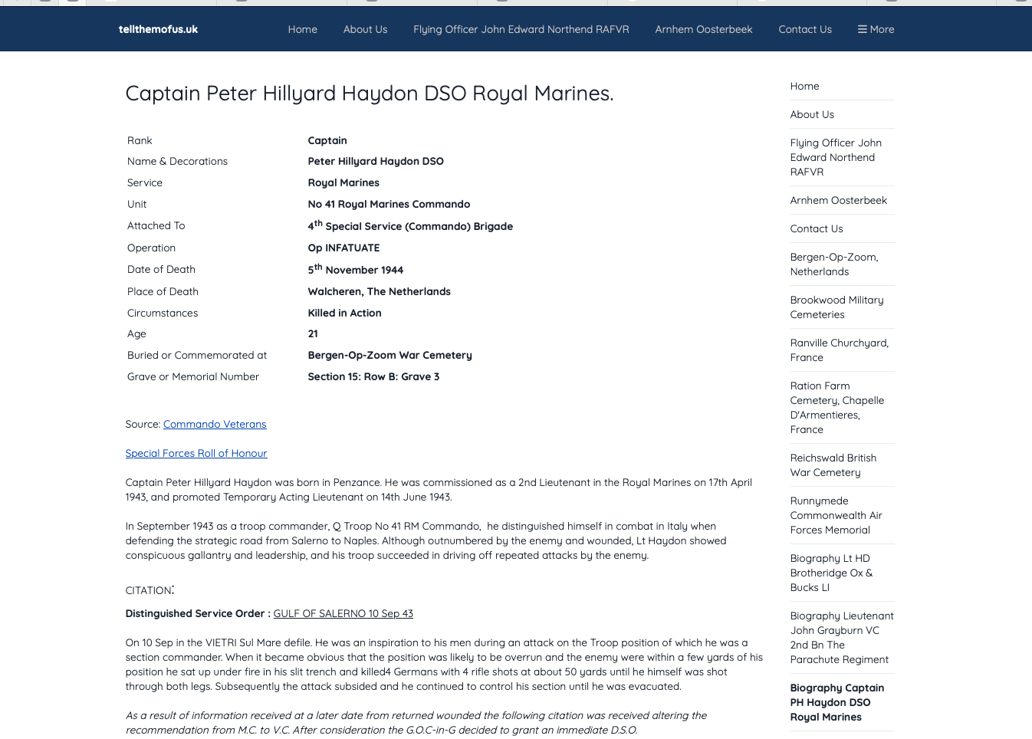 Figure 24: Example of a casualty biography page

Website Articles.
- Illustrated article for the Commonwealth War Graves Commission Foundation website. Published Monday 17 February 2025.

URL : https://foundation.cwgc.org/blog/tell-them-of-us-a-cwgf-member-s-photographic-journey/

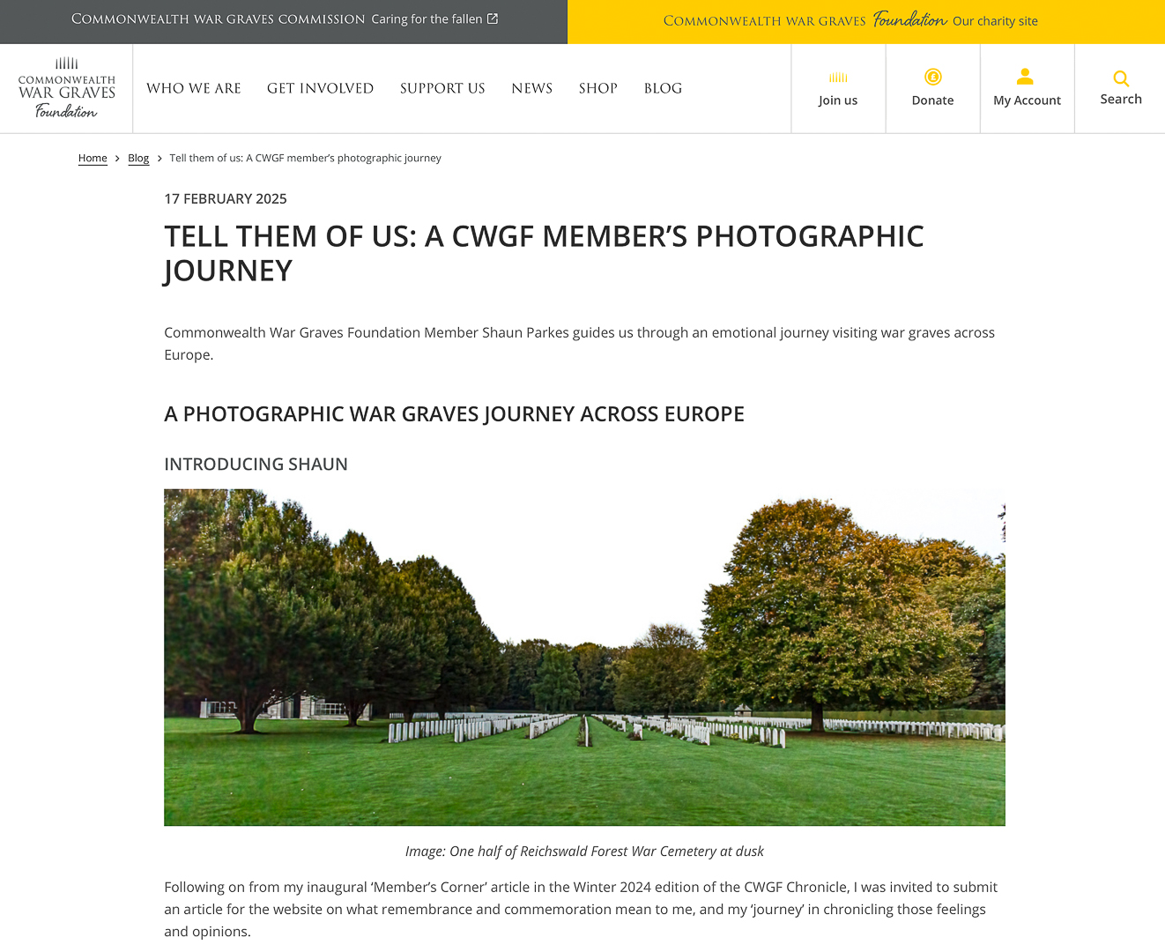

Chapter 4. Conclusion and Future Outcomes.

Conclusions.
The project has utilised an effective balance of personal connection to the subject matter with an objective documentary practice approach, combining memorial photography that balances historical significance with contemporary relevance whilst simultaneously being as environmentally as sustainable as possible. This approach delivers methodological innovation by integrating serious contemporary concerns about sustainability within the planning phase to optimise route-planning, thus avoiding unnecessary fuel consumption and vehicle pollution.

The fusion of contemporary photographic practice with modern and historical research in a multi-layered strategy delivers a more profound final product, showing how architecture and landscape intersect seamlessly in modern memorialisation. The synthesis of ecological, practical, theoretical and technical considerations in this project offers a sound model for future project work, including potentially sourcing photographic material for multiple projects in the same journeys.

It further demonstrates that memorial photography is still very relevant in the modern, contemporary documentation and communication of our military heritage, and as part of our on-going remembrance.

Digital photography is also essential for generating content utilising multiple and multi-media platforms for dissemination, such as public exhibition, illustrated talks, websites and printed matter. This approach will successfully engage diverse audiences while maintaining academic integrity. These dissemination strategies have the potential for memorial photography to be contemporaneously relevant in both academic and public spheres, hopefully contributing to broader discussions about commemoration and collective memory.

In conclusion, the project has delivered enhancements in both practical and theoretical understanding of memorial photography, simultaneously developing a methodologically and sound framework for future research through its innovative approaches to sustainable production of developing and producing material, insights into the intersect between architecture, landscape and photography in memorial contexts, and in utilising successful models for public engagement with sensitive historical subjects and content.

Future public outcomes

Public Engagement.
10th March 2025 20:00 hours
- Illustrated talk at the Royal British Legion Sleaford (postponed from 9th December 2024 due to ill health)

- Exhibition - Cranwell Village Hall – 3 days in May 2025 exact dates to be confirmed. £10 / hour +£6 / hour setup and takedown. Images to be displayed on a mock (safe, plastic) barbed wire installation:

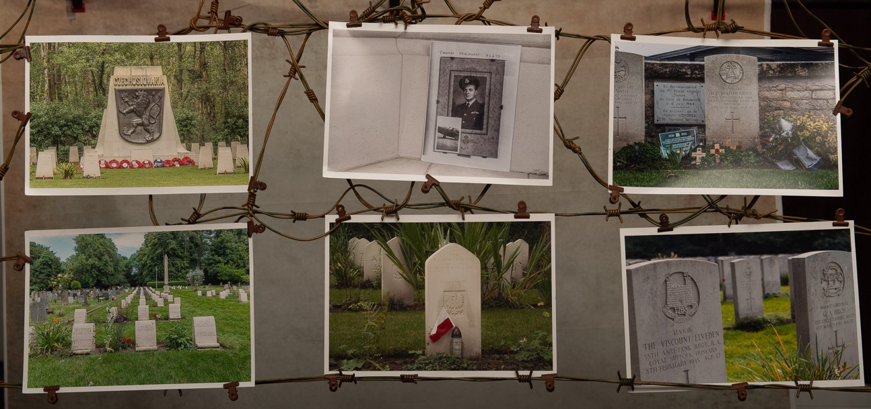

Potential Book(s)
- A Tour of The European Cemeteries of Sir Edwin Lutyens, a principal architect of the Imperial / Commonwealth War Graves Commission.
- Ordinary people, extraordinary stories – the stories behind the headstones.
- An ordinary family at war - the Parkes / Northend / Ricaldone family. (My maternal grandfather was born in July 1914 as the illegitimate son of an Italian Army Officer Luigi Ricaldone, who we have recently (January 2025) managed to identify through DNA analysis,110 years after the birth of my grandfather.)
- Graves of the Dambusters – Graves and stories of the 53 men lost on the Dambusters raid, and of other losses from 617 (Dambusters) Squadron, and their stories.
- The Military graves of Lincolnshire.
- The Battle of Arnhem in Lincolnshire. The British 1st Airborne Division was headquartered and billeted all around Lincolnshire before flying to Holland for Operation Market Garden 17-24 September 1944.

Future Articles in Publications.
- Focus On the Northeast – Spring 2025
- Heritage Photography, Journal of the RPS Archaeology and Heritage Special Interest Group – Spring 2025

List of Figures (CROP)

Figure 1. Soldiers clear unexploded mines away from the site of the Imperial War Graves Commission Hooge Crater Cemetery in the battlefields of the Ypres Salient on the Western Front.
Credit: https://www.cwgc.org/our-work/blog/what-was-the-imperial-war-graves-commission-doing-in-1918/

Figure 2: European road journey planning tools, map sheet, road atlas and Excel spreadsheet itinerary.
Credit: Shaun Parkes 2024

Figure 3: The grave of Betty Stevenson is tended to by a member of the Women's Army Auxiliary Corps (WAAC) in a graveyard at Étaples, France.
Credit: Olive Edis 1919. Copyright: Imperial War Museum Q8028
https://www.iwm.org.uk/collections/item/object/205214324

Figure 4: ‘Presence of a lost generation’.
Credit: Raymond Depardon 2014
Copyright: Courtesy of Raymond Depardon / Magnum photos. Raymond Depardon, Franche-Comté, Doubs, Glère.
https://www.rencontres-arles.com/en/expositions/view/409/raymond-depardon

Figure 5: Prison cell, Town Hall, Poperinge, West-Vlaanderen, used to hold 2nd Lt Eric Skeffington Poole on the eve of his execution.
Credit: Chloe Dewe Matthews.
Shot at Dawn

Figure 6: Grave of 2nd Lt Eric Skeffington Poole, 11th Bn. West Yorkshire Regiment (Prince of Wale’s Own), Poperinghe New Military Cemetery. One of the ‘Shot at Dawn’ Soldiers.
Credit: Shaun Parkes 2024.

Figure 7: East Gate Street Chester. (Deller, 2016, p.31.)
Credit: Mark Carline 2016.

Figure 8: Colour late from ‘Hidden’, 2003.
Credit: Paul Seawright 2002.

Figure 9: 'Queen and Country', art installation cabinet with 160 portrait images of British military personnel who died on active service in Iraq. © IWM Art.IWM ART (17290)
Credit: Steve McQueen.

Figure 10: Belgian National Cemetery Plot, Brookwood Military Cemeteries.
Credit: Shaun Parkes 2024.

Figure 11: CWGC ‘Eyes On, Hands On’ Volunteer Spike Sheldon tending to an isolated grave.
Credit: Shaun Parkes 2024.

Figure 12: Cover page of Commonwealth War Graves Foundation Chronicle Winter 2024.

Figure 13: Inaugural Members’ Corner page, Commonwealth War Graves Foundation Chronicle Winter 2024. My photographs published in the chronicle.

Figures 14,15,16,17,18,19 and 20: My article in the magazine ‘Focus on the NorthEast’.

Figure 21: Website www.tellthemofus.uk.
Figure 22: Website www.tellthemofus.uk Introductory Page.
Figure 23: Website www.tellthemofus.uk Example of a cemetery / memorial page including link to a casualty biography page
Figure 24: Website www.tellthemofus.uk Example of a casualty biography page
Figure 25: Website https://foundation.cwgc.org/blog/tell-them-of-us-a-cwgf-member-s-photographic-journey/ Article published on CWGC website

References
SMITH, Cecil Harcourt. 1919. Inscriptions Suggested for War Memorials. London: HM Stationery Office and the Victoria and Albert Museum.
BINYON, Robert Laurence. 1914. For the Fallen. London: The Times.

Bibliography
Bibliography directly relevant to the project ‘Tell them of us’

Van der BIJL, Nick. 2006. No. 10 (Inter-Allied) Commando 1942-45. Oxford: Osprey Publishing.
BINYON, Robert Laurence. 1914. For the Fallen. London: The Times.
BLAIS, Allison and Lynn RASIC. 2015. A Place of Remembrance; Official book of the National September 11 Memorial. Washington DC: The National Geographic Society.
BOORMAN, Derek. 2005. A Century of Remembrance. Barnsley: Pen and Sword Books.
BORG, Alan. 1991. War Memorials. London: Pen and Sword Books Ltd.
BOWDLER, ROGER. 2019. War Memorials. Stroud: Amberley Publishing.
BURT, Denis. 2006. Arnhem in Lincolnshire and the surrounding area. Boston UK: Lancfile Publishing.
CAMPANY, David, 2007. Safety in numbness: some remarks on problems of ‘late photography’. In: CAMPANY, David. ed. The cinematic: documents in contemporary art. London: Whitechapel Gallery.
COLE, Steve. 2017. Photographing Historic Buildings. Swindon: Historic England.
DEAR, Ian. 1987 & 2010. Ten Commando 1942-1945. London: Heinemann Group.
DELLER, Jeremy, and Rufus NORRIS. 2017. ‘We’re Here Because We’re Here’: A National Memorial to Mark the 100th Anniversary of the First Day of the Battle of the Somme. London: (Published on behalf of 14-18 NOW by) Cultureshock Media.
DYER, Geoff. 1994. The Missing of the Somme. Harmondsworth: Penguin Books.
FOSTER, Charles. 2018. The Complete Dambusters: The 133 Men Who Flew On The Dams Raid. Stroud: The History Press.
GARFIELD, John. 2008. The Fallen. Stroud: Spellbound Publishers.
GODDEN, Tim. 2018. ‘Memory, Landscape and the Architecture of the Imperial War Graves Commission’ in DALY, Selena, SALVANTE, Martina and WILCOX, Vanda 2018 (ed.) Landscapes of the First World War. Cham, Switzerland. Palgrave Macmillan.
GRAVES, Robert (edited by Michael LONGLEY). 2014. Selected Poems. London: Faber and Faber.
GUERST, Joeren. 2010. Cemeteries of the Great War by Edwin Lutyens. Rotterdam: 010 Publishers.
LAMBERT, David. 2015. War Memorial Parks and Gardens. Great Britain: Historic England.
MARCO, Paul de. 2021. Missing, presumed dead. Great Britain: Amazon.
MATTHEWS, Chloe Dewe. 2014. Shot at Dawn. Madrid: Ivorypress.
McINTYRE, Colin. 1990. Monuments of War. London: Robert Hale Limited.
MILLINGTON, Roy. 1989. Northend Fine Print: A History of J. W. Northend Ltd., Printers of Sheffield, 1889-1989.
SANTAYANA, George. 1923. Soliloquies in England. New York: Scribner.
SEAWRIGHT, Paul. 2003. Hidden. UK: Imperial War Museum.
SMITH, Cecil Harcourt. 1919. Inscriptions Suggested for War Memorials. London: HM Stationery Office and the Victoria and Albert Museum.
SONTAG, Susan. 2004. Regarding the pain of others. UK: Penguin.
STAMP, Gavin.2006. The Memorial to the Missing of the Somme. London: Profile Books.
SUMMERS, Julie. 2007. Remembered; The History of the Commonwealth War Graves Commission. London: Merrell Publishers Limited.
SUMMERS, Julie. 2010. British and Commonwealth War Cemeteries. Oxford: Shire Publications Limited.
WILSON, Marc. 2022. Remnants. Bath: two&two press.
WILSON, Marc. 2021. A Wounded Landscape - bearing witness to the Holocaust. Bath: two&two press.
WILSON, Marc. 2014. The Last Stand. Bath: two&two press.

Bibliography relevant to the evolution of my photographic practice through the MA.

ALEXANDER, J.A.P. 2020. Perspectives on Place. Abingdon: Routledge.
BAYLES, David and Ted ORLANDO. 2023. Art & Fear. London: Souvenir Press.
BERGER, Arthur Asa. 1998. Media Analysis Techniques. London: SAGE Publications Ltd.
BERGER, John. 2013. Understanding a Photograph. London: Penguin.
BUNNY, Tessa. 2004. Moor and Dale. Self-published.
BUNNY, Tessa. 2007. Hand to Mouth. Bradford: Impressions Gallery.
BUNNY, Tessa. 2012. Järvenjää/Lakeice. Self-published.
CHAPMAN, Chris. 1977. The right side of the hedge. Newton Abbott: David and Charles.
CHAPMAN, Chris. 2000. Wild Goose and Riddon: The Dartmoor Photographs of Chris Chapman. Devon Books.
COTTON, Charlotte.2004. World of Art: The Photograph As Contemporary Art. New York: Thames and Hudson.
DARCH, Robert. 2022. The Island. LIDO Books.
DURDEN, Mark (ed). 2013. Fifty Key Writers on Photography. Abingdon/ New York: Routledge.
La GRANGE, Ashley. 2005. Basic Critical Theory for Photographers. Burlington MA: Focal Press (Elsevier).
HIDO, Todd. 2014. on Landscapes, Interiors, and the Nude. New York: Aperture Foundation.
HODDINOTT, Ross and Mark BAUER. 2019. 52 Assignments Landscape Photography. Lewes: Ammonite Press.
JESSEN, Joost. 2022. One Photo A Day Keeps The Doctor Away. Antwerp: Luster Publishing.
KILLIP, Chris. 2015. Isle of Man Revisited. Goettingen:Steidl ·
MISRACH, Richard. 2020. on Landscape and Meaning. New York: Aperture Foundation.
MINNS, Justin. 2020. Essex in Photographs. Stroud: Amberley Publishing.
MIZUKOSHI, Takeshi. 2012. Photographers Around the Word Heritage. Japan:Clevis.
NEWTON, Helmut. 2019. SUMO: 20th Anniversary Edition. Cologne: Taschen.
RAVILIOUS, Robin. 2017. James Ravilious, A Life. London: Wilmington Square Books.
READ, Shirley and Mike SIMMONS. 2017. Photographers and Research. New York: Routledge.
ROSE, Sarah F. 2017. No Right To Be Idle: The invention of disability. USA: University of North Carolina Press.
SALGADO, Sebastião. 2021. Amazônia. Cologne: Taschen.
SALGADO, Sebastião. 2021. Exodus. Cologne: Taschen.
SALGADO, Sebastião. 2013. Genesis. Cologne: Taschen.
SONTAG, Susan. 2019. On Photography. UK: Penguin.
SOTH, Alec. 2022. Gathered Leaves Annotated. London: Mack.
SOTH, Alec. 2022. A Pound of Pictures. London: Mack.
SOTH, Alec. 2021. Sleeping by the Mississippi. London: Mack.
STORM, Anna. 2014. Post- Industrial Landscape Scars. New York: Palgrave MacMillan.
WALLE, Jan W. and David J. CONNOR. 2019. Rethinking Disability: A disability studies approach to inclusive practices. Abingdon/ New York: Routledge
WELLS, Liz. 2021. Land Matters Landscape Photography, Culture and Identity. Abingdon: New York
WELLS, Liz (Edited By). 2021. Photography: A Critical Introduction. Abingdon/ New York: Routledge.
WHITEHEAD, Craig. 2023. Find Your Frame: A street photography masterclass. London: Quarto Publishing.

Internet Research

Page 55
https://www.cwgc.org/our-work/blog/who-were-the-architects-of-the-commonwealth-war-graves-commission/. Accessed 14 September 2024.
https://www.cwgc.org/our-work/blog/what-was-the-imperial-war-graves-commission-doing-in-1918/. Accessed 14 September 2024.
Page 58
https://www.iwm.org.uk/collections/item/object/205214324. Accessed 4 October 2024.
https://www.rencontres-arles.com/en/expositions/view/409/raymond-depardon. Accessed 17 August 2024.
Page 60
https://www.chloedewemathews.com/shot-at-dawn/. Accessed 17 August 2024.
Page 62
https://www.tate.org.uk/art/artworks/deller-were-here-because-were-here-p82019. Accessed 19 August 2024.
Page 63
https://www.paulseawright.com/hidden. Accessed 19 August 2024.
Page 64
https://www.iwm.org.uk/history/8-powerful-works-from-our-contemporary-art-collection. Accessed 20 November 2024.
Page 66
https://www.cwgc.org/our-work/caring-for-our-sites/horticulture/. Accessed 21 August 2024.
Page 74
https://www.tellthemofus.uk Accessed 13 February 2025.

Appendices.
Appendix 1. Accessed 14 September 2024.
https://www.rafcommands.com/database/wardead/details.php?qnum=58665
https://losses.internationalbcc.co.uk/loss/102763
Appendix 2. Accessed 14 September 2024.
https://www.bbm.org.uk/airmen/CarterLR.htm
https://aircrewremembered.com/carter-leslie.html
Appendix 3. Accessed 14 September 2024.
https://www.rafcommands.com/database/serials/details.php?uniq=R1440
https://www.cwgc.org/find-records/find-war-dead/casualty-details/1269787/thomas-fairhurst/
https://losses.internationalbcc.co.uk/loss/208822
https://www.natwestgroupremembers.com/our-fallen/our-fallen-ww2/f/thomas-fairhurst.html
Appendix 4. Accessed 14 September 2024.
https://www.cwgc.org/find-records/find-war-dead/casualty-details/1800461/john-frederick-hopkinson/
https://www.wrecksite.eu/wreck.aspx?1200
Appendix 5. Accessed 14 September 2024.
https://losses.internationalbcc.co.uk/loss/218664/
https://www.cwgc.org/find-records/find-war-dead/casualty-details/1079360/william-albert-mcginley/
Appendix 6. Access 14 September 2024.
https://losses.internationalbcc.co.uk/loss/100671/
Appendix 7. Accessed 14 September 2024.
https://www.findagrave.com/memorial/184351415/ralph-reather
https://livesofthefirstworldwar.iwm.org.uk/lifestory/3676116
Accessed 13 February 2025.
https://www.newmp.org.uk/person/r-reather-1920/
Appendix 8. Accessed 15 September 2024.
https://combinedops.com/D-DAY%20BEACH%20LANDING.htm
https://ww2talk.com/index.php?threads/sword-beach.38764/page-3
https://military-history.fandom.com/wiki/Arthur_Cocks_(cricketer)
https://www.findagrave.com/memorial/64872390/arthur-denis_bradford-cocks
Appendix 9. Accessed 14 September 2024.
https://www.cwgc.org/find-records/find-war-dead/casualty-details/2750132/john-henry-ayto/
Appendix 10. Accessed 15 September 2024.
https://vcgca.org/our-people/profile/1807/Kenneth-MUIR

Appendix 11. Accessed 15 September 2024.
https://www.ancestry.co.uk/search/collections/62274/records/111541
https://www.naval-history.net/xDKCas1941-10OCT.htm
Appendix 12. Accessed 15 October 2024.
https://vcgca.org/our-people/profile/1775/James-STOKES
Appendix 13. Accessed 16 October 2024.
http://ecole.nav.traditions.free.fr/177_tanniou.htm
https://compagnonshavrais.jimdofree.com/biographies-de-ffl-du-havre/tanniou-pierre-fnfl-page-1/
https://youtu.be/b-rWgqIFoXc
Appendix 14. Accessed 01 December 2024.
https://www.france-libre.net/bfm-commando-flessingue/
https://web.archive.org/web/20140527212054/http://musee.fusco.lorient.free.fr/biofuscodemontlaur.htm
Appendix 15. Accessed 25 November 2024.
https://www.paradata.org.uk/people/gordon-s-sheill accessed 25/11/2024
https://www.cwgc.org/find-records/find-war-dead/casualty-details/2041860/gordon-spencer-sheill/ accessed 25/11/2024
https://www.ancestry.co.uk/search/collections/1904/records/14477221?tid=&pid=&queryId=7ef474cc-199e-496e-8eb9-43f0eb8a3888&_phsrc=Qwo1&_phstart=successSource accessed 25/11/2024
https://www.pegasusarchive.org/normandy/gordon_spencer_shiell.htm accessed 25/11/2024
Appendix 16. Accessed 25 November 2024.
https://www.pegasusarchive.org/arnhem/Biog3/Hubert_Ellis_Pearson_1.htm
Appendix 17. Accessed 25 November 2024.
https://www.commandoveterans.org/August_Roozeboom_Commando
https://www.paradata.org.uk/people/august-m-bakhuis-roozeboom
https://www.liberationroute.com/en/pois/2163/the-story-of-august-bakhuis-roozeboom
Appendix 18. Accessed 24 November 2024.
https://www.cwgc.org/stories/stories/lieutenant-herbert-denham-brotheridge/

Appendix 19. Accessed 17 October 2024.
https://www.bbc.co.uk/news/stories-45516556
https://eehe.org.uk/25536/frantisek/
Appendix 20. Accessed 17 October 2024.
https://asn.flightsafety.org/wikibase/181702
http://www.luftwaffe.no/Table2.html
Appendix 21. Accessed 25 September 2024.
https://spartacus-educational.com/2WWbusch.htm
Appendix 22. Accessed 14th July 2024.
https://www.cwgc.org/stories/stories/flying-officer-john-edward-northend-119289-royal-air-force-volunteer-reserve-61-sqdn/. (Accessed 22 November 2024.)
https://www.cwgc.org/find-records/find-war-dead/casualty-details/2040753/john-edward-northend/
https://www.findagrave.com/memorial/56037069/john-edward-northend
https://www.rafcommands.com/database/awards/details.php?qnum=119289&qname=NORTHEND
Appendix 23. Accessed 17 July 2024.
https://thameremembers.org.uk/wp-content/uploads/2016/01/Bristow-CF-plaque.pdf
https://www.royalengineersbombdisposal-eod.org.uk/individual/bristow-c-f/
Appendix 24. Accessed 09 July 2024.
https://cairogang.com/soldiers-killed/jacobs/jacobs.html
https://www.cwgc.org/find-records/find-war-dead/casualty-details/2001981/w-r-jacobs/
Appendix 25. Accessed 18 October 2024.
https://www.cwgc.org/find-records/find-war-dead/casualty-details/58733/oliver-frank-pennefather/#&gid=2&pid=2
https://www.aucklandmuseum.com/war-memorial/online-cenotaph/record/C12196
https://www.everyoneremembered.org/profiles/soldier/58733/
https://www.nzwargraves.org.nz/casualties/oliver-frank-pennefather
https://nzef.adfa.edu.au/showPerson?pid=202456

Webinar
https://www.youtube.com/watch?v=wYLEi1XBE9Y
Edwin Lutyens: CWGC Memorials within the Battlefields of the Western Front. The Lutyens Trust: 2nd December 2024.

List of Appendices
- Sergeant Francis John Brooker RAF.
- Flight Sergeant Leslie Raymond Carter RAF.
- Pilot Officer Thomas Fairhurst RAF.
- Aicraftman 2nd Class John Frederick Hopkinson RAF.
- Sergeant William Albert McGinley RAF.
- Sergeant Lloyd James Atkins RAF.
- Private Ralph Reather, Lincolnshire Regiment.
- Lieutenant Colonel Arthur Cocks, Royal Engineers.
- Lance Corporal J H Ayto, 2nd Battalion Sherwood Foresters (Notts & Derby Regiment)
- Major Kenneth Muir VC, The Argyll & Sutherland Highlanders
- Leading Airman D Stewart RN.
- Private James Stokes VC, The King’s Shropshire Light Infantry.
- Corporal Pierre Tanniou, No 10 (Inter-Allied) Commando and No 4 Commando.
- Sergeant Guy de Villardi, comte de Montlaur, No 10 (Inter-Allied) Commando and No 4 Commando
- Captain Gordon Spencer Sheill MC, Royal Army Medical Corps (Airborne)
- Lieutenant HE “Jimmy” Pearson MC, The Reconnaissance Corps,
- Private AMB Roozeboom, No 10 (Inter-Allied) Commando.
- Lieutenant HD Brotheridge, Ox & Bucks Light Infantry (Airborne)
- Flight Sergeant Josef Frantisek RAF.
- Lieutenant Henning Leifseth, Royal Norwegian Air Force.
- General Field Marshal Ernst Busch, German Army.
- Flying Officer John Edward Northend, RAF
- Lance Serjeant CF Bristow GM Royal Engineers
- Corporal William Jacobs, Middlesex Regiment.
- Rifleman Oliver Frank Pennefather - New Zealand Army
- Map of principal Cemeteries and Memorials visited
27. Index to Map

Appendix 1: 742131 Sergeant Francis John BROOKER RAFVR

Rank | Sergeant (Pilot)
Name | Francis John BROOKER
Service | Royal Air Force Volunteer Reserve
Unit | 50 Squadron RAF
Attached To | RAF Lindholme
Operation | Night bombing raid on Koln (Cologne)
Date of Death | 5th October 1940
Place of Death | Unknown
Circumstances | Forced landed at sea? Body never recovered
Decorations | None
Age | 27
Buried / Commemorated at | Runnymede Commonwealth Air Forces Memorial
Grave or Memorial Number | Panel 12

Date of Death 05-10-1940
Age: 27 years.
Served in 50 Sqdn
Burial/Commemoration Details: Panel 12. at Runnymede Memorial
More Details: Son of Henry Francis and Dorothy Dyson Brooker, of Poynings, Sussex.

Aircraft Name: Hampden Mk I P4417 | Date of Crash:  5/6 Oct 1940 | Unit  Pilot | Airfield /Crash Location United Kingdom

Details | Took off from RAF Lindholme. Night raid on Koln (26% moon) Lost without trace.

Citation: AIR81
Casualty File Description: LinkAIR81/3636

FULL CREW:
Pilot
742131 Sergeant F J Brooker RAF VR aged 27. Son of Henry Francis Brooker, a farm worker, and Dorothy Dyson Brooker, of Park Cottages, Poynings, Sussex.

Observer (Navigator)
43020 Pilot Officer Andrew Stenhouse Boak aged 28 RAF. Son of William and Helen Ross Stenhouse Boak.

Wireless Operator (Wop)
Sergeant J D Marshall aged 29, RAuxAF. Son of Thomas and Margaretta Marshall. Husband of Marion Christina Marshall, of Malvern, Worcestershire.

Air Gunner
Sergeant Charles Harold Wise RAF IGSM. aged 32: Son of William G. and Eliza Jane Wise. Husband of Rose Marion Wise, of Doncaster, Yorkshire. Possibly Jewish born Charles Harold WEISE in Peterborough (then part of Northants) family name change 1930s, father was travelling salesman.

Sources: https://www.rafcommands.com/database/wardead/details.php?qnum=58665
https://losses.internationalbcc.co.uk/loss/102763

Appendix 2: Flight Sergeant Leslie Raymond CARTER RAFVR

Rank | Flight Sergeant (Pilot)
Name | Leslie Raymond Carter
Service | Royal Air Force Volunteer Reserve
Unit | 74 Squadron RAF
Attached To | RAF Manston (Kent)
Operation | Circus 35 (Escorting bombers, to Lille)
Date of Death | 6th July 1941
Place of Death | Believed to be over the English Channel
Circumstances | Shot down by Messerschmidt 109 fighters
Decorations | Nil
Age | 21
Buried / Commemorated at | Runnymede Commonwealth Air Forces Memorial
Grave or Memorial Number | Panel 35
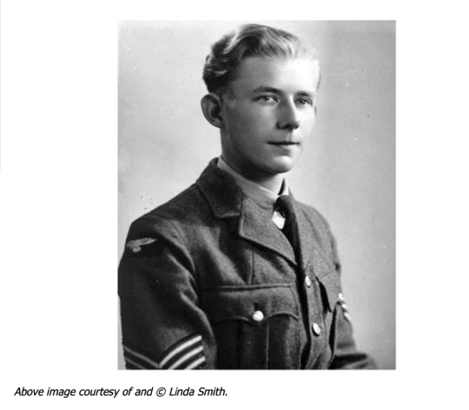
Leslie Raymond Carter of Shenley, Hertfordshire was born in St. Albans on 15th April 1920, the son of Albert William Carter (1893-1965) and Jeanetta Caroline Carter (nee Abbott-Toms 1895-1993).

He attended school there. On leaving he trained as an aeronautical engineer and also joined the RAFVR on 28th June 1939 as an Airman under training (u/t) Pilot.
Called up on 1st September 1939, he was sent to No.1 ITW Cambridge on 2nd October, going on to flying training at 30 Elementary Flying Training School (EFTS) Burnaston until 9th April 1940 then 14 Service Flying Training School (SFTS) Kinloss and Cranfield. Carter was awarded his wings on 28th June 1940. He then went to 7 OTU Hawarden on 10th August 1940 to convert to Spitfires.

He was posted to 74 Squadron at Kirton-in-Lindsey on the 26th but three days later he joined 66 Squadron at Coltishall. When the squadron moved to Kenley that day, Carter remained behind for further training.

He rejoined 66 at Kenley on 7th September. However again the stay was short and Carter was posted to 610 Squadron at Acklington on the 10th. He moved on again on 1st October 1940, joining 41 Squadron at Hornchurch.
On the 11th Carter, whilst climbing to engage Me109s, collided with F/O DH O'Neill in X4042. Both pilots baled out but O'Neill's parachute failed to open and he was killed. Carter's Spitfire, X4554, crashed and burned out at South Ash Manor, West Kingsdown. Carter sustained frostbite to his fingers and was assigned to ground duties till they healed.

He was able to make a first flight on 16th December.
On 9th May 1941 Carter was posted to 74 Squadron at Manston. He was reported 'Missing' on 6th July 1941 when his Spitfire Vb W3176 was shot down by Me109s on Circus 35 to Lille.

He was 21 and is commemorated on the Runnymede Memorial, panel 35.

Sources.
https://www.bbm.org.uk/airmen/CarterLR.htm
https://aircrewremembered.com/carter-leslie.html

Appendix 3: 85673 Pilot Officer Thomas FAIRHURST RAFVR

Rank | Pilot Officer
Name | Thomas FAIRHURST
Service | Royal Air Force Volunteer Reserve
Unit | 99 Sqn RAF
Attached To
Operation | RAF Waterbeach
Date of Death | 9th April 1941
Place of Death | Isseljmeer, Holland
Circumstances | Shot down by Oberfeldwebel Paul Gildner in BF110 nightfigther, crashed into Ijsselmeer
Decorations | Nil
Age | 21
Buried / Commemorated at | Runnymede Commonwealth Air Forces Memorial
Grave or Memorial Number | Panel 32

Source: https://www.rafcommands.com/database/serials/details.php?uniq=R1440

Pilot Officer Thomas FAIRHURST (85673) pilot of Wellington IIc R1440
Date of Death 1941-04-09 Age : 21 years.
Served in 99 Sqdn RAF
Burial/Commemoration Details : Panel 32. at Runnymede Memorial, United Kingdom
More Details: son of James and Alice Fairhurst, of Bispham, Lancashire.

Incidents/Accidents
Date | Aircraft |  | Pilot Name | Location
09 Apr 41 | Wellington IC R1440 | 99 Sqdn | PO Thomas Fairhurst | Ijsselmeer
Remarks | Took off 2020 9 April 1941 from Waterbeach. Sent “NGZ” signal on W/T at 2336 after which the bomber crashed into the IJsselmeer.

Date: | Thursday 10 April 1941
Time: | 01:07 LT
Type: | 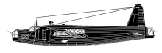  Vickers Wellington Mk IC
Owner/operator: | 99 Sqn RAF
Registration: | R1440
MSN: | LN-?
Fatalities: | Fatalities: 6 / Occupants: 6
Other fatalities: | 0
Aircraft damage: | Destroyed
Location: | IJsselmeer W of Hindeloopen, Friesland - Netherlands
Phase: | Combat
Nature: | Military
Departure airport: | RAF Waterbeach, Cambridgeshire
Destination airport:
Narrative:
Took off from RAF Waterbeach at 20:20 LT for an operation to Bremen-Vegesack. Sent NGZ signal on w/t at 23:36 hrs, after which the bomber crashed in the IJsselmeer. The aircraft was shot down by night fighter pilot Oberfeldwebel Paul Gildner of the 4./NJG 1, who was flying Bf 110 G9+HM from Leeuwarden airfield.
Sgt Brown is buried at the Harderwijk General Cemetery; his companions have no known graves and are commemorated on the Runnymede Memorial:
Crew:-
Pilot : Pilot Officer Thomas Fairhurst RAFVR 85673 (NCO:745865 : Commission Gazetted Tuesday 22 October, 1940) [Killed]
Wireless Operator / Air Gunner : Sergeant Gordon Wilfred Brown RAF 634099 [Killed]
Sergeant Charles William Hall RAFVR 944123 [Killed]
Sergeant William Robert Moore RAFVR 974190 [Killed]
Sergeant Wilbur Lloyd Waldron RCAF R/64120 [Killed]
Sergeant Howard Vivian Wansbrough RAFVR 988001 [Killed]

CWGC Information

Source https://www.cwgc.org/find-records/find-war-dead/casualty-details/1269787/thomas-fairhurst/

Pilot Officer THOMAS FAIRHURST
Service Number: 85673
Regiment & Unit/Ship
Royal Air Force Volunteer Reserve, 99 Sqdn.
Date of Death
Died 09 April 1941 (missing presumed killed, reported crashed into the Ijsselmeer)
Age 21 years old
Buried or commemorated at
RUNNYMEDE MEMORIAL
Panel 32.United Kingdom

Source: International Bomber Command Centre (Canwick, Lincoln) https://losses.internationalbcc.co.uk/loss/208822
Rank P/O
Forename(s) Thomas
Surname Fairhurst
Gender M
Age 21
Date of Death 09-04-1941
Next of Kin Son of James and Alice Fairhurst, of Bispham, Lancashire.

Aircraft Information
Aircraft Vickers Wellington Mk Ic
Serial No R1440
Markings LN- ?

Memorial Information
Burial / Memorial Place United Kingdom
Burial / Memorial Place Runnymede Memorial
Grave Reference Panel 32
IBCC Memorial Information
Phase 2
Panel Number 162
Enlistment Information
Service No 85673
Service RAFVR
Group No 3 Grp
Squadron 99 (Madras Presidency)
Squadron Motto Quisque Tenaz (Each tenacious)
Trade Pilot
Country of Origin United Kingdom

Casualty Pack Number (Public Records office, Kew)
AIR 81/13326 (P358239/41)

Last Operation Information
Start Date 09 April 1941
End Date 10 April 1941
Take off Station Waterbeach
Day / Night Raid Night (95% moon)
Operation Vegesack
Reason For Loss Crashed into the Ijsselmeer

Civilian Employment

https://www.natwestgroupremembers.com/our-fallen/our-fallen-ww2/f/thomas-fairhurst.html

Name: Thomas Fairhurst
Bank: District Bank
Place of work: Preston branch
Died: 9 April 1941

Thomas Fairhurst was born on 25 March 1920, the son of James and Alice Fairhurst. He joined the staff of District Bank as a junior at its Preston branch in August 1937.

In September 1939 Fairhurst left the bank to go on military service, joining the Royal Air Force Volunteer Reserve. On 9 April 1941 Pilot Officer Fairhurst was reported missing when his Wellington bomber failed to return from an operational flight over Germany. It was later discovered that the aircraft had crashed into the Ijsselmeer, a lake in the north of the Netherlands, and it was presumed that he had been killed on that day, two weeks after his 21st birthday.

Pilot Officer Thomas Fairhurst came from Bispham in Lancashire. The 21 year old son of James and Alice Fairhurst, prior to the war he was a junior in the Preston Branch of the District Bank; later part of the Nat West banking group; which he joined in August 1937.

He was commissioned into the RAF Volunteer Reserve in September 1939. He was the pilot of a Vickers Wellington Mk Ic bomber serial number R1440 of No. 99 (Madras Presidency) Squadron RAF, which left RAF Waterbeach on the night of 9/10 April 1941. It was not an ideal night for bomber operations with a 95% moon, meaning that German night fighters would have an easier job of finding the bombers in the night sky.

The aircraft never returned from the operation and the crew were posted as “missing”.

It was later discovered that the aircraft had crashed in the Ijsselmeer, a large lake in the north of the Netherlands, and it was presumed and recorded that Thomas and his crew had died in the early hours of 10th April 1941, just two weeks after his 21st birthday.

Appendix 4: 617338 Aircraftman 2nd Class John Frederick HOPKINSON RAFVR

Rank | Aircraftman 2nd Class
Name | John Frederick Hopkinson
Service | Royal Air Force Volunteer Reserve
Unit
Attached To
Operation | Operation AERIAL (Continuation of the Evacuation of the British Expeditionary Force from France, 1940.)
Date of Death | 17 June 1940
Place of Death | Off St. Nazaire, France.
Circumstances | Onboard RMS Lancastria troopship when sunk by Luftwaffe bomber aircraft.
Decorations | Nil
Age | 20
Buried / Commemorated at | Runnymede Commonwealth Air Forces Memorial
Grave or Memorial Number | Panel 27

Source: Commonwealth War Graves Commission
https://www.cwgc.org/find-records/find-war-dead/casualty-details/1800461/john-frederick-hopkinson/

AIRCRAFTMAN 2ND CLASSJOHN FREDERICK HOPKINSON
Service Number: 617338
Regiment & Unit/Ship Royal Air Force
Date of Death Died 17 June 1940
Age 20 years old
Buried or commemorated at
RUNNYMEDE MEMORIAL
Panel 27.
United Kingdom

Additional Info: Son of Rowland and Ophelia Hopkinson, of Brighouse, Yorkshire.

Operation Aerial took place in June 1940, two days after Operation Dynamo, the evacuation of British Expeditionary Force personnel from France from the beaches of Dunkirk.

Source https://www.wrecksite.eu/wreck.aspx?1200
The Cunard / White Star passenger liner Lancastria, the former Tyrrhenia (16.243 tons) is bombed and sunk off St. Nazaire, France. While lying at anchor in the Charpentier Roads, five enemy KG.30 Dornier Do17 planes dive bombed the ship which sank in twenty minutes taking the lives of nearly 3,000 troops and over 1,000 civilians. The Lancastria had been converted into a troopship and set sail from Liverpool on June 14th. to assist in the evacuation of British troops and refugees from France (Operation Aerial). Her captain, Rudolphe Sharp, took on board as many troops and refugees as possible. She was about to sail to England after loading on board soldiers and RAF personnel of the British Expeditionary Force, plus about a thousand of civilian refugees. One bomb exploded in the Number 2 hold where around 800 RAF personnel had been placed. About 1.400 tons of fuel oil spilled from the stricken vessel as the Dornier´s dropped incendiaries in an attempt to set the oil on fire. The 2,477 survivors, including her captain, were picked up by HMS Havelock and other ships. The bomb which actually sank the Lancastria went straight down the funnel. The loss of the Lancastria was the fourth largest maritime disaster of the war. Captain Rudolphe Sharp later lost his life when the ship he commanded, the Laconia, was sunk. Under the Official Secrets Act, the report on the Lancastria cannot be published until the year 2040. If it is proved that Captain Sharp ignored the Ministry of Defence instructions not to exceed the maximum loading capacity of 3000 persons, grounds for compensation claims could be enormous.

The final minutes of RMS Lancastria.

As the RMS Lancastria lay at anchor to board troops and allied civilians, a flight of Luftwaffe bombers, conflcting accounts state wither Dornier Do17s or Junkers Ju88s appeared overhead at 15:45 hours and began bombing the ships. The ships were unprotected as the RAF Hurricanes were elsewhere at the time. Three or four bombs hit the Lancastria and the ship quickly listed to starboard. The bridge crew shouted for everyone to go to the port side to try and counter the list to starboard, initially the Lancastria levelled but quickly keeled over to the port side.

The order was given to take to the lifeboats, but there were far too few boats for the troops embarked. The order "every man for himself" was given.

Some men in life jackets jumped overboard from the starboard side, but the lifejackets caused them to break their necks when they hit the water, and they were killed. Others tried to escape by walking down the hull, but the could see the horrific sight of men trapped inside through.

Those that did get into the water sere then subjected to further attacks by the German bombers, strafing with machine guns and dropping flares to ignite the patches of diesel oil on the surface to try and burn the survivors to death.

Other ships tried to rescue as many as possible. Those who couldn’t swim stayed on the hull of the Lancastria awaiting rescue, singing “Roll out the barrel”. When the ship sank some 15 minutes after the bombing, those who had not been rescued slipped into the water. This included some 800 men of the RAF who had been directed below into one of the capacious holds.

Some 2,477 people were rescued but more than 3,500 men, women and children were killed. John Frederick Hopkinson was one of those who did not survive.

Source:
Sebag-Montefiore, H. (2006). Dunkirk: Fight to the Last Man. London: Penguin. ISBN 978-0-14-102437-0.

Appendix 5: 926591 Sergeant William Albert MCGINLEY RAFVR

Rank | Sergeant (WOp/AG)
Name | William Albert McGinley
Service | Royal Air Force Volunteer Reserve
Unit | 102 (Ceylon) Sqn
Attached To | RAF Topcliffe, No 4 Group RAF
Operation | Night time bombing raid Hanover
Date of Death | 26 July 1941
Place of Death | North Sea 10 km west of De Kooy (Den Helder) air base
Circumstances | Shot down by German nightfighter
Decorations
Age | 20
Buried / Commemorated at | Runnymede Commonwealth Air Forces Memorial
Grave or Memorial Number | Panel 47

From IBCC
https://losses.internationalbcc.co.uk/loss/218664/
Son of Hugh McGinley, and of Mabel McGinley, of Hartley Wintney, Hampshire.

From CWGC
Source https://www.cwgc.org/find-records/find-war-dead/casualty-details/1079360/william-albert-mcginley/

McGinley’s pilot was Squadron Leader Eric Alliott Verdon-Roe, the son of Sir Alliott Verdon-Roe, the founder of the famous aircraft manufacturer A.V. Roe & Co., more commonly known as Avro and famous for the Lancaster bomber and later the Vulcan bomber.

Appendix 6: 1164953 Sergeant Lloyd James ATKINS RAFVR
Rank | Sergeant (Pilot)
Name | Lloyd James Atkins
Service | Royal Air Force Volunteer Reserve
Unit | 150 Sqn RAF
Attached To | RAF Snaith
Operation | Night bombing raid on Mannheim
Date of Death | 08 November 1941
Place of Death | Believed crashed in the sea off the Dutch coast
Circumstances | Nil
Decorations
Age | 20
Buried / Commemorated at | Runnymede Commonwealth Air Forces Memorial
Grave or Memorial Number | Panel 38

From IBCC Losses Database
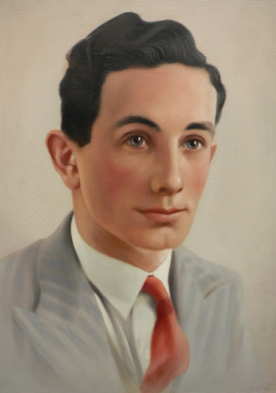
Source: https://losses.internationalbcc.co.uk/loss/100671/

Son of Charles Coles Atkins and Elsie Atkins, of Knowle, Bristol.

AIRCRAFT INFORMATION
Aircraft Vickers Wellington IC
Serial Number R1606
Markings JN-G
Figure 1: Image from IBCC Losses Database

Appendix 7: 29263 Private Ralph REATHER, The Lincolnshire Regiment.

Rank | Private
Name | Ralph Reather
Service | British Army
Unit | The Lincolnshire Regiment
Attached To | The Labour Corps
Operation
Date of Death | 17th January 1920
Place of Death | Durham
Circumstances | Died of Wounds received on Active Service
Decorations | NIL
Age | 40
Buried or Commemorated at | Waterhouses Cemetery, Esh Winning, Durham
Grave or Memorial Number | A.95.

Date of Death : 17 January 1920
Cause of Death : Died from wounds sustained on active service
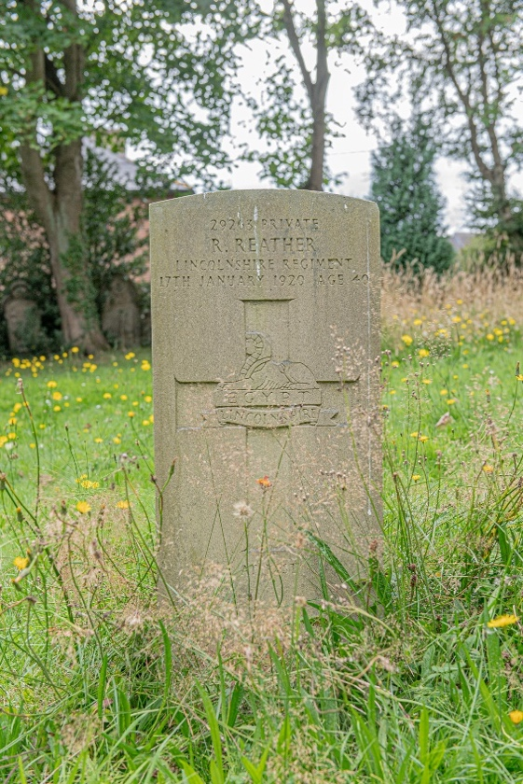
The son of a coal miner, Ralph was a Club Steward and Barman from Esh Winning in Co Durham. He married Elizabeth Eliza Baker in 1905, and they had five children, all of whom survived and lived long lives.

Ralph enlisted in Durham on 18 July 1916. He was sent to France on 20 August 1916, where was wounded c 27 September 1917, sustaining a gunshot wound to the back; he was transferred back to the United Kingdom on 12th October 1917.

He was then transferred into the Labour Corps into the 17th Company with the service number 10039. Ralph was awarded the Silver War Badge number 434684. Following a medical report by a Medical Board at the King George Hospital in Stamford Street, London SE1, Ralph was discharged on the16th August 1918, under Kings Regulations 392, Pars XVI a (1). He was discharged due to being permanently medically unfit due to wounds received on active service. He received a medical discharge and was awarded a 100% medical pension of 27s and 11d dating from 17 August 1918. Ralph died of his wounds in Sherburn Hospital, Durham, on 17th January 1920.

Elizabeth Eliza Baker was born c 1883 in Esh Winning. Her father John Baker was also a coal miner, described as a ‘hewer’, hewing coal from the seam at the coal face. After Ralph Reather’s death, she married Robert Walton in July 1923. Elizabeth died in July 1961.
Sources
https://www.findagrave.com/memorial/184351415/ralph-reather
https://livesofthefirstworldwar.iwm.org.uk/lifestory/3676116
https://www.newmp.org.uk/person/r-reather-1920/

Appendix 8: Lieutenant Colonel Arthur COCKS Royal Engineers.

Rank | Lieutenant Colonel
Name | Arthur Denis Bradford Cocks
Service | British Army
Unit | 5 Assault Regiment, Royal Engineers,
Attached To | 5th Independent Battery, Royal Marines Armoured Support Group, 8th Infantry Brigade
Operation | Operation Overlord (D-Day)
Date of Death | 6th June 1944
Place of Death | Sword Beach, near Ouistreham, Normandy
Circumstances | Killed in Action
Decorations | Nil
Age | 39
Buried or Commemorated at | Frimley St. Peters Churchyard
Grave or Memorial Number | Grave 239

Source https://combinedops.com/D-DAY%20BEACH%20LANDING.htm

(Queen Red Sector, SWORD BEACH)

The Mk 5 LCT(A) 2052 and 2191 were built in the USA and crewed by the Royal Navy. They were also part of the 100th LCT(A)(HE) Flotilla of Assault Group S3 Support Squadron out of Portsmouth. There were originally 8 craft in the Flotilla but only 6 reached their destination, including 2052 and 2191, the other two having broken down. They were transporting the 5th Independent Battery of the Royal Marine Armoured Support Group with their Centaur and Sherman tanks. Both LCTs received direct hits from an enemy mobile 88mm gun and became total losses. Fortunately, in both cases their tanks had already been off-loaded.
LCT(A) 2191 lost half her crew with others severely wounded. LCT(A) 2052 did not fair much better. Their coxswain was killed at his station in the wheelhouse and other crew members were also severely wounded. The dead from both craft are buried in Hermanville cemetery. Full story here.

Mk4 LCT 947 was ‘Leader’ of the 45th LCT(AVRE) Flotilla assigned to the 5th Assault Regiment, Royal Engineers. Only one tank managed to disembark LCT 947 that morning. The second tank in line carried Commander Royal Engineers, Lt Col ADB Cocks. As the tank moved forward, the LCT took three direct hits in her bows. The tank lurched sideways and stopped in its tracks, blocking the exit. Despite frantic efforts by engineers and the forecastle party, it proved impossible to move the tank out of the way, so the remaining tanks on board could not disembark. A greater explosion soon followed, when pipes packed with dynamite on board a neighbouring AVRE 'Carpet–Layer'^{(k)}, exploded. The blast killed Lt Col Cocks and the tank commander. Despite the damage, LCT 947 turned about and returned to England, with most of her original cargo and the bodies of the men who had been killed still aboard.

Source https://ww2talk.com/index.php?threads/sword-beach.38764/page-3

LCT 109 (with 4 Troop and CRE) was hit after leading flail had disembarked, second flail jammed in doorway having been knocked out. Craft further damaged by fire and ordered back to UK. Capt. Fairlie reported this by R/T at H+4 approx stating heavy casualties sustained including “CRE Lt.Col ADB Cocks killed and Lt.Charlton wounded."

Source: https://military-history.fandom.com/wiki/Arthur_Cocks_(cricketer)

Arthur Denis Bradford Cocks (29 July 1904 – 6 June 1944) was an English first-class cricketer and British Army officer. Cocks served with the Royal Engineers from 1925–1944, serving in the Second World War, in which he was the first British officer killed on D-Day. He also played first-class cricket for the British Army cricket team.

Life and military career
The son of George Arthur Cocks and his wife, Annie Violet Cocks, he was born in British India at Dharamshala. Cocks was educated in England at Bedford School, where he played cricket for the school team. He played minor counties cricket for Bedfordshire in 1924, making a single appearance in the Minor Counties Championship. After leaving Bedford, he decided on a career in the army and attended the Royal Military Academy, Woolwich. He graduated from Woolwich in January 1925, entering into the Royal Engineers as a second lieutenant. He was promoted to the rank of lieutenant in January 1927. In May of the same year he made his debut in first-class cricket for the British Army cricket team against Oxford University at Oxford, before making a second appearance in June against Cambridge University at Fenner's. He scored 30 runs in his two first-class appearances, while with the ball he bowled a total of 51 wicketless overs.
He married Majorie Du Caurroy Chads in 1932 and shortly after served in British Burma, where he was stationed at Rangoon. He returned to England in 1936, where he was promoted to the rank of captain in January, before being seconded to the War Office as a staff captain in December 1937. He relinquished his appointment at the war office in January 1939. He served in the Second World War with the Royal Engineers, during which he was promoted to the rank of major in January 1942, with a further promotion to the rank of lieutenant colonel. On D-Day he landed at Sword Beach with the 5th Assault Regiment, known as the 'Hobart's Funnies', in the course of which he was killed in action. He was the first British officer to be killed on D-Day. His body was returned to England and buried at St. Peter's Church, Frimley.

Source: https://www.findagrave.com/memorial/64872390/arthur-denis_bradford-cocks
Lieutenant Arthur Denis Bradford COCKS : Royal Engineers : 5 Assault Regiment. Service No: 31536 .
Killed in action 6th June 1944. Aged 39. Buried St Peter’s 13th June 1944.
Husband of Marjorie Du Caurroy Cocks, of Camberley.
Arthur was born in Dharamshala, India on the 29th July 1904, the eldest son of George Arthur Cocks CBE and his wife Annie Violet.
He attended Bedford School, where he was a remembered as not only a School Monitor a Sergeant, but also as a member the Officer Training Corps.
He was also an excellent sportsman being a member of Bedford School 1st cricket XI and later when he excelled as a right-handed batsman for the Bedfordshire County Team.
He went to the Royal Military Academy at Woolwich and played cricket when there against Sandhurst.
When he finished his training at Woolwich in 1925 he joined the Royal Engineers.
He played cricket for the Army (All England) team in 1927.

Appendix 9: 305830 Lance Corporal John Henry AYTO 2nd Battalion Sherwood Foresters (Notts & Derby Regiment)

Rank | Lance Corporal
Name | John Henry Ayto
Service | British Army
Unit | 2nd / 8th Battalion The Sherwood Foresters (Notts and Derby) Regiment
Date of Death | 19 June 1917
Place of Death | Birmingham Military Hospital
Circumstances | Died of phthisis (tuberculosis)
Decorations | Nil
Age | 20
Buried or Commemorated at | Newark-Upon-Trent Cemetery
Grave or Memorial Number | Section O: Row C : Grave 96
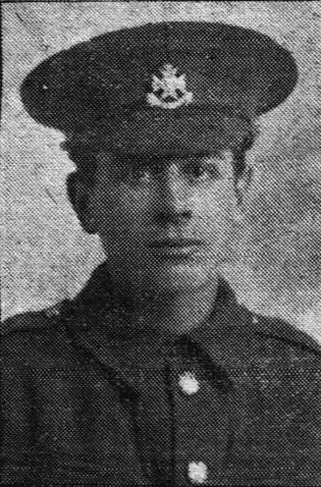
305830 Lance Corporal John Henry AYTO
2nd / 8th Battalion Sherwood Foresters (Notts and Derby) Regiment
Died of phthisis (tuberculosis) on 19 June 1917, at Birmingham Military Hospital, aged 20.

John Henry Ayto was born in 1897 at Newark and was the son of Thomas a general labourer and Sarah Jane Ayto née Newstead, of 66, Northgate, Newark.

His father Thomas was born in 1872 at Dry Doddington, Lincolnshire, his mother Sarah
Figure 2 https://thesherwoodforesters.com/ayto-john-henry/

Jane Newstead was born in 1873 at Balderton,
they were married in 1895 at Newark and went on to have 4 children, George b1894 Balderton, John Henry b1897 Newark, Arthur William b1900 Newark and Annie Elizabeth b1906 Newark. In the 1911 census the family are shown living at 15 Queens Road, Newark and are shown as Thomas 39 yrs a labourer, he is living with his wife Sarah Jane aged 38 yrs and their children, George 17 yrs a maltster, John Henry 14 yrs a barley dresser, Arthur William 11 yrs a scholar, and Annie Elizabeth 5 yrs.

https://www.cwgc.org/find-records/find-war-dead/casualty-details/2750132/john-henry-ayto/

Appendix 10: Major Kenneth MUIR VC, Argyll and Sutherland Highlanders

Rank | Major
Name | Kenneth Muir
Service | British Army
Unit | The Argyll & Sutherland Highlanders
Attached To | 27th Brigade
Operation | Battle for Hill 282
Date of Death | 23 September 1950
Place of Death | near Songju, Korea
Circumstances | Killed in Action
Decorations | Victoria Cross, Distinguished Service Cross (USA) (both posthumous)
Age | 38
Buried at | UN Memorial Cemetery, Korea
Commemorated at | On the headstone of his father Colonel Garnet Wolseley’ Muir’s grave, Frimley St. Peters Churchyard
Grave or Memorial Number

Kenneth Muir fell in the Korean War and therefore his grave is not tended by the CWGC. His is an interesting case in showing how casualties of other conflicts are handled and commemorated. He is buried in the UN Memorial Cemetery in Korea where he fell, and he is commemorated on the grave of his father in St. Peter’s Churchyard in Frimley, Surrey, close to Frimley Military Hospital and to the Royal Military Academy, Sandhurst.

Source: The VC & GC Association
https://vcgca.org/our-people/profile/1807/Kenneth-MUIR

BIOGRAPHIC PROFILE
Born: 6 Mar 1912 at Wayside, Lache, Chester, Cheshire. Son of Garnet Wolseley Muir, CO A&SH (1923) and Mary Williamina (née Cunninghame).
Educated at Malvern Schooland the Royal Military Academy, Sandhurst.

Career:
28 Jan 1932 2nd Lieutenant Argyll & Sutherland Highlanders; 1935-38 on North West Frontier, India.
Served in World War II until July 1943 attached Sudan Defence Force but mainly on staff or attached to Military Police; Temporary Major; Mentioned in Despatches 1944.
1 July 1946 as a Major worked in Provost Marshal’s branch, War Office, London, then joined 1st Bn Argyll & Sutherland Highlanders in Hong Kong as Second In Command (2IC); 25 Aug 1950 bn embarked for Korea with 27th Brigade ; bn arrived Pusan, Korea together with 1st Bn Middlesex Regt; Sept 1950 served as 2IC in Pusan action coordinating bn administrative support but he studied (the military) situation during daily visits to bn Forward HQ.

23 Sept 1950 VC Action at Hill 282, SE of Songju, S Korea (KIA).
Final rank: Maj.
Died: 23 Sept 1950 Hill 282, SE of Songju, S Korea.
Buried: UN Memorial Cem, Pusan, S Korea.
Commemoration: headstone; name on father’s headstone in St Peter’s Churchyard, Frimley, Surrey.
Other awards: 1908-35 Indian General Service Medal with clasp NW Frontier 1935; Indian General Service Medal 1936-39 with clasp NW Frontier 1936-37; 1939-45 Star; Africa Star; Italy Star; France and Germany Star; Defence Medal 1939-45; War Medal 1939-45 with MiD; Korea Medal 1950-53; UN Korea Medal 1950-53; Distinguished Service Cross (USA) (1950). VC Investiture: 14 Feb 1951 to his parents at Buckingham Palace by King George VI (his last VC Investiture).
VC location: A&SH Museum, Stirling Castle.

Source: The London Gazette 2 January 1951
Citation for the award of the Victoria Cross.

Major Kenneth Muir (50980), The Argyll and Sutherland Highlanders (Princess Louise’s), in recognition of gallant service in Korea. On 23rd September, 1950, “B” and “C” Company of the 1st Battalion, The Argyll and Sutherland Highlanders, attacked an enemy-held feature, Hill 282, and by 0800 hours had consolidated upon it. Some difficulty was experienced in evacuating the wounded from the position and demands were made for stretcher-bearing parties to be sent forward by the Battalion. At this juncture the position came under mortar and shell fire. At approximately 0900 hours a stretcher-bearing party arrived and with it came the Battalion Second-in-Command, Major K. Muir. He proceeded to organise the evacuation of the casualties. At approximately 0930 hours, small parties of the enemy started to infiltrate on the left flank necessitating the reinforcing of the forward platoon. For the next hour this infiltration increased, as did the shelling and mortaring, causing further casualties within the two companies. By 1100 hours, casualties were moderately severe and some difficulty was being experienced in holding the enemy. In addition, due to reinforcing the left flank and to providing personnel to assist with the wounded, both companies were so inextricably mixed, that it was obvious that they must come under a unified command. Major Muir, although only visiting the position, automatically took over command and with complete disregard for his own personal safety, started to move around the forward elements, cheering on and encouraging the men to greater efforts despite the fact that ammunition was running low. He was continually under enemy fire, and, despite entreaties from officers and men alike, refused to take cover. An air-strike against the enemy was arranged and air recognition panels were put out on the ground. At approximately 1215 hours the air-strike came in, but unfortunately the aircraft hit the Companies’ position instead of that of the enemy. The main defensive position was hit with fire bombs and machine gun fire, causing more casualties and necessitating the withdrawal of the remaining troops to a position some fifty feet below the crest. There is no doubt that a complete retreat from the hill would have been fully justified at this time. Only some thirty fighting men remained and ammunition was extremely low. Major Muir, however, realised that the enemy had not taken immediate advantage of the unfortunate incident and that the crest was still unoccupied although under fire. With the assistance of three remaining officers, he immediately formed a small force of some thirty all ranks and personally led a counter-attack on the crest. To appreciate fully the implication of this, it is necessary to realise how demoralising the effect of the air-strike had been and it was entirely due to the courage, determination and splendid example of this officer that such a counter-attack was possible. All ranks responded magnificently and the crest was re-taken. From this moment on, Major Muir’s actions were beyond all possible praise. He was determined that the wounded would have adequate time to be taken out and he was just as determined that the enemy would not take the crest. Grossly outnumbered and under heavy automatic fire, Major Muir moved about his small force re-distributing fast diminishing ammunition and when the ammunition for his own weapon was spent, he took over a 2 inch mortar which he used with very great effect against the enemy. Whilst firing the mortar, he was still shouting encouragements and advice to his men and for a further five minutes the enemy were held. Finally, Major Muir was hit with two bursts of automatic fire which mortally wounded him, but even then he retained consciousness and was still determined to fight on. His last words were:-
“The Gooks will never drive the Argylls off this hill”. The effect of his splendid leadership on the men was nothing short of amazing, and it was entirely due to his magnificent courage and example and the spirit which he imbued in those about him that all the wounded were evacuated from the hill, and, as was subsequently discovered, very heavy casualties inflicted on the enemy in the defence of the crest.
Third Supplement to The London Gazette of 2 January 1951. 5 January 1951, Numb. 39115, pp. 133-34

Appendix 11: D/MX64183 Leading Air Mechanic Donald STEWART Royal Navy

Rank | Leading Air Mechanic (RN) (Pilot u/t)
Name | Donald Stewart
Service | Royal Navy
Unit | H.M.S. Daedalus
Attached To | Service Flying Training School No 1
Operation
Date of Death | 28th October 1941
Place of Death | Netheravon
Circumstances | Air Crash
Decorations | Nil
Age | 22
Buried or Commemorated at | Newark-On-Trent. Cemetery
Grave or Memorial Number | Section A West: Grave 257.

Sources
https://www.ancestry.co.uk/search/collections/62274/records/111541
https://www.naval-history.net/xDKCas1941-10OCT.htm

Whilst engaged in bombing practice, the aircraft, a Fairey Battle Mk I, failed to pull out of a dive and crashed at the Pepperbox Hill Bombing Range.
Son of James and Kate Florence Stewart of Newark.

Appendix 12: 1592376 Private James STOKES VC, Kings Shropshire Light Infantry

Rank | Private
Name | James Stokes
Service | British Army
Unit | 2nd Bn Kings Shropshire Light Infantry
Attached To
Operation | Op BLOCKBUSTER
Date of Death | 1 March 1945
Place of Death | Kervenheim, Germany
Circumstances | Killed in Action
Decorations | Victoria Cross
Age | 30
Buried or Commemorated at | Reichswald War Cemetery, Kleve, Germany.
Grave or Memorial Number | Plot 62 : Row E : Grave 14.

Source VC & GC Association.
https://vcgca.org/our-people/profile/1775/James-STOKES

Born: 6 Feb 1915 Hutchesontown, Glasgow, Lanarkshire, Scotland.
Family: Son of George Stokes, a builder’s labourer and Mary Ann (née Mallon). Educated: St Luke’s School, Glasgow.
Married: 9 Sept 1939, 150 Hope Street, Glasgow to Janet Dawson Graham (née Kennedy); one son.
Career: on his parents’ death, he was sent aged 11 or 12 to southern Ireland for two or three years to work on relatives’ farms; returned Scotland as a building labourer and other manual jobs.
War Service: James was called up in 1940 and on 29 July 1940 he enlisted as a Gunner in the Royal Artillery, following his brother into the Army.

On 14 Oct 1943 he was transferred to the Gloucestershire Regt. Whilst on leave in early 1944 he was involved in brawl and was sentenced to prison; he was later reprieved in order to join the KSLI as a Private and took part in Normandy landings.
A month later, on 7 July 1944 he was transferred to the Warwickshire Regt then on 3rd September1944 back to the 2nd Bn KSLI. He took part in the battles for Caen and the Rhineland. On 1st March 1945 whilst taking part in the continuing Operation Blockbuster to capture land between the Meuse (Maas) and Rhein (Rhine) rivers, he took part in an action at Kervenheim, Germany where he was Killed in Action (KIA) but his gallantry was recognised by the award of a posthumous Victoria Cross
Final rank: Private.
Died: 1 Mar 1945 Kervenheim, Germany.
Buried: Reichswald Forest War Cem, Cleves, Germany, Plot 62, Row E, Grave 14.
Commemorations: headstone; memorial in Gorbals Rose Gdn, Old Rutherglen Rd, Glasgow.
Other awards:
1939-45 Star;
France and Germany Star;
Defence Medal 1939-45;
War Medal 1939-45.
VC Investiture: 9 Apr 1946 to his widow and son by King George VI, Buckingham Palace.

Victoria Cross Citation.
In Holland, on 1st March, 1945, during an attack on Kervenheim, Private Stokes was a member of the leading section of a Platoon. During the advance the Platoon came under intense rifle and medium machine gun fire from a farm building and was pinned down. The Platoon Commander began to reorganise the Platoon when Private Stokes, without waiting for any orders, got up and, firing from the hip, dashed through the enemy fire and was seen to disappear inside the farm building. The enemy fire stopped and Private Stokes reappeared with twelve prisoners. During this operation he was wounded in the neck. This action enabled the Platoon to continue the advance to the next objective, and Private Stokes was ordered back to the Regimental Aid Post. He refused to go and continued the advance with his Platoon. On approaching the second objective the Platoon again came under heavy fire from a house on the left. Again, without waiting for orders, Private Stokes rushed the house by himself, firing from the hip. He was seen to drop his rifle and fall to the ground wounded. However, a moment later he got to his feet again, picked up his rifle and continued to advance, despite the most intense fire which covered not only himself but the rest of the Platoon. He entered the house and all firing from it ceased. He subsequently rejoined his Platoon – who, due to his gallantry, had been able to advance – bringing five more prisoners. At this stage the Company was forming up for its final assault on the objective, which was a group of buildings, forming an enemy strong point. Again, without waiting for orders, Private Stokes, although now severely wounded and suffering from loss of blood, dashed on the remaining 60 yards to the objective, firing from the hip as he struggled through intense fire. He finally fell 20 yards from the enemy position, firing his rifle until the last, and as the Company passed him in the final charge he raised his hand and shouted goodbye. Private Stokes was found to have been wounded eight times in the upper part of the body. Private Stokes’ one object throughout this action was to kill the enemy, at whatever personal risk. His magnificent courage, devotion to duty and splendid example, inspired all those round him and ensured the success of the attack at a critical moment; moreover, his self-sacrifice saved his Platoon and Company many serious casualties.
Supplement to The London Gazette of 13 April 1945. 17 April 1945, Numb. 37033, p. 2011

Appendix 13: 5235FN40 Corporal Pierre François TANNIOU No 10 (Inter-Allied) and No 4 Commandos

Rank | Corporal
Name | Pierre FrançoisTanniou
Service | Free French Forces
Unit | Ist Bn de Fusiliers Marins, (later the  1st Bn French Marine Commandos)  Then No 10 (Inter-Allied) Commando and  No.1 Troop, No. 4 Commando.
Attached To | 1st Special Service (Commando) Brigade
Operation | Operation Overlord (D-Day, Normandy)  Operation Infatuate (Walcheren)
Date of Death | 4th May 1985
Place of Death | Le Havre, France
Circumstances | Unspecified.
Decorations | Croix de Guerre with Silver Star (Fr)
Age | 63
Buried or Commemorated at | Ranville Churchyard
Grave or Memorial Number | Inside the perimeter wall along the northeast boundary

Author’s Note.
Pierre Tanniou survived the War but is included in this project as an example of how some communities and societies respect their war veterans and accord them the same respects and dignities as their war dead. Tanniou was indeed a brave warfighter and fought in some famous actions and was very lucky not to have been killed in action.

Sources (Translated from the French)
http://ecole.nav.traditions.free.fr/177_tanniou.htm
https://compagnonshavrais.jimdofree.com/biographies-de-ffl-du-havre/tanniou-pierre-fnfl-page-1/

Biography.
Born in Le Havre on July 23, 1922, Pierre TANNIOU left France on March 30, 1940, embarking in Saint Nazaire as a stewart on the Champlain.Disembarking in New York on April 12, 1940, he was then, by the care of the Compagnie Transatlantique, embarked on the Normandie as an assistant cook.
Suspected of wanting to join General de Gaulle's forces and as a result threatened with imprisonment, he left the Normandie.

The priest of the French parish of New York provided him with subsidies and on October 5, through the care of the British consul, he embarked at Newport-News, on the Dutch cargo ship Salabangka.

He landed in Glasgow on 28 December where the immigration service had him accompanied to London the same day. He was then interrogated by the Intelligence Service and the 2nd Bureau.

His enlistment in the Free French Naval Forces was taken into account from July 1940 (source: GR 28 P 2 269), he then served in the Navy on the destroyer Leopard before joining the 1st Company of Commando Marines in January 1942.

From 17 January 1942, Philippe Kieffer, who trained a first nucleus of 16 members at the Old Dean camp, near Camberley, described Pierre TANNIOU in his book "Green Beret", as "pale, thin, taciturn but endowed with great tenacity".

Video clip of French Marine Commandos training at the Achnacarry Commando Training Centre in Scotland. Pierre TANNIOU, recognizable because of his glasses, appears in this silent film at 1 minute 02 seconds
https://youtu.be/b-rWgqIFoXc

19 AUGUST 1942, THE DIEPPE RAID
The 1st company of commando marines was in existence for 17 months in 1942 and was still waiting to be engaged: The raid on Dieppe was to be the baptism of fire for a small group of them. The French representation was extensive: a crew officer, Lieutenant Francis Vourc'h, three petty officers and eleven quartermasters and sailors left Wales to take part in the operation.

Divided into three groups, they were to reinforce the Canadian troops attacking in the centre, and two operations by British commandos to attack coastal artillery batteries.

Pierre TANNIOU and five men under the command of Lieutenant Vourc'h were part of this group. Caught under fire from the violent gunfire, they will unfortunately not be able to disembark.

On November 28, 1942, Rear-Admiral Auboynneau expressed his satisfaction with the 7 commandos of this group "for their beautiful attitude under fire".

EASTBOURNE, 1943
In May 1943, Eastbourne on the south coast of England, was chosen to host the French commandos. The Commando Marine Fusiliers Company had now reached the strength of one battalion and, on October 8, 1943, it officially became the 1st Battalion of Marine Commandos (1er BFMC).

Pierre TANNIOU appears in a photograph from the Archives of Henri Fercocq, taken on October 8, 1943 in Eastbourne, in the presence of Admiral Thierry d'Argenlieu and Commander Philippe Kieffer.
This photo also features Le Havre's Marcel Niel and Pierre Quéré.

JUNE 1944, THE NORMANDY LANDINGS
Pierre TANNIOU participated with the 1st BFMC in the D-Day landings of 6 June 1944 in Ouistreham, as part of Troop 1 of No. 4 Commando.

The barges arrived opposite La Brèche on the morning of June 6, around 7:25 a.m. Lieutenant-Colonel Dawson gave the 177 men of the 1st BFMC the first chance to touch French soil, nearly 10% of whom were from Le Havre: Bernard Beux, Jean Bouilly, Robert Boulanger, Marcel Derrien, Marcel Fromager, Jacques Guyader, Henri Le Chaponnier, Maurice Le Floch, Yves Meudal, Marcel Niel, Pierre Quéré, Marcel Raulin, Georges Ropert, Pierre Tanniou, Eugène Troyard and Michel Vincent.

They all managed to get back up the beach and, when the Ouistreham casino was taken by Troop 1, Marcel RAULIN testified:
"Equipped with yellow scarves that we wave from time to time to be recognized by others, we move forward in successive leaps, as if in training. Still in the lead, Louis rushes forward, and jumps into a huge bomb hole.
We imitate him; Autin, Allain and then TANNIOU go through...".

During the Normandy campaign, on 16 August 1944, the whole of the 4th Commando marched on Bavent, joined the 1st Special Brigade at Goustrainville on the evening of 19 August, and the next day annihilated a resistance point at a place called l'Epine, near Dozulé in Calvados. During this operation, Pierre TANNIOU and Marcel Niel, injured, had to be evacuated and hospitalized.

WINTER 44, THE DUTCH CAMPAIGN
Finally, in November 1944, Pierre Tanniou took part in the Dutch campaign, during which he joined his comrades in the capture of Vlissingen and the island of Walcheren.
In June 1945, promoted to Quartermaster, Pierre TANNIOU was mentioned in the Order of the Division.

After the war, Pierre TANNIOU had to have both legs amputated and experienced the greatest misery. When he died in Le Havre on May 4, 1985, he was about to be buried in a mass grave.

On June 6, 2017, the Commando Léon Gautier testified of the circumstances in which the solidarity of the commandos saved him from this sad fate. Thus Pierre TANNIOU is buried today with his comrades in the cemetery of Ranville, near the church.

Appendix 14: Sergeant Guy Joseph Marie de VILLARDI, comte de Montlaur, No 10 (Inter-Allied) Commando and No 4 Commando

Rank | Sergeant (later Lieutenant)
Name | Guy Joesph Marie de Villardi, comte de Montlaur
Service | Free French Forces
Unit | Ist Bn de Fusiliers Marins, later the  1st Bn French Marine Commandos  Then No 10 (Inter-Allied) Commando and  No.1 Troop, No. 4 Commando.
Attached To | 1st Special Service (Commando) Brigade
Operation | Operation Overlord (D-Day, Normandy)  Operation Infatuate (Walcheren)
Date of Death | 10th August 1977
Place of Death | Garches, Hauts-de-Seine, Île-de-France
Circumstances | Unspecified
Decorations | Légion d'honneur (France)
Age | 58
Buried or Commemorated at | Ranville Churchyard
Grave or Memorial Number | Inside the perimeter wall along the northeast boundary

Guy de Villardi, comte de Montlaur. Aristocrat, Commando and artist.

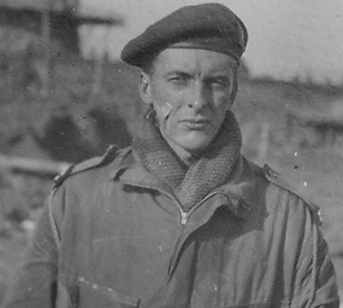
As a young man Montlaur studied philosophy at the Sorbonne, and painting at the Académie Julian from 1936-1938. He worked with Emmanuel Fougerat and Jean Souverbie.

In October 1938 he was conscripted for military service, serving in the 3e Régiment de Hussards. He was a member of the 15è Groupe de Reconnaissance de Corps d’Armée initially based at Sarreguemines on the German border during the battle of France. He eventually left France, travelling to England via Lisbon to join the Free French in October 1942.

He served as a Second-Maître (Sergeant) with the commandos of the 1st BFMC (1er Bataillon de Fusiliers Marins Commandos / 1st Battalion of Marine Commandos) known as the "Kieffer commandos" after its Commanding Officer Commandant (Major) Phillipe Kieffer, and took part in the Battle of Normandy landing at Ouistreham. Originally part of No. 10 (Inter-Allied) Commando, the 1st BFMC were integrated into No. 4 Commando, 1st Special Service Brigade (Brigadier the Lord Lovat) before the Normandy operation. He also took part in the assault on the Dutch island of Walcheren ("Operation Infatuate") on 1 November 1944, having been commissioned at a lieutenant. Montlaur received seven citations and the French légion d'honneur by the age of 25. In the 1962 film The Longest Day he was played by Georges Rivière.

After the war Montlaur worked at the Art Students League of New York from 1947–1949, and exhibited his work regularly in Paris thereafter.[1] As an artist, Montlaur's pictorial work is influenced by the great classics: Paolo Uccello, Jean-Auguste-Dominique Ingres, Eugène Delacroix, and later, Wassily Kandinsky. Four styles can be defined as characterizing the evolution of Montlaur's painting: Cubism just after the war, geometric abstraction from 1949, abstract expressionism from 1955 and finally lyrical abstraction around 1960 when he reached the fullness of his art and technique. His painting is often mystical, sometimes religious; It is marked by the terrible memories of the battles fought during the war.

References
https://www.france-libre.net/bfm-commando-flessingue/ accessed 01/12/2024
https://web.archive.org/web/20140527212054/http://musee.fusco.lorient.free.fr/biofuscodemontlaur.htm accessed 01/12/2024

Appendix 15: 111789 Captain Gordon Spencer SHEILL MC Royal Army Medical Corps (Airborne)
Rank | Captain
Name | Gordon Spencer SHEILL MC
Service | British Army
Unit | 225 Parachute Field Ambulance RAMC
Attached To | British 6th Airborne Division
Operation | Varsity
Date of Death | 24th March 1945
Place of Death | Near Hamminkeln, Germany
Circumstances | Died of Wounds
Decorations | Military Cross
Age | 28
Buried or Commemorated at | Reichswald Forest War Cemetery
Grave or Memorial Number | Plot 42: Row B: Grave 8.

Gordon Spencer Sheill was born in Dublin in April 1916, the son of Doctor Spencer Sheill.

He was commissioned in June 1940. Captain Shiell was attached to the 716th Light Composite Company, RASC, during the early stages of the Normandy battle. He was awarded the Military Cross:

On June 8th, 9th, 10th 1944 at Haute Longueville Captain Shiell was in charge of the Regimental Aid Post of the Divisional Maintenance Area. Casualties were heavy and many units were passing wounded through for attention. In difficult conditions and without regard to his own safety Captain Shiell attended Allied and Enemy wounded alike often in the face of intensive aerial bombardment or Artillery and mortar fire. His quiet efficiency skill were without doubt instrumental in the saving of many lives, and his unflagging energy and cheerfulness throughout these difficult operations was an inspiration to officers and men alike.

Captain Shiell was killed during Operation Varsity on the 24th March 1945.

The next airborne operation by 255th (Parachute) Field Ambulance, was Operation Varsity in March 1945. The 6th Airborne Division would land on the east bank of the River Rhine in the area of the Diersfordter woods, near the town of Hamminkeln.^{[1]} The 225th now commanded by Lieutenant-Colonel N.J.P. Hewlings still part of the 5th Parachute Brigade would land to the north of the woods, in daylight and a large number of casualties were expected.^{[2]}
Landing on 24 March the 225th established their MDS in some farm buildings at the edge of the woods, and were soon treating the casualties from the landings. The German infantry pulling back from the Rhine actually marched through the farm buildings without discovering the MDS.^{[3]} On the afternoon 25 March the leading units of the 15th (Scottish) Division, linked up with the airborne division.^{[4]}

Citations.
Ferguson, p.29
Cole, p.159
Cole, p.164
Cole, p.168

References.
Cole, Howard N (1963). On wings of healing: the story of the Airborne Medical Services 1940–1960. Edinburgh: William Blackwood.
Ferguson, Gregor (1984). The Paras 1940–84. Volume 1 of Elite series. Oxford: Osprey Publishing.
Online References :
https://www.paradata.org.uk/people/gordon-s-sheill accessed 25/11/2024
https://www.cwgc.org/find-records/find-war-dead/casualty-details/2041860/gordon-spencer-sheill/ accessed 25/11/2024
https://www.ancestry.co.uk/search/collections/1904/records/14477221?tid=&pid=&queryId=7ef474cc-199e-496e-8eb9-43f0eb8a3888&_phsrc=Qwo1&_phstart=successSource accessed 25/11/2024
https://www.pegasusarchive.org/normandy/gordon_spencer_shiell.htm accessed 25/11/2024

Appendix 16: Lieutenant HE “Jimmy” PEARSON MC, The Reconnaissance Corps

Rank | Lieutenant
Name | Hubert Ellis (Jimmy) Pearson MC
Service | British Army
Unit | HQ Troop  1st Airborne Reconnaissance Squadron,  The Reconnaissance Corps
Attached To | British 1st Airborne Division
Operation | Operation Market Garden
Date of Death | 19th September 1944
Place of Death | Arnhem Bridge
Circumstances | Killed in Action
Decorations | Military Cross
Age | 23
Buried / Commemorated at | Arnhem Oosterbeek War Cemetery
Grave or Memorial Number | Plot 1 : Row B : Grave 4

Source: https://www.pegasusarchive.org/arnhem/Biog3/Hubert_Ellis_Pearson_1.htm
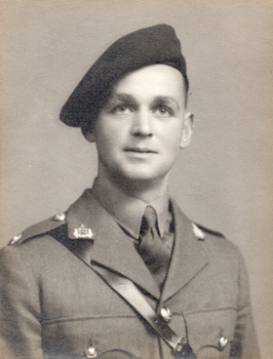
Hubert Ellis Pearson was born in 1921, the son of William and Dora Pearson of Cambridge. From 1930 to 1940, he was educated at Silcoates School, Wakefield, Yorkshire, then subsequently attended St. Edmund Hall, Oxford. On the 19th September 1942, he was granted an emergency commission as a Second Lieutenant in the Reconnaissance Corps of the Royal Armoured Corps. In September 1942, "Jimmy" Pearson, as he was always known, was an early volunteer for the then 1st Air Landing Squadron, Reconnaissance Corps, and became a Section Commander in "B" Troop.

Promoted to War Substantive Lieutenant on the 19th March 1943, he served in North Africa and then Italy, disembarking at Taranto on the 9th September. "B" Troop proceeded to reconnoitre towards Locorontondo, and had two encounters with the enemy between that town and the village of Martina Franca during the early morning of the 10th September. The Troop suffered heavily in the second encounter, losing three men killed and several taken prisoner, including Lieutenant Pearson. He escaped from the train carrying him north, but despite being quickly recaptured he managed to get away again, and after many months successfully reached the Allied lines with Lance-Corporal Hynes in June 1944. On the 26th July 1945, it was announced in the London Gazette that he had been awarded the Military Cross for his activities during this period.
His citation reads:

Lieutenant PEARSON was taken prisoner at TARANTO on the 9th September 1943. During transit north in an electric train, the occupants of his truck broke it open with a piece of iron concealed from the guards. Only six men had jumped when the escape was detected. Although the wagon was surrounded by wire and guards rode on the steps, the remainder of the prisoners-of-war unscrewed the ventilator at the bottom end of the wagon, just above the buffers. With two other paratroopers, Lieutenant PEARSON jumped as the train was slowing down to enter ROVIGA station, but the three were caught by Fascists soon afterwards and sent to a former Infantry barracks at PADUA.

Again they were entrained and before the journey commenced had made, with knives, a small hole in the side of the truck. Fifteen men jumped out north of VICENZA under fire from guards in the next truck. With two Other Ranks, Lieutenant PEARSON proceeded to PORTO CHIOGGIA, and when evacuation by sea proved impossible, returned to the mountains. Later attempts were made to cross the lines at CASTEL DI SANGRO and ALFEDENA, but each was defeated by enemy defences. Returning to the ASCOLI area, they waited for the Allied advance and reported on the 19th June 1944.

During January 1944, with another officer, Lieutenant PEARSON distributed to prisoners-of-war assistance dropped by parachute and provided through the ROME organization. Although he tried to form a contingent of prisoners-of-war to help a local band of patriots, the offer was not welcomed and the rebels were dispersed before the idea matured.

On the 22nd June 1944, he reported to British troops who had reached ASCOLI PICENO, having helped to keep order at a nearby village.

Another prisoner-of-war remarked on the fine example displayed by Lieutenant PEARSON in planning escapes and encouraging others to try also. Due to his leadership, many prisoners-of-war escaped.

Pearson wrote to Major Gough in July 1944, to inform him that he and Hynes had escaped, and immediately after arriving in the UK on the 12th August 1944, telephoned him to say that he had returned was ready for duty. Although allowed on survivors leave, he had made it clear that he wanted to be involved in any future operations that the Squadron would be involved in, and Gough found a place for him as the commander of a 'spare' jeep crew in Headquarters Troop.

During Operation Market Garden, Lieutenant Pearson flew to Holland with the first lift on Sunday 17th September 1944. Following the losses suffered by "C" Troop as they encountered Battalion Krafft during their attempt to reach Arnhem Bridge, Pearson volunteered to join them, and remained in the area of the landing zones throughout the 18th September. On the following day, he took part in the reconnaissance mission to the Ede - Arnhem road to the north of Wolfheze, but during their return the Troop was ambushed on the road running through the woodland at Planken Wambuis, and Pearson was killed when his jeep was shot up. He was 23, and was first buried in the Temporary Military Cemetery near Ginkel Heath, beside Verlengde Arnhemseweg, but now lies at rest in the Arnhem/Oosterbeek War Cemetery, Plot 1, Row B, Grave 4.

Pearson prepared the following letter to his mother on the 25th April 1943:

Dear Mother,

I hope this will make you feel a little better, now that it has actually happened. I can't write all I feel, but I do want to say "Thank you" to all of you - you have all been so very kind to me. Please just remember two things, which I mean in all seriousness - I do not regret in the least the line I have taken and should do the same again if necessary. Like you, I do not believe this is the end - somewhere I shall see you all again. Turning to more material things - I have not bothered to make a will; please use the money I have in Glyn Mills Bank (now £60) to help any children Mary may have after this is over. Well, Mother, we are off very soon now - where, I can only guess. But I go with the grandest set of chaps anyone could wish to have and in the hope that this time it will not be in vain. So, Goodbye to you all. I am thinking of you all again. Hubert.

Captain John Hay, the commander of "C" Troop, wrote a letter to Pearson's father on the 25th April 1945, and the subsequent report, apparently written by Hay in the third person, followed on 30th April:

Dear Mr Pearson,

I got back to this country last week and came out of hospital the other day. I will try and tell you what happened to Jimmy. As you know we tried to make a break for it down a main road about 8 miles from Arnhem. Jimmy and I were in the leading jeep, Jimmy driving. After about ½ a mile we came on a bunch of Germans in the trees by the road. They were completely surprised and we got by all right! Unfortunately there were some more further down the road, who, having heard the firing, were ready for us. I was hit, and immediately afterwards Jimmy must have been hit, as the jeep left the road out of control and turned over. I saw Jimmy lying about 5 yards away and called to him, but got no reply. The Germans then came up and pulled me out. I asked them about Jimmy, who had not moved, and one of them went to him, but came back and said he and the other man in the jeep were both dead. I think there can be no doubt that Jimmy was killed outright in the jeep. I know how you must feel, as he had only just got back from Italy, but it was just like him to volunteer to come with all his friends, and I was very pleased when he attached to my Troop; he was a terrific help. Please do not hesitate to let me know if there is anything else I can tell you.

Sunday, 17 Sept 44.
2 p.m. Jump at Arnhem. Jimmy found Hay at Rendezvous. (Dug in). Moved off 3 p.m. to Wolfheze. Occupied slit trenches, protecting Brigade H.Q. nearby, big house burning. Dutch very good. I noted (house or hospital) burning at W. [Wolfheze] "Nurses seemed very glad to see us & they gave us apples and hot tea", on the Sunday evening when their place was burning. During Sunday night, Hay, with some men, went to look for Bell [Brumwell?] & party, who had made first contact with enemy. (Original orders were to go to Arnhem Bridge, Jimmy & one man detailed to cut wires if bridge mined; but enemy held up the movement). Hay during Sunday night reconnoitring, found bodies of Bell [Brumwell?] & others. While Hay absent, Jimmy was left in charge.

Monday morning.
Jimmy went with Hay & men & brought in bodies of Bell [Brumwell?], Peter Bucknall and 4 others. They dug a grave at Wolfheze and burial service was conducted by a Padre. Monday - later - 2 patrols were sent out, Jimmy leading one. Returned about 3 o/c & reported had seen the Germans without being seen (20 or 30 Germans). Jimmy lay in scrub & heather & saw Germans pass close by. Much firing near at hand during the night, but Hay's Troop spent a quiet night at Hotel at Oosterbeek, Brigade H.Q. which they were told off to guard.

Tuesday morning.
Good breakfast - hot tea and dehydrated porridge. About 8 a.m. sent on Reconnaissance. First, North across railway line to cross-roads, there seen by Germans & mortar fire, returned towards Oosterbeek. F.W. I90's (German fighters) attacked - no casualties, took refuge in slit trenches (ready made) until air attack ended. Back to Oosterbeek, then followed another route, joining main road to Rotterdam, about 3 miles N.W. of Wolfheze. Man came from rear reported had been shadowed - (wooded country with stretches of heath, like Aldershot district). Could see Germans in woods; realised surrounded. Hay consulted with J [Jimmy] & two other officers - decided to attempt to break out at high speed. Gave orders, if any jeep hit, others must not stop. Hay's letter tells the rest of the story.
No chance for proper meals - depended upon the 24 hours emergency rations - also chocolate & biscuits, when they could.
One man (prisoner) back in England, Bowles (????)

Scene of action 19th Sept. 6 miles W. of Arnhem in Wolfhaze or Wolfhezen. Spot 2 m. N.W. of Wolfhaze on main road. Other men in leading jeep, Trooper Brawn (Wireless Operator), nothing more known of him.

Hay & Jimmy were together in N. Africa at Mascara & latter at Sousse. Job on runway, marshalling gliders, shared tent.

In July 1973, Edwin Waring, aka Lance-Corporal Frank Hynes, who escaped from Italy with Pearson, submitted the following to the Pegasus Journal:

On the second [Note: third] day of the Arnhem operation a young Lieutenant, 1st Airborne Reconnaissance Squadron was presumed killed (September 1944). He was head boy, captain of Cricket and Rugger and the hero of all the younger boys at his school. (Silcoates School of St Edmund's Hall, Oxford). His inspiring leadership at that school had been invaluable. He was always trying to force a win from the start of any game. His Headmaster said, "We look for great things from him in the future". Well, he did not look in vain.

Perhaps I am the only one who knows the full story of that annoying chapter in Italy when he twice broke from his captors. Together we unscrewed the 'vent' plate of a cattle truck after being taken prisoner near Bari in September 1943. We jumped from the train buffers and made good our escape. The escape was planned by Pearson who felt he must not let Freddie Gough down, "We must get back to our unit", he said. The lads of the Reconnaissance who had been led by him were proud and glad he had returned, tired, injured and footsore, to lead them again.

To sum up the history of this brave, gallant officer, I quote from a House Magazine, "To an Old Boy Killed In Action".

I can remember how, when June's steep-diving
sun and cricket's minuet, slow pacing,
made ballet-dance of white and blue and green,
a trick of flight deceived you, bowled you clean,
just when we thought to see the deep-field chasing
like Atalanta in the race, your driving.

And I remember how you laughed in trying
to discern your fault in cut or hook:
and as I see you in that simple game,
so I can see how, cavalier, you took
the bullet in your brain and laughed at dying.

Major Gough replied to this letter with:

I was very interested in the article by Edwin Waring on the subject of Jimmy Pearson, who was killed in an ambush whilst he was striving to make his way to the bridge at Arnhem [Note: incorrect, as explained above]. Reference is made quite rightly to his “inspiring leadership”, as this was the hallmark of his character.

'Jimmy' Pearson joined the 1st Airborne Reconnaissance Squadron whilst we were in Newbury and his athletic prowess was the first thing to manifest itself. He was a brilliant rugby player, having won a war-time Blue at Oxford, and he represented the Airborne Division - as it was then called - in a series of fantastic victories while we were training at Bulford. Not only did we give the Guards Armoured Division a 40-point thrashing, but we also defeated the full strength of the Royal Air Force in a splendid match played at Richmond, from which the R.A.F. Benevolent Fund and the Airborne Forces Security Fund shared a substantial gate.

Edwin Waring very rightly refers to the time when he and 'Jimmy' were "on the run" in Italy in late 1943. For his exploits during that period 'Jimmy' Pearson was awarded the Military Cross, and he reported back to the Squadron at Ruskington at the beginning of September 1944. When he heard about "Market-Garden" - and although he was due for a well-earned leave - he pestered me until I agreed to take him with us to Arnhem, where he was killed. I feel that he would have died of a broken heart if we had left him behind.

Those of us who survive know what the country owes to the many young men who, like 'Jimmy' Pearson, were proud to wear the Red Beret and give their lives for their country.

The following tribute to Lieutenant Jimmy Pearson by his old school was printed in The Silcoatian in April 1945:

Hubert Pearson is now posted as 'Presumed Killed'. There are those still in the School who knew him as their Head Boy, Captain of Cricket and Rugger, and probably and naturally, their hero. Pearson was good at whatever he turned his hand to, but not always without hard effort and painstaking attention to detail. In his great success (starting so far as games are concerned when he was so young that anyone would have excused him if his head had been turned) he was always quietly unassuming and he genuinely disliked any fuss to be made or tribute paid. He was much more than merely a fine all round athlete and a first-rate Captain: he was a fine fellow and a born leader. Unlike some born leaders, he led always in the right direction, and sometimes so unobtrusively that people did not even know that they were taking a course of their own volition. It would be invidious here to detail all his triumphs at School or at St. Edmund Hall, Oxford, where he spent one all too short year. But we would like to reprint what F.P. Lusted wrote of him in "The Silcoatian" at the end of the triumphant 1939 Cricket Season:

'This success owes so much to the play and leadership of our Captain, H.E. Pearson, that the term must not close without an appreciation. His actual scores made and wickets taken speak to a certain extent for themselves, but mere figures are feeble in an attempt to show his worth. We have seen his fighting efforts for quick runs and his control of the game when he scored 79 out of 85 for the last wicket: and his taking of wickets when it was only necessary for the opponents to last out for a few minutes in order to escape defeat. More than most personal efforts, his inspiring leadership has been invaluable. Always trying to force a win from the start of the game, and never afraid to take risks, he has had the success he deserved. He has changed his bowling so well that opponents hardly ever looked 'set' and has given an example in the field which has been followed by most of the side. He has varied his field to combat individual batsmen's strokes with intelligence and has kept the whole field keen.' (One remembers vividly that this tribute fell into Pearson's hands in manuscript when he was being consulted about the cricket report in the Magazine. "Must this go in?" he said, puckering with distaste his sometimes simian countenance in the familiar way, "It was the team, you know".)

One remembers how he was called to leave his own beloved House to take over command of another left without a leader; how sad he was though he spoke of it to no-one, and how his new charge went ahead from that moment. One remembers how, though no great actor, he gave himself completely to the job of putting up a good show even in the cricket term and one remembers him in his first part, a pathetic German prisoner, in Journey's End, and, joyously idiotic, in his last part, Charley's Aunt in the play of that name.

A glance through the 'Silcoatian' in those days finds his name everywhere, in every walk of School life: Sports Champion, breaker of records, swimmer, "In the Fives House Championship Pearson has so dominated the play that his House, Haworth's, have easily won the Championship." When old George Hirst visited Wakefield and bowled against the Silcoates representatives sent down, he said that the only criticism he had to make of Hubert was that he had no Yorkshire qualification. In Hubert's last term there appeared this Editorial comment: "It is right that we should here set on record our appreciation not only of his fine achievements both on the Rugby and Cricket fields, but of a captaincy which has done so much to make our record in both games in the last two years so memorable. The same qualities showed in his leadership of the School as Head Boy. We look for great things from him in the future, only trusting that circumstances beyond his and our control do not interfere seriously with future achievements of which the School may with reason expect to be proud."

Well, we did not look in vain. Probably even his parents do not know the full story of that amazing chapter in Italy when he twice broke from his captors (it must have been a tough moment for the Herrenvolk, the moment before he was taken prisoner that day near Bari in September '43) and of his trek after his second escape in October from a train bound for Germany, making his way to British lines the following June... "we tried all ways of passing the front by boat, by foot, and even had an aeroplane scheme prepared. Jerry began moving out two weeks ago, and we sat on top of the mountains and laughed and cheered his infantry on as the poor devils straggled back. I am on my way down now to get a boat back home (I hope!) and I stand a good chance, as the Div, is back there now... Great news from France isn't it... P.S: 9 months without tea!" When he did get home, he could easily have stayed there. He had a very long leave due, like all returned P.O.W. But the sublime Arnhem job was afoot and his Division went and he insisted on going too. Of course. There were 'great things for him in the future.' The greatest. You who have been led by him will know how glad his men must have been to have him back to lead for the last time, into that matchless adventure.

From his former Headmaster.
Hubert Pearson was lent to Silcoates for ten splendid years. It is very difficult for those to whom he was dear to speak about him.

But the School owes him a great and undischargeable debt. His wise leadership of every branch of its life for so many years has left a mark quite ineffaceable. In dozens of ways he created tradition. Lapse of time may erase the connection between the tradition and his name, but those who lived with him will always know how boldly, though unassumingly, he wrought in those later nineteen-thirties. And, better still, many in distant places, years after School has been left behind, will be taking decisions along the lines: "No! I can't do that. Jimmy would never have done it."

He never found class-work easy work, but because it was right to do it, it was done, and well done. But essays and syntax and a healthy mind formed only one side of a complete life, they were never allowed to seal his horizon. What an exposition, year-long and rare and fascinating, he gave us of the corpus sanum! Who will ever forget his coming in to bat for the 1st XI when his bat and he were approximately of equal length? How graceful and thorough were his fielding, his Rugger, his running, his captaincy! To pick out only a quartette of items from his enviable sportsman's repertoire.

But Juvenal's healthy mind in a healthy body were not enough for Hubert: life had another dimension. As he grew older, he understood people better. He saw how leadership implies a cheery word to the nervous, a warning word to the slacker, a job for the timorous, and above all, a personal example of a life controlled, cleanly, enthusiastic for everything of good report. That, the most precious of all donations a school can receive, he gave us, liberally, generously, pressed down, running over.

Our sympathy goes to the three at home, but he was ours, too; with them we sorrow. And we rejoice! For he is our assurance that though men are often baffled to fight better, right triumphs, goodness wins and endures, the pure in heart see their Lord. S.H.M.

From the "Old Boys' Section".

After anxious months since September, when he was reported 'Missing believed killed' 8 miles north of Arnhem, Hubert (Jimmy) Pearson (1930-40), 1st Airborne Reconnaissance, is now posted as 'Presumed Killed'. Jimmy was the flower of a fine generation of Silcoatians (how he would hate to be described) and though S.H.M. has written elsewhere in this number of him, very finely, we would add this anonymous tribute, in the name of all who knew him. There cannot be a Silcoatian the poorer for knowing him: many owe him a deep debt they cannot pay, even if he is found alive. His father and mother should know that the dominant emotion of Silcoatians is pride rather than grief: pride in his character and achievement, pride in being part of that which went to make him.

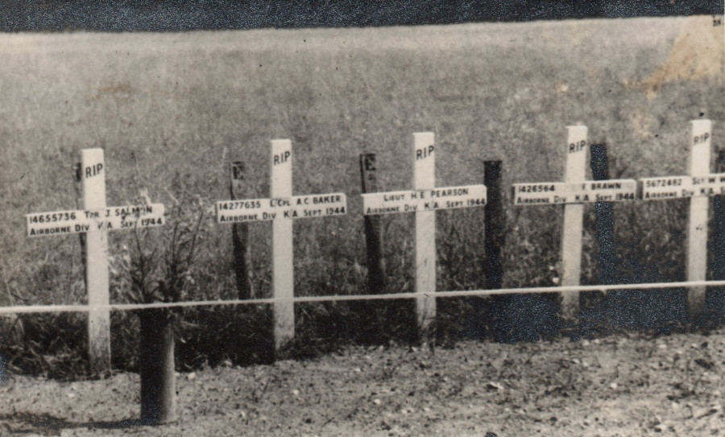

Lieutenant Pearson's battlefield grave and those of other Reconnaissance Squadron personnel, 1945. Courtesy of Peter Cablis.

Appendix 17: 2632 Private AMB ROOZEBOOM No 10 (Inter-Allied) Commando.
Rank | Private
Name | August Ferdinand Marie Bakhuis-Roozeboom
Service | Netherlands Army
Unit | No. 2 (Dutch) Troop, No. 10 (Inter-Allied) Commando
Attached To | HQ 1st British Airborne Division
Operation | Operation Market Garden
Date of Death | Tuesday, September 19, 1944
Place of Death | Oosterbeek, Arnhem
Circumstances | Killed in Action
Decorations
Age | 22
Buried or Commemorated at | Arnhem Oosterbeek Cemetery
Grave or Memorial Number

Source: ROOZEBOOM, August M. Bakhuis | ͏
https://www.commandoveterans.org/August_Roozeboom_Commando

Pte. Roozeboom, who served in 2 (Dutch) troop of the Commando, was killed during operations at Arnhem whilst attached to the 1st Airborne Division.

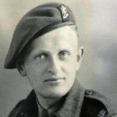

Source: August M Bakhuis-Roozeboom | ParaData
https://www.paradata.org.uk/people/august-m-bakhuis-roozeboom

Pte Bakhuis-Roozeboom was a member of No. 2 (Dutch) Troop, No.10 (Inter Allied) Commando. A party of 12 men landed near Wolfheze on 17 September 1944, of which four were captured. Pte Bakhuis-Roozeboom was killed in action near Oosterbeek on 19 September 1944, aged 22, and was given a field burial in the Hartenstein Hotel area. He was later re-interred in the Arnhem Oosterbeek War Cemetery. (Roll of Honour, 5th revised edition, 2011)

No 2 (Dutch) Troop, No 10 (Inter-Allied) Commando
“By no means all of the Dutch Troop, however, came from Holland during the war years, and several had no idea even how to speak Dutch”.. and Roozeboom only knew English as he, like Knijff and Offerman, came from Canada”. (Dear, 1987: 30).

“Though the Dutch Troop suffered heavy casualties with several of its members being wounded or taken prisoner of war, their losses in killed, compared to the Britis forces at Arnhem, were light, with only two dying in action. One, Private Hagelaars, was shot by the Germans after Arnhem when, on 5 October, he tried to visit his parents near Den Bosch when the area was still occupied by the enemy.
The other, Private Bakhuys Roozeboom, was killed in action while attached to 1st Airborne Division… he was with the Divisional Commander and worked from the Divisional HQ at the Hotel Hartenstein in Oosterbeek. On 19 September two volunteer guides were called for to help try and get a patrol through to the bridge at Arnhem. Two Dutch Resistance fighters, Jan Diepenbroek and Hendrik Beekhuisen, immediately stepped forward. (Dear, 1987: 30).

One of the two Dutch Resistance fighters, Hendrik Beekhuisen, was quoted in an article “August F.M. Bakhuys Roozeboom, the forgotten Commando of Arnhem, 1944”, published in 1980 by Major A L J van Viet of the Military History Section of the Royal Dutch Army Service Corps:

“We had to put on British uniforms. We got hand grenades and ammunition for our rifles. There was also an interpreter with us as we could hardly speak any English. This was a young soldier with a green beret. His name was Bakhuys and he took us outside to the jeep with a British major and four soldiers. With eight men on the jeep, legs hanging outside, the Major at the steering wheel, we drove towards the bridge. Near it we were shot at from both sides, but were not hit. After 400 metres we saw a high-sided vehicle coming towards us. We stopped and took cover on both sides of the road. We forced the driver to stop. It was a German Red Cross ambulance with two soldiers. The Major did not like
the situation as, of course, Red Cross vehicles were protected by the Geneva Convention. Then one of us opened the back of the ambulance and found it was full of ammunition and weapons, so we took the Germans prisoner. Bakhuys told us that the Major had decided to go back as we were surrounded by Germans, but we would try to get the ambulance back to Oosterbeek. On the way back the ambulance was stopped by a German patrol, but the Major drove his jeep at them. Then about ten Germans started shooting at us from the bridge with automatic weapons. Bakhuys was throwing hand grenades while the Major was driving. Suddenly I realized that Bakhuys was sinking in between the Major and I without a sound. It was a miracle to me that we were still alive. We stopped in Oosterbeek near a church which had been turned into a hospital and the Major and I looked to see where Bakhuys had been wounded. We soon saw that he had been hit in the head and must have died immediately”. (repeated in Dear, 1987: 30).
1980, the Dutch Commando Training Camp at Roosendaal where the current Korps Commandotroepen, the successors to No 2 (Dutch) Troop of No. 10 (Inter-Allied) Commando are trained, was named after Bakhuys Roozeboom.
https://www.liberationroute.com/en/pois/2163/the-story-of-august-bakhuis-roozeboom

Among these brave fighters was August Ferdinand Marie Bakhuis Roozeboom, one of the first commandos to give his life since the establishment of No.2 Dutch Troop. On the evening of September 19, 1944, Bakhuis Roozeboom departed from Hotel ‘Hartenstein’ with British paratroopers and Dutch resistance fighter H. Beekhuizen in a Jeep. Their mission was to make contact with the parachute battalion at the Rhine Bridge in Arnhem. Despite their determination, their attempt failed, and they had to retreat towards Oosterbeek. During their retreat, they managed to capture a German Red Cross vehicle, which unexpectedly turned out to be filled with weapons.
It was en route, near the overpass west of Arnhem, that the Jeep came under heavy fire. Bakhuis Roozeboom, standing between the driver and the passenger, bravely defended his comrades with a Tommy gun and grenades. But at that critical moment, he was struck and fell mortally wounded. The remaining members of the group succeeded in bringing the Jeep back to Oosterbeek, where Bakhuis Roozeboom was buried in the garden of Hotel ‘Hartenstein’.
After the war, Bakhuis Roozeboom was buried as ‘Known unto God’ at the War Cemetery in Oosterbeek. It wasn’t until 1996 that his exact burial site could be located. On May 5, 1997, in the presence of fellow fighters from No.2 Dutch Troop, tribute was paid to Bakhuis Roozeboom. His grave was visited with great respect and reverence, and on that day, his comrades and the public said goodbye to a brave hero.
As a lasting tribute to his courage and sacrifice, the training camp where all commandos receive their basic training is named after August Bakhuis Roozeboom.

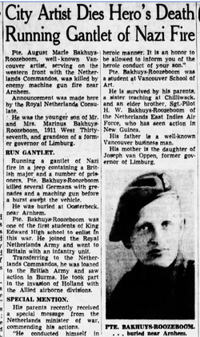
https://www.findagrave.com/memorial/67986753/august_fernand_marie-bakhuis_roozeboom

Appendix 18: Lieutenant HD BROTHERIDGE. Ox & Bucks Light Infantry (Airborne)
Rank | Lieutenant
Name | Herbert Denham (Den) Brotheridge
Service | British Army
Unit | Oxfordshire & Buckinghamshire Light Infantry (Airborne)
Attached To | British 6th Airborne Division
Operation | Op. DEADSTICK
Date of Death | 6th June 1944
Place of Death | Ranville, France (Pegasus Bridge)
Circumstances | Killed in Action
Decorations | Nil
Age | 29
Buried at | Ranville Churchyard
Grave Number | Grave 43

Source: https://www.cwgc.org/stories/stories/lieutenant-herbert-denham-brotheridge/

Lieutenant Herbert Denham (Den) Brotheridge was born on 8 December 1915, the son of Herbert Charles and Lilian Brotheridge, of Smethwick, Staffordshire. Educated at Smethwick Technical College, he was a keen sportsman playing football for Aston Villa Colts and cricket for Mitchell and Butlers, Smethwick. He later became a weights and measures inspector for Aylesbury Borough Council and married Margaret Plant on 30 August 1940.
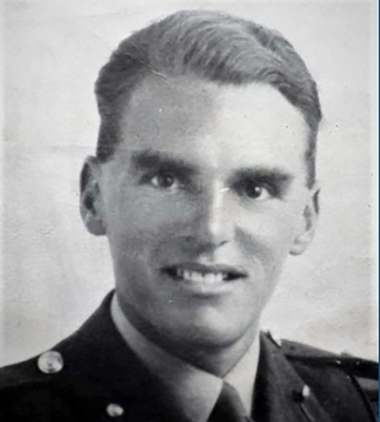
Den was commissioned into the Ox and Bucks Light Infantry in July 1942 and quickly became a popular member of his unit. At 00.16 hrs on 6th June, his glider landed less than 50 feet from the bridge over the Caen Canal but sadly (he) was hit by machine gun fire while leading his platoon in the first charge.

He was taken to the Casualty Collection Post but died moments later. He is believed to have been the first Allied serviceman to die through enemy action on French soil during the Normandy Campaign. Den was 29 years old. His wife Maggie gave birth to their daughter Margaret two weeks later.

He is buried in Ranville Churchyard, his Commission headstone inscribed with words chosen by Maggie: ‘Out of the bitterness of war, He found the perfect peace’. He is also commemorated by a plaque in Smethwick Council House unveiled by his daughter Margaret on 2 April 1995.

Appendix 19 – Flight Sergeant Josef FRANTIŠEK DFM* RAFVR.

Rank | Flight Sergeant (Plutonowy)
Name | Josef František
Service | Royal Air Force
Unit | 303 (Polish) Squadron
Attached To | No 11 Group Fighter Command RAF
Operation | N/A
Date of Death | 8th October 1940
Place of Death
Circumstances | Killed in Action
Decorations | Distinguished Flying Medal and Bar (*)
Age | 26
Buried or commemorated at | Northwood Cemetery
Grave or Memorial Number | Plot H: Grave 246

Sources:
https://www.bbc.co.uk/news/stories-45516556
https://www.bbm.org.uk/airmen/Frantisek.htm

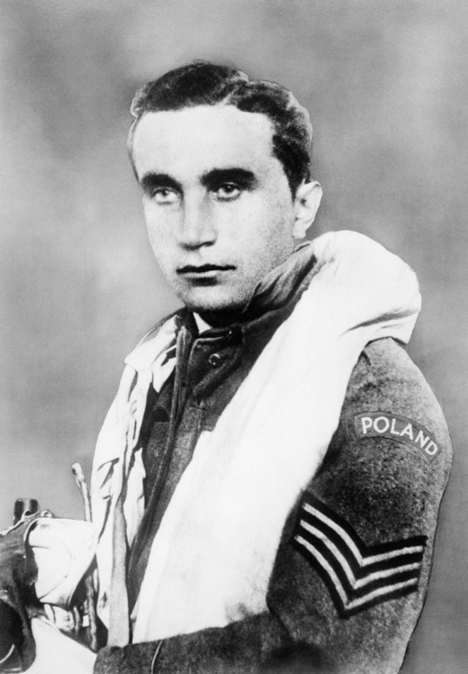
Winston Churchill described the Battle of Britain pilots as "these splendid men… who will have the glory of saving their native land". But they weren't all British. A new film, Hurricane, tells the story of the Polish pilots of 303 Squadron - and also highlights the brilliance of an often-overlooked Czech flying ace, Josef Frantisek.
He was "remarkable - some thought a little crazy", wrote the historians Lynne Olson and Stanley Cloud. A Czech "who flew with a fury none of the others could match".
Josef Frantisek has been credited with shooting down 17 enemy aircraft in one month at the height of the Battle of Britain - September 1940 - as Hitler sought to achieve the air superiority he needed to invade the UK.
Figure 3: FS Josef František © Imperial War Museum.

The Imperial War Museum calls Frantisek the "top scorer" of the Battle of Britain, external, and he is generally considered to be one of the top scorers of the entire war, despite his death in its very early stages.

Beyond the statistics, however, Frantisek remains an elusive figure.
"His aplomb in the sky is documented, of course, but not much else," Hurricane's director, David Blair, tells me.
But Blair says he became fascinated by Frantisek - a "lone wolf" pilot who kept breaking away from the squadron to chase enemy planes on his own - and worked hard to discover more about him.

"I like his freedom and wildness, his romantic attitude," says Czech actor Krystof Hadek, who plays Frantisek in the film. "He didn't have discipline - but he was the best."

So how did he end up in Northolt, West London, flying with a squadron of Poles?

Frantisek was born in 1914 in a village that became part of Czechoslovakia after the collapse of the Habsburg empire. He was a boisterous child, driving cars from the age of 12. But after training in the Czechoslovak air force he had to watch in huge frustration as that country's military was ordered not to resist Nazi invasion in 1939.

Driven by what his mother called a "deadly hatred" of the Nazis he escaped across the border to Poland and started flying for the Polish air force but witnessed defeat later that year against overwhelming German power. Stories of Frantisek flying low in primitive planes to drop hand grenades on German units hint at his seemingly reckless courage against daunting odds.

He fled Poland after its defeat and eventually made his way to France where he managed to fly in combat for exiled Polish and other units. Then, after the fall of France in June 1940, he headed for Britain, where he joined the RAF and the new Polish 303 Squadron.

Frantisek chose to fly with the Poles because he admired their fighting spirit, but his Czech origins reinforced his status as something of an outsider. Another pilot in the squadron remembered Frantisek as tall, well-built but "sometimes a bit absent-minded, as if shrouded in a strange sadness".

With their previous combat experience and burning desire to avenge what Nazi invaders were doing to their countries 303 Squadron's pilots longed to begin active RAF service. But their Canadian and British commanding officers were wary of the pilots' lack of English language skills, experience of radio communication and tight-formation flying.

It was a situation guaranteed to frustrate Frantisek in particular - constantly challenging and exasperating authority throughout his career. But Frantisek's formidable flying skill was what counted when 303 Squadron was finally given permission to enter combat, at a time when the RAF, facing a growing Luftwaffe onslaught, was desperately short of trained pilots.

Claims of enemy "kills" are a much-disputed area - researchers have found that Allied and German statistics do not match - but Frantisek's achievements certainly gave him one of the highest personal scores of any Battle of Britain pilot in Fighter Command.

Why was he so successful? Peter Devitt from the RAF Museum in London points to his willingness to fly close to the enemy before opening fire. His courage, says Devitt, like that of the Polish pilots around him, may have come from a sense of having "nothing to lose" given what had happened to his home country. But Devitt also points out that 303 Squadron lost fewer pilots during the Battle of Britain than most RAF units.

Frantisek submitted his own laconic reports of his successes. On one action against a vastly superior German force he wrote of "swarms of Messerschmitt 109s diving to attack us" after which he "played hide and seek with them in the clouds", nearly collided with a German bomber and then shot down two enemy planes in a few minutes before he was hit. But north-east of Brighton he "found a cabbage field and made an excellent landing".

What marked Frantisek out was his habit of breaking away from strict squadron formation to chase enemy planes on his own, often pursuing stragglers back across the Channel towards France. The Poles flew and fought as a team, and some of his comrades resented what they called "Frantisek's method". František’s colleagues disliked his habit of just dropping out of the Squadron’s formation and going off on his own to hunt for targets, and some RAF and Polish officers in the squadron initially his lack of discipline, arguing that it endangered everyone's safety. There was also a fear that younger pilots would seek to emulate him.

But as his successes grew, there came about what Devitt calls a "remarkable compromise". In a unique compromise, František as a Czech was officially considered a ‘guest’ in the Polish Squadron and was therefore allowed to break formation and fight alone, as long as in so doing he did not endanger the lives of any of his colleagues. "The Czech ace was permitted to fight what was in effect a private war against the Germans," Devitt says.

The squadron's impressive record did not go unnoticed. "Had it not been for the magnificent material contributed by the Polish squadrons and their unsurpassed gallantry," wrote Air Chief Marshal Sir Hugh Dowding, head of RAF Fighter Command, "I hesitate to say that the outcome of the Battle (of Britain) would have been the same."

King George VI visited 303's Northolt base near London, and the Polish and Czech airmen were feted in the media.

But within weeks there was a final, characteristically mysterious twist in the Frantisek story. The pilot who had survived so many hours of hazardous combat was killed in on 8 October 1940 after he broke away from his squadron and then apparently crash-landed in a field in Surrey. His aircraft flipped over, and he was killed instantly. Rumours quickly circulated that suggested a death more befitting a romantic hero - that he had perhaps been performing low level acrobatics showing off to a girlfriend. But the reality is likely to have been more mundane - lack of fuel, exhaustion perhaps, a final, fatal misjudgement.
František personally claimed 17 kills and was the highest-scoring individual on the Squadron at the time of his death in October 1940, a day after his 26th birthday.

František was awarded a number of medals and decorations:
the Polish Virtuti Militari Silver Cross, the Cross of Valour 4 times, the Czech War Cross , Československá medaile Za chrabrost před nepřítelem (“Bravery in Face of the Enemy”) , Československá medaile za zásluhy, 2. stupně (“Medal of Merit, Second Class”, the French Croix de guerre with palm leaf, and the British awarded him the Distinguished Flying Medal and bar for a second award, and the 1939-45 Star with Battle of Britain clasp. in 2015, František was further honoured with the posthumous award of the Order of the White Lion 1st Class Military Division by the Czech President, Miloš Zeman.

From https://eehe.org.uk/25536/frantisek/ his decorations were listed as
Virtuti Militari 5th Class (VM), 18.09.1940
• Distinguished Flying Medal (DFM) – for recommendation see TNA AIR 2/9326.”This award, although recommended on 01.10.1940 by ACM Dowding and Granted by King George VI, was never actually presented to Frantsek as he died just a week later. Unusually he had been strongly recommended for a bar to his DFM just twenty days after gaining the medal.
• Virtuti Militari 5th Class (VM), 23.12.1940
• Polish Cross of Valour (KW) with three bars, 1.02.1941, or 1.07.1941, says JR
• Polish Air Force commission – 16.07.1941
• Czech Military Cross to DFM, 15.07.1941 and
• posthumously commissioned as 1st. Lieutenant 1945.

Appendix 20: N1056 Lieutenant Henning Adolf LEIFSETH, RAFVR
Rank | Lieutenant
Name | Henning Leifseth
Service | Royal Air Force Volunteer Reserve
Unit | 331 (Norwegian) Sqn. RAF
Attached To | RAF North Weald
Operation
Date of Death | 21 July 1942
Place of Death | Dunkirk, France
Circumstances | Shot down by anti-aircraft fire, crashed on Dunkirk beach
Decorations | Recipient (posthumously) of: Deltakermedaljen [Defence Participation Medal], St. Olavsmedaljen med eikegrein [St. Olav's Medal with oakleaf], Krigsmedaljen [War Medal] and Haakon VII's 70-årsmedalje [Haakon VII's 70th birthday Medal].
Age | 27
Buried at | Dunkirk Town Cemetery
Grave Number | Plot II: Row 3: Grave 28


Date: | Tuesday 21 July 1942
Time: | 17:00
Type: | Supermarine Spitfire Mk Vb
Owner/operator: | 331 (Norw.) Sqn RAF
Registration: | BL919
MSN: | FN-C
Fatalities: | Fatalities: 1 / Occupants: 1
Aircraft damage: | Destroyed
Location: | Beach at Dunkirk - France
Phase: | Combat
Nature: | Military
Departure airport: | RAF North Weald
Destination airport:

Narrative:
During a low-level sweep around the city the aircraft was hit by anti aircraft fire and went down in flames and crashed on the beach of Dunkirk. Pilot: Lt (N1056) Lt Henning Adolf Leifseth RAFVR - killed.

Sources:
https://asn.flightsafety.org/wikibase/181702
http://www.luftwaffe.no/Table2.html

Appendix 21: General Field Marshal Ernst Bernard Wilhelm BUSCH, German Army.

Rank | General Feld Marschall (Field Marshal)
Name | Ernst Bernard Wilhelm Busch
Service | Wehrmacht (Germany Army)
Unit | Commander, Army Group Centre
Attached To
Operation
Date of Death | 17th July 1945
Place of Death | Aldershot Military Hospital, Aldershot Garrison
Circumstances | Died of an angina pectoris attack
Decorations | Multiple
Age | 60
Buried or Commemorated at | Deutsche Soldaten Friedhof (Cannock Chase German Military Cemetery), Cannock Chase, Staffs, UK.
Grave or Memorial Number | Plot 6: Row 5: Grave 112

Source: https://spartacus-educational.com/2WWbusch.htm

Ernst Busch was born in Essen-Steele, Germany, on 6th July, 1885. After being educated at Gross Lichterfelde Cadet Academy he joined the German Army in 1904 and during the First World War served on the Western Front, where he fought at Arras and Verdun. In 1918 he won the Pour le Mérite for showing exceptional courage during battle.

Busch remained in the army and in 1925 was appointed Inspector of Transport Troops and in 1930 was promoted to the rank of lieutenant colonel and placed in command of the 9th Infantry Regiment.

An ardent supporter of the Nazi Party, Busch achieved rapid promotion after Adolf Hitler came to power in 1933. Within two years he had been promoted to major general and was commander of the 23rd Infantry Division. In February 1938 Hitler appointed him general. Whereas most senior officers pleaded with Hitler to move with caution, Busch and fellow Nazi, Walther von Reichenau, urged him to invade Czechoslovakia.

Busch served under Siegmund List during the invasion of Poland in September 1939. The following year he led the 16th Army during the Western Offensive. On the 26th May 1940, Hitler awarded him the Knight's Cross.

Busch took part in Operation Barbarossa and on 8th September 1941 his 16th Army took Demyansk before taking part in the siege of Leningrad. Despite a counter-attack by the Red Army Busch's troops held the line from Staraya to Ostashkov. After a brave defence of his position he was promoted to Field Marshal.

In October 1943 Busch replaced General Gunther von Kluge as head of Army Group Centre. However, he only held the post until June 1944 when he was replaced by General Walther Model.

Busch was recalled in March 1945 when he became head of Army Group Northwest. Along with Kurt Student and his 1st Parachute Army, Busch had the task of trying to halt the advance of the Allies into Germany.

Ernst Busch surrendered to Field Marshal Montgomery on 3rd May, 1945. He was taken to Britain as a prisoner of war, where he died in captivity on 17th July 1945 at Aldershot Garrison Military Hospital, from an angina attack. He was originally buried in the Aldershot Military Cemetery but was later reinterred in the German Military Cemetery at Cannock Chase.

Appendix 22 - 119289 Flying Officer John Edward NORTHEND, RAFVR.
Rank | Flying Officer
Name & Decorations | John Edward Northend
Service | Royal Air Force
Unit | 61 Squadron
Attached To | No 5 Group RAF
Operation | N/A
Date of Death | 13th January 1943
Place of Death | Near Mettman, Germany
Circumstances | Killed in Action
Decorations | N/A
Age | 22
Buried Commemorated at | Reichswald Forest War Cemetery
Grave / Memorial Number | Plot 8 : Row G : Grave 2
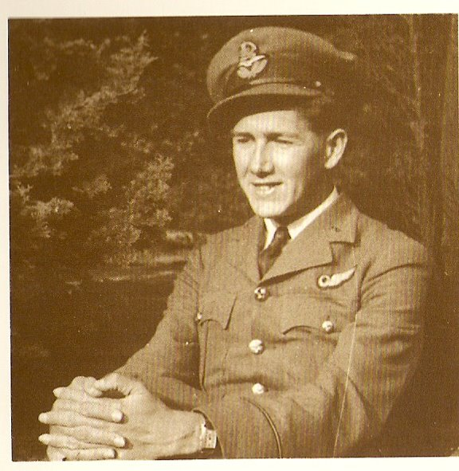
John Edward Northend was the son of William and Phyllis Northend, and was born on the 21st September 1920 at Sheffield in the West Riding of Yorkshire. John was brought up knowing of his family’s military service and sense of duty.

His father William Frederick Northend was a veteran of the Great War, having served in the 1/3rd West Riding Field Ambulance (1/3rd WR Fd Amb), Royal Army Medical Corps in the 43rd W Riding Division.
Figure 4: Flying Officer John Northend RAFVR. (Image from Millington: 1989. 56)

William’s brother Ernest was a pre-war Territorial soldier and member of the 1/3rd WR Fd Amb. He was decorated with the Military Medal on the first day of the Battle of the Somme in 1916.
A second Uncle, Edgar, also served. He volunteered for service with the Honourable Artillery Company, however before the war Edgar had spent two years working in a print house in Leipzig to learn the advancements made in the
German printing industry, and had become fluent in German. He was therefore posted to the Field Headquarters of the Royal Engineers and was employed on signals interception duties, receiving and translating German radio transmissions.

A third Uncle, Lewis Northend, had suffered from chronic asthma since childhood and was medically unfit for military service; he died as a result of an asthma attack in 1939.

John gained his matriculation at King Edward VII School in Sheffield in 1937 and entered the family business as an apprentice printer, but was called up for service in September 1940 as an Aircraftsman 2nd Class; appointed as Sergeant aircrew sometime in 1941 under service number 1378643; after basic training he was posted abroad to Rhodesia for navigation gunnery and bombing courses.

He arrived back in the England in February 1942 , having been appointed to an emergency commission as a Pilot Officer in the General Duties Branch of the RAF Volunteer Reserve (RAFVR) on 31st January 1942. He underwent further training in night flying on heavy bombers in Wales and at RAF Kinloss in Scotland. John was posted to No 61 Sqn at RAF Syerston in Nottinghamshire, flying Whitley bombers, and took part in maritime anti-submarine operations in the Atlantic and in the Bay of Biscay area. It is thought that he was promoted to Flying Officer on 1st October 1942.

After conversion on to the much larger Lancaster bomber, 61 Squadron took part in some of the long-range bombing operations against Northern Italian cities, as wekk as the more usual German targets.
Early in the morning of 13 January 1943 Lancaster bombers of No.61 Squadron, were part of a force of 55 Lancasters from Nos. 1 & 5 Groups RAF, with target indication by 4 Mosquito aircraft from the Pathfinder Force; taking part in an attack on the Krupps works at Essen, one of the cities in the industrial heartland of Germany, the Ruhr.

The Oboe precision navigation equipment of the first Mosquito to arrive failed and the other 3 Mosquitos were all late. Because of this many of the Lancasters bombed on dead reckoning, relying on pinpoint accurate navigation to hit the target. Some bombs did fall in Essen, where 20 houses were destroyed or seriously damaged and 9 people were killed, but other bombs fell in Neviges, Remscheid, Silongen and Wuppertal, a group of towns 12-20 miles south of Essen. 19 people were killed in Remscheid.

John Northend was the navigator of Lancaster MkI serial number W4192 carrying the 61 Sqn. markings ‘QR-E’, piloted by Flt Lt David Stapylton Gillett of Leatherhead in Surrey. They took off at 03:35hrs on 13 January from RAF Syerston. After successfully bombing their target, the Krupps factory in Essen, their Lancaster crashed near Mettman, 14 km ENE of Düsseldorf.

The crew were all killed, and were buried in the Nordfriedhof cemetery on 18 Jan 1943. John and Sergeants Burton and Roberts could not be individually identified and were buried together in a communal grave. They were later reburied as part of the post-war consolidation of graves into large, British cemeteries by the CWGC, at which point they were identified individually and were buried separately; their graves are now in the Reichswald War Cemetery near Kleve close to the German – Dutch border.

t is not known exactly why they crashed, as there were no outstanding claims by German night fighter or anti-aircraft artillery batteries; it is therefore believed that they may have been damaged by flak over the target. It is also possible that the aircraft suffered a structural failure.

John had attended King Edward VII School, Sheffield. The following obituary appeared in edition no 3 of volume XI of the school journal, the King Edward VII School Magazine in July, 1943.

JOHN EDWARD NORTHEND (1930-37),
Flying Officer, R.A.F.V.R.
Believed killed in action, January 1943. Aged 22.

John Northend was reported missing in January after a bombing raid over Germany. "He was a member" (his Wing Commander writes) " of a very fine crew that had carried out many most praiseworthy sorties, including the famous raids on Italy. I feel that we have lost seven exceptionally good men who were welded into the finest of crews. Of John Northend I had the highest opinion; his work was of the highest standard, and so too was the example he set as an officer, while I admired his inherent cheerfulness. Popular in the Mess and with all ranks in the Squadron, we are going to miss him very much." No news of the fate of his aircraft was heard, but subsequent information was that he and his crew were believed to be buried at Dusseldorf.

The full crew of Lancaster W4192 “QR-E” were:
Pilot | Flt Lt David Stapylton Gillett RAFVR: Service number 117679: age 22: Grave 8.G.5. Son of William Alan and Ella Mabel Gillett, of Leatherhead, Surrey; husband of Margaret Virginia Gillett, of Leatherhead.
Flight Engineer | Sgt Albert Frederick Haden RAFVR: 1185774: age 22: Grave 8.G.3.  Son of Horace H Haden and Rebecca Jane Haden, born Shurlock Row, Maidenhead, Berks.
Observer (Navigator) | F/O John Edward Northend RAFVR: 119289: age 22: Grave 8.G.2  Son of William Frederick and Phyllis Northend, of Sheffield.
Air Bomber | F/S John Charles Morgan RAFVR: 969408: age 36: Grave 8.G.7  Son of the Revd. John Arthur Morgan, M.A., and Anna Ida Morgan; husband of Dorothea Mary Morgan, of Derby. B.A. (Cantab.): Pembroke College
Wireless Operator | Sgt Edward Roberts RAFVR: 1064318: age 29: Grave 8.G.4.  Son of Harry and Ada Ellen Roberts, of Hull.
Mid Upper  Gunner | P/O Ronald Henry William Hatt RAFVR: 132167: age 23: Grave 8.G.8.  Son of Henry William and Fanny Hatt; husband of Mavis Cynthia Hatt.
Rear  Gunner | Sgt Herbert Frank Burton RAFVR: 913376: age 24: Grave 8.G.6.  Son of Arthur Frank and Ada Burton, of Cliffe-at-Hoo, Kent.

(Grave numbers refer to the REICHSWALD FOREST WAR CEMETERY).
John Northend’s father William was one of four brothers, however John was the only son produced by the four brothers, so his branch of the Northend family died out when his father and uncles died.

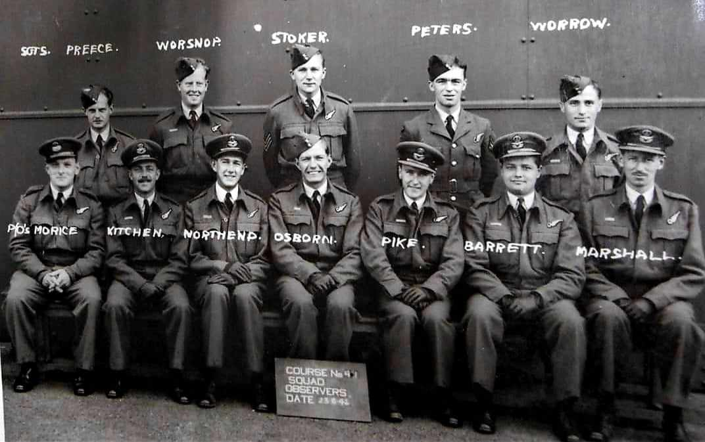
Figure 5: Observer Course No. 41 at 12 OTU RAF Kinloss, 23 June 1942. Copyright unknown.

John Northend’s Observer Course at No 12 OTU (Operational Training Unit) RAF Kinloss*. Of the 12 ‘Observers’ (Navigators) on the course;
8 were killed in action in bomber command during World War 2
3 including John Northend were posted to 61 Squadron at RAF Syerston
All 3 posted to 61 Sqn. were killed in action in the first 5 weeks of 1943

*As an RAF Reserve Officer myself, I was on a week’s attachment to RAF Kinloss when my promotion to Squadron Leader took effect on 1st August 2010.

Appendix 23: 13005511 Lance Serjeant CF BRISTOW GM Royal Engineers.

Rank | Lance Sergeant (Corporal)
Name | Charles Frederick Bristow
Service | British Army
Unit | 22 Bomb Disposal Company
Attached To | Corps of Royal Engineers
Operation | N/A
Date of Death | 9th April 1942
Place of Death | St. Georges Hospital London
Circumstances | Killed in Action (Died of Wounds)
Decorations | George Medal
Age | 43
Buried or Commemorated at | St Andrews. Churchyard, Cranwell
Grave or Memorial Number | Plot 1 : Row B: Grave A

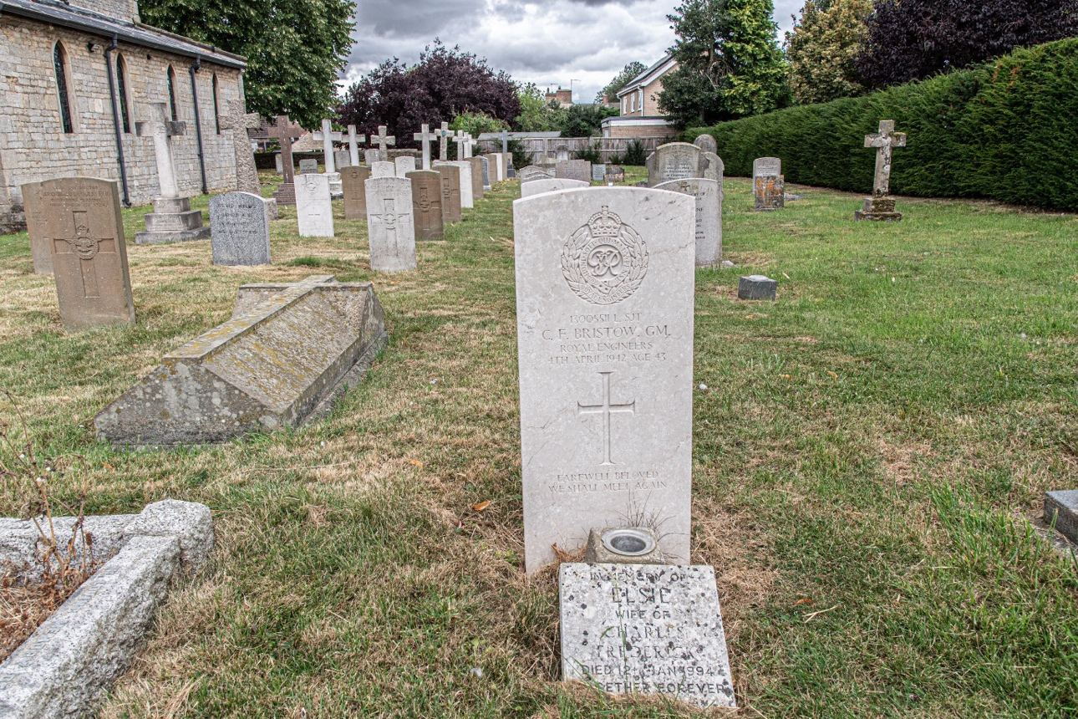

Figure 6: Grave of L/Sjt CF Bristow GM ; Image SM Parkes Aug 2024.

https://thameremembers.org.uk/wp-content/uploads/2016/01/Bristow-CF-plaque.pdf

Charles Frederick Bristow was born in Cranwell, Lincolnshire, on 10th October 1898, the son of Fred, who was a farmer, and Rose Bristow, one of three children. After serving during the Great War, he married Elsie Lomas at St Mary's, Thame on 26th December 1924. She was the daughter of the manager of Thame gasworks. They went to live in East Kesteven, Lincs, and had three children, Rita, Enid and Annie. At the start of the second world war, Charles again volunteered and after serving at first in the Pioneer Corps and coming through the evacuation at Dunkirk, he transferred to the Royal Engineers. 13005511 Charles Frederick Bristow, Royal Engineers, 22 Bomb Disposal Company, was awarded the George Medal on 17th February 1942 in recognition of conspicuous gallantry for carrying out hazardous work associated with de-fusing unexploded bombs in Rainham, Essex, during the winter of 1940/41. On the 1st April 1942, in company with Lieutenant Walton, they attempted to defuse a Yellow Peril (British) balloon bomb. The bomb exploded killing Lieutenant Walton instantly, Sergeant Bristow died of his wounds on the 4th April in St Georges Hospital, London. He was 43 years of age, and was buried with full military honours in Cranwell (St Andrews) churchyard. He is commemorated on the church memorial in Cranwell village, but has yet to be remembered in Thame.

Bristow, C.F. | The Royal Engineers Association (royalengineersbombdisposal-eod.org.uk)

Incident. Lance Sergeant C.F. Bristow. GM, was injured on the 1st April 1942 working with Lieutenant J.P. Walton GM dealing with a Yellow Peril balloon bomb, on Halfway House Marshes, near Great Wakering. Lieutenant J P Walton GM was killed and Lance Sergeant C F Bristow was injured he died of his wounds 3 days later. George Medal details. On the 5th November 1940, as then Corporal C.F. Bristow was assisting Lieutenant J. Walton with a 250kg bomb fitted with a clockwork time delay fuze and a sensitive anti disturbance fuze. This was inside a gasometer at Romford, Essex. Due to the gas they could only work for twenty minutes at a time. Whilst working in these dangerous and arduous conditions an air raid was also in progress. For their efforts both men were awarded the George Medal. Details extracted from The Dangers of UXB’s. Lt Col E.E. Wakeling.

Bristow, C.F. | The Royal Engineers Association (royalengineersbombdisposal-eod.org.uk)

Carl Harris on 13th March 2019 at 11:05 pm
L/Sgt. Charles Frederick Bristow GM and Elsie Bristow, (nee Lomas), were my maternal Grandparents. My Grandmothers ashes were interred at the grave of my Grandfather in 1994 with the simple inscription on a supplementary syne, saying, ‘Together Forever’.
Lance Sgt. Bristow’s medals, together with the Parachute from the Yellow Peril that caused his sad loss are in the possession of my son, Colonel Carl Christian Harris MBE, RM.

13005511 Cpl Charles Frederick Bristow. GM.
22 Bomb Disposal Company.
Placed in the London Gazette on the 17th February 1942.
Awarded for work at Gas works Romford and A13 road Rainham, Essex.Cpl Bristow assisted Lt J.P Walton on the 5th November 1940 in dealing with two 250kg bombs armed with both no 17 and 50 fuzes. These were in gasholders at the Romford Gas Works. The air conditions were so bad that work had to be stopped every twenty minutes. This work was completed in the shortest possible time, ensuring minimum damage and services to be re-started with the least disruption. Also this work was carried out whilst the air raid continued. Also on the 26th to 28th February 1941, Bristow assisted Walton in dealing with three remaining 250kg bombs of a stick of four straddling the A13 at Rainham, Essex. One of this stick exploded after 18 hours. Work commenced on these bombs after a safety period of four days, they were fuzed with both No 17 and 50 fuzes. Two when uncovered were found to be ticking but immunized successfully.

Appendix 24: 6192346 Corporal William JACOBS, Middlesex Regiment.

Rank | Corporal
Name | William Jacobs
Service | British Army
Unit | 1st Battalion Middlesex Regiment
Attached To | Belturbet Garrison
Operation | N/A
Date of Death | 29th August 1921
Place of Death | Belturbet, Co. Cavan, Ireland
Circumstances | Accidentally shot in barracks
Decorations | None
Age | 32
Buried or Commemorated at | Belturbet Church of Ireland Churchyard
Grave or Memorial Number | N/A – southeast of church (near boundary wall)

The son of Mrs. Jacobs, of 13, Granville Rd., Kilburn, London, William Jacobs was born in Liverpool in 1889.

Whilst stationed in the garrison at Belturbet in Ireland, he was accidentally shot in the stomach by Private Adams, an inexperienced soldier, handling a revolver. Cpl Jacobs passed away approximately half an hour after being shot. The subsequent Court of Inquiry found the incident to be entirely accidental and the soldier involved was ‘almost delerious’ (sic) over the event.

Sources accessed 09 Jul 24
https://cairogang.com/soldiers-killed/jacobs/jacobs.html
https://www.cwgc.org/find-records/find-war-dead/casualty-details/2001981/w-r-jacobs/
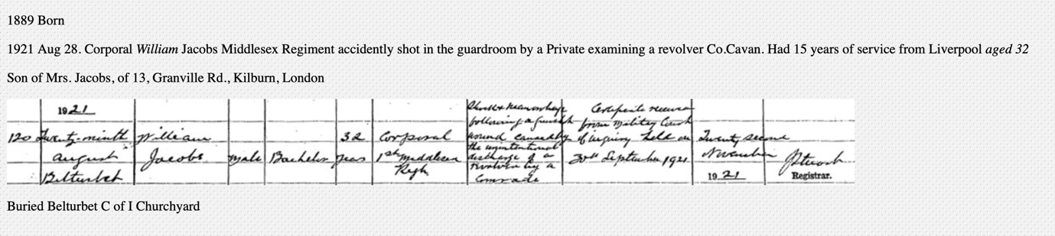

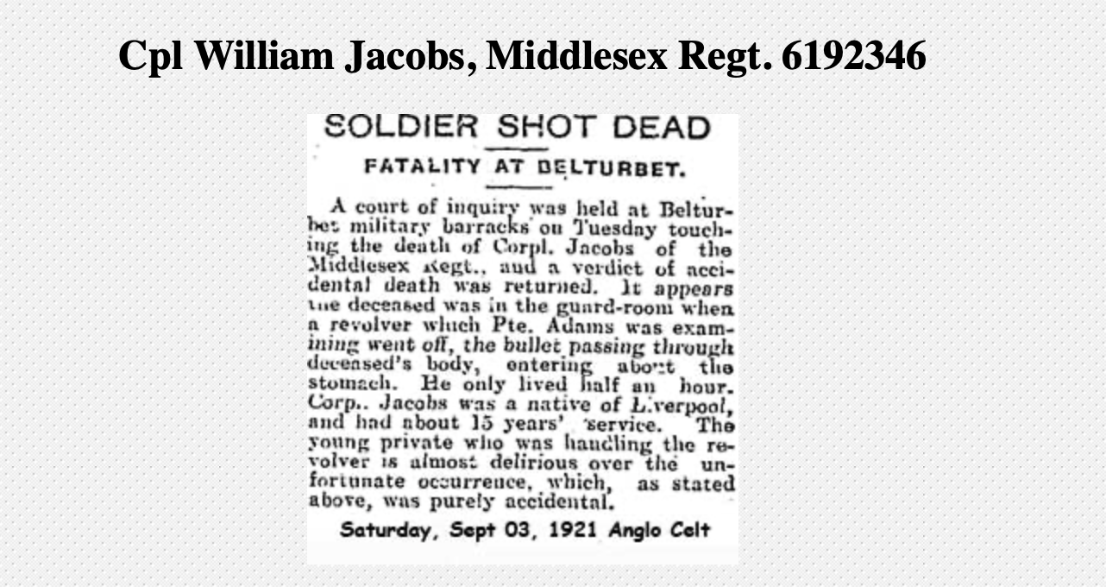

Appendix 25: Rifleman Oliver Frank PENNEFATHER - New Zealand Army
Rank | Rifleman
Name | Oliver Frank Pennefather
Service | New Zealand Army
Unit | 2nd Battalion, 3rd NZ Rifle Brigade
Attached To | New Zealand Expeditionary Force
Operation | Battle of the Somme
Date of Death | 10th July 1916
Place of Death | Armentieres, France
Circumstances | Killed in Action
Decorations | Nil
Age | 21
Buried or Commemorated at | Ration Park Military Cemetery, La Chapelle D’Armentieres
Grave or Memorial Number | Plot II : Row E : Grave 16

Biography provided by Frank’s great grandniece: Bridget Herlihy, PhD, MA, BA(Hons), Adult Learning Tutor Ohakea - NZDC, New Zealand Defence College Te Ope Kātua o Aotearoa | New Zealand Defence Force.
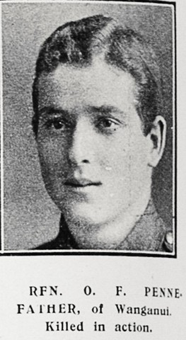
Rifleman Oliver Frank Pennefather (‘Frank’) was born in Fordell, a small township south of Whanganui in New Zealand’s North Island. He was one of eight children born to Oliver Bateman Pennefather and Francis Annie Pennefather. Like his father, Frank was a farmer before he enlisted in the Army to join the WWI war efforts. He was deployed as part of the 3rd Rifle Brigade.

After completing training, Frank departed New Zealand in mid-1915, landing in Suez on 20th December 1915. He was posted to Ismailia,
Figure 7: Rfn OF Pennefather:
Image: Sir George Grey Special Collections, Auckland Libraries, AWNS-19160817-40-16

Egypt for several months, before embarking for
France in Alexandria on 6th April 1916.

On the 10 July 1916, while posted to Armentieres in Northern France, Frank agreed to swap a patrol shift with another member of his battalion. It was during this shift that he was killed in action in the field by a German sniper. Frank was only 21 when he died.

He was interred at Ration Farm Military Cemetery, La Chapelle-d’Armentieres, Nord, France, along with a number of fellow New Zealanders who lost their lives near the French-German border.

He was posthumously awarded the 1914-1915 Star Service Medal, the British War Medal and the Victory Medal, which were presented to his parents.

His sister Umilta and her husband Emmett Herlihy delivered their first child, a son, on 10 July 1923; the seventh anniversary of Frank’s death, They named their son Frank in his honour (who then went on to serve with the RNZAF/RAF during WWII).
https://www.cwgc.org/find-records/find-war-dead/casualty-details/58733/oliver-frank-pennefather/#&gid=2&pid=2

Frank’s brother 2nd Lt Stephen Sidney Pennefather MC DCM had a distinguished military career.

Source: https://www.geni.com/people/2nd-Lt-Sydney-Stephen-Pennefather-DCM-MC/6000000032510033821

Frank’s brother Stephen Sidney Pennefather joined the New Zealand Army and as a Sergeant was commissioned from the ranks as a 2nd Lieutenant. He served with distinction, and was highly decorated for his valour, being awarded the Distinguished Conduct Medal in 1917 for his bravery in leading patrols behind enemy lines and the Military Cross in 1918 for mustering, reorganising and leading two platoons in a successful attack during the battle of Passchendaele. He also served in World War 2, but not in a combat role.

Appendix 26: Map of locations visited and photographed.
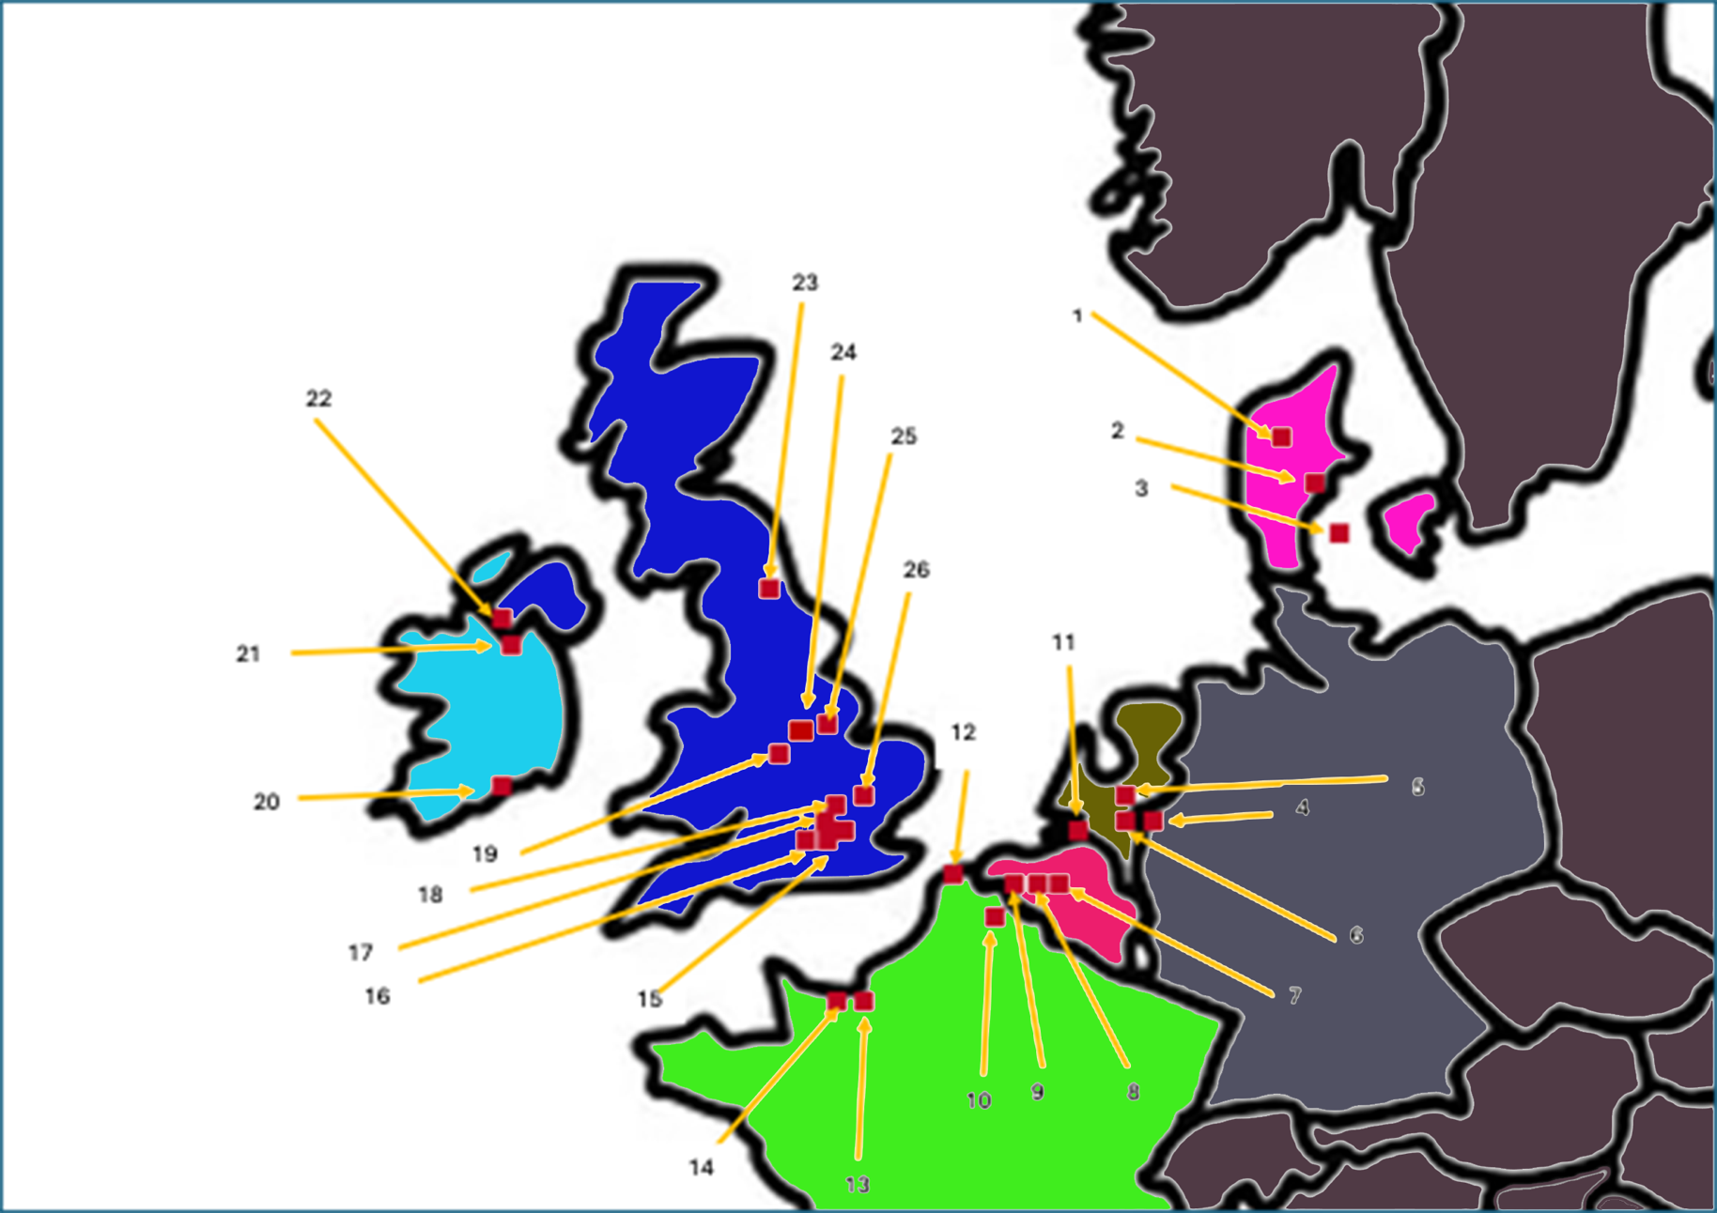

Appendix 27: Index to Map

Denmark
- Arestrup Kirkegard. (11 members of the crew of a B24 Liberator crashed nearby)
- Aarhus Vestre Cemetery.
- Odense Assistens Cemetery.
Germany
- Reichswald British War Cemetery, Kleve.
Holland
- Jonkerbos Cemetery, Nijmegen. (Mainly Graves from Op MARKET GARDEN 1944)
- Arnhem Oosterbeek Cemetery. (Graves from Op MARKET GARDEN 1944)
Belgium
- Tyne Cot Cemetery.
- Menin Gate Memorial, Ieper (Ypres).
- Poperinghe New Military Cemetery. (17 Graves of Soldiers ‘Shot at Dawn’).
- Bergen-Op-Zoom Cemetery. (Graves from Op INFATUATE, Walcheren 1944).
France
- Ration Farm Cemetery, Chapelles D’Armentieres.
- Dunkirk Town Cemetery.
- Ranville (Pegasus Bridge).
- Normandy
  - Sword and Juno Beaches
  - British Normandy Memorial
  - Ryes War Cemetery
  - Bayeux War Cemetery
  - Port-En-Bessin, and 47 RM Cdo Memorial
Ireland
20. Cork Military Cemetery Park. Republic of Ireland.
21. Belturbet Church of Ireland Cemetery. Republic of Ireland.
22. Enniskillen. Northern Ireland.

England
- Surrey
  - Brookwood Military Cemeteries
  - Frimley Cemetery
- Hampshire
  - Basingstoke Worting Road Cemetery
  - Aldershot Military Cemetery
- Runnymede Commonwealth Air Forces Memorial.
- North West London Area
  - Northwood
  - Harefield ANZAC
  - Denham
- Cannock Chase German Military Cemetery, Cannock Chase Military Cemetery.
23. Waterhouses Cemetery, Esh Winning, Durham.
24. Newark-on-Trent, Nottinghamshire.
25. Lincolnshire
a. Cranwell
b. Scopwick
c. Leasingham
d. South Kyme - St Mary and All Saints Churchyard
e. Wildmore - St Peter Churchyard

Appendix 28: Glossary
* Indicates a ‘Bar’ or repeat award of a medal e.g. DFC ** would indicate an original and 2nd and 3rd awards. So-called because the full-sized medal ribbon would have an additional metal bar or clasp added to denote further awards
2IC Second in Command
AVRE Armoured Vehicle Royal Engineers. A specialist armoured vehicle used by assault engineers and armoured vehicle recovery units.
Bde Brigade. Army formation consisting of several battalions or regiments.
Bn Battalion. An army formation consisting of 3-4 infantry companies, an HQ company, a support / heavy weapons company, and sometimes a reconnaissance troop or company.
Cdo Commando (either an individual Commando soldier, or a unit of Army or Royal Marine Commandos, approximately equivalent in size to an Army battalion.)
CGM Conspicuous Gallantry Medal
CRE Commander Royal Engineers
CWGC Commonwealth War Graves Commission (formerly the IWGC)
DFC Distinguished Flying Cross
DFM Distinguished Flying Medal
DSO Distinguished Service Order
GC George Cross
Gp Group. Usually, an RAF term used to denote a formation of several Wings, each of 2-4 individual squadrons. Sometimes used to denote a military formation or battle group made up of elements of other regiments e.g. an Armoured Assault Group consisting of infantry, engineers, artillery, and armoured (tank) units.
GM George Medal
IBCC International Bomber Command Centre (Canwick Hill, Lincoln)
IGSM Indian General Service Medal
IWGC Imperial War Graves Commission (Developed out of the British Army Graves Registration Units / Commission in. 1915, renamed the Commonwealth War Graves Commission in 1960)
IWM Imperial War Museum
KSLI King’s Shropshire Light Infantry
LCT Landing Craft, Tank
LCT(A) Landing Craft, Tank (Armoured)
MC Military Cross
Mk Mark
Mne Marine – lowest enlisted rank in the Royal Marines.
NJG NachtJagdGeschwader (Night Fighter Wing, Luftwaffe, German Air Force)
No Number
Op Operation name, or codeword for a particular military operation; (in British Military documents, the Operation name is always given in upper case e.g. Operation DEADSTICK)
Pte Private - lowest enlisted rank in the Army.
RAF Royal Air Force
RAFVR Royal Air Force Volunteer Reserve
RAuxAF Royal Auxiliary Air Force
Rfn Rifleman; a rank equal to Private, used in various units e.g. The Rifle Brigades, Kings Royal Rifle Corps, modern regiment The Rifles.
RM Royal Marines / Royal Marines Commandos
RN Royal Navy
RNAF Royal Netherlands Air Force
RNoAF Royal Norwegian Air Force
Sqdn / Sqn Squadron (A sub-unit of the Royal Air Force; a sub-unit of a cavalry or armoured regiment.)
Tp Troop (approximately platoon sized unit e.g. No.2 Troop.)
VC Victoria Cross (highest British military award, inscribed ‘For Valour’.)
WOp Wireless Operator
WOp / AG Wireless Operator / Air Gunner

